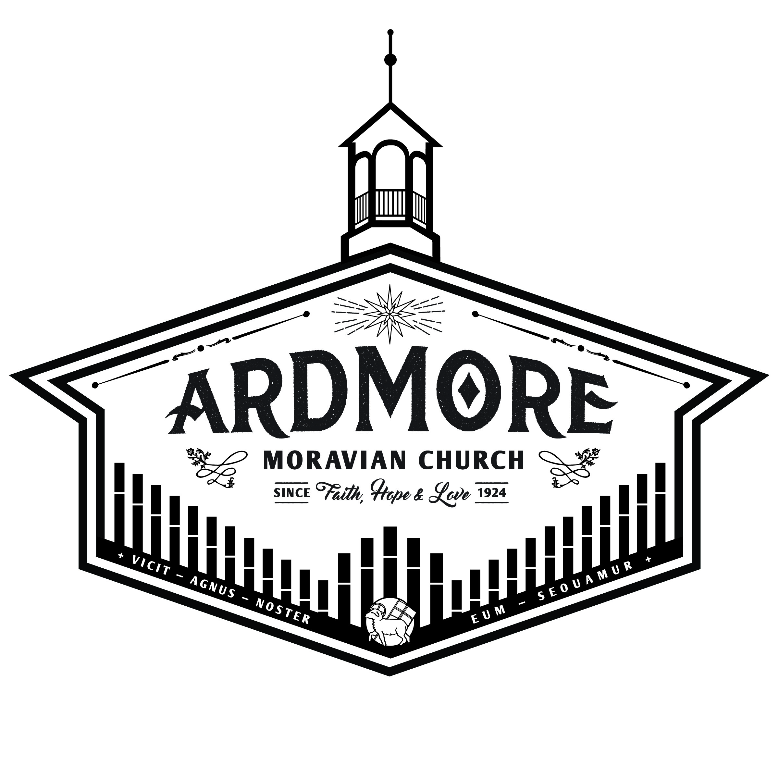

Ardmoremoravian.org
February 23, 2020

WATCH WORD FOR THE WEEK:
God said, “This is my Son, the Beloved;
with him I am well pleased; listen to him!
Matthew 17:5

The flowers are placed today to the glory of God
and in celebration and thanksgiving for Pastor Daniel,
who has been a special blessing to our congregation.

Elder/Trustee Greeter for Today, Feb. 23: George Wright
Elder/Trustee Greeter for March 1: David Peery

Revelation 3:14-22

¹⁴ “To the angel of the church in Laodicea write: These are the words of the Amen, the faithful and true witness, the ruler of God’s creation.
¹⁵ I know your deeds, that you are neither cold nor hot. I wish you were either one or the other!
¹⁶ So, because you are lukewarm—neither hot nor cold—I am about to spit you out of my mouth.
¹⁷ You say, ‘I am rich; I have acquired wealth and do not need a thing.’ But you do not realize that you are wretched, pitiful, poor, blind and naked.
¹⁸ I counsel you to buy from me gold refined in the fire, so you can become rich; and white clothes to wear, so you can cover your shameful nakedness; and salve to put on your eyes, so you can see.
¹⁹ Those whom I love I rebuke and discipline. So be earnest and repent.
²⁰ Here I am! I stand at the door and knock. If anyone hears my voice and opens the door, I will come in and eat with that person, and they with me.
²¹ To the one who is victorious, I will give the right to sit with me on my throne, just as I was victorious and sat down with my Father on his throne.
²² Whoever has ears, let them hear what the Spirit says to the churches.”

ARDMORE MORAVIAN CHURCH
Last Sunday after the Epiphany
February 23, 2020

PRELUDE Hayes
“Christians, We Have Met to Worship”
WELCOME / ANNOUNCEMENTS
RIGHT HAND OF FELLOWSHIP
CALL TO WORSHIP “Great Things” arr. Rouse
SPECIAL RECORDING Dr. S.M. Lockridge

That’s My King

He’s the King of the Jews – That’s a racial king.
He’s the King of Israel – That’s a national king.

He’s the King of Righteousness.
He’s the King of the ages.
He’s the King of Heaven.
He’s the King of Glory.
He’s the King of kings,
And He is the Lord of lords!
Now, that’s my King!

Well, I wonder if you know Him.
Do you know Him?
Don’t try to mislead me.
Do you know my King?

David said,
“The heavens declare the glory of God, and the firmament showeth His handiwork.” (Psalms 19:1)

My King is the only one whom there’s no means of measure can define His limitless love.
No far-seeing telescope can bring into visibility
the coastline of His shoreless supplies.
No barriers can hinder Him from pouring out His blessing.

He’s enduringly strong.
He’s entirely sincere.
He’s eternally steadfast.
He’s immortally graceful.
He’s imperially powerful.
He’s impartially merciful.
That’s my King!

He’s God’s Son.
He’s the sinner’s Savior.
He’s the centerpiece of civilization.
He stands alone in Himself.

He’s august.
He’s unique.
He’s unparalleled.
He’s unprecedented.
He’s supreme.
He’s preeminent.

He’s the loftiest idea in literature.
He’s the highest personality in philosophy.
He’s the supreme problem in high criticism.
He’s the fundamental doctrine of true theology.
He’s the coronal necessity of spiritual religion.
That’s my King!

He’s the miracle of the age.
He’s the superlative of everything good
that you choose to call Him.
He’s the only One able to supply all of our needs simultaneously.
He supplies strength for the weak.
He’s available for the tempted and the tried.

He sympathizes and He saves.
He guards and He guides.
He heals the sick. He cleansed the lepers.
He forgives sinners. He discharges debtors.

He delivers the captives.
He defends the feeble.
He blesses the young.
He serves the unfortunate.
He regards the aged.
He rewards the diligent.
And He beautifies the meek.
Do you know Him? – Well!

My King is the Key of knowledge.
He’s the Wellspring of wisdom.
He’s the Doorway of deliverance.
He’s the Pathway of peace.
He’s the Roadway of righteousness.

He’s the Highway of holiness.
He’s the Gateway of glory.
He’s the Master of the mighty.
He’s the Captain of the conquerors.

He’s the Head of the heroes.
He’s the Leader of the legislators.
He’s the Overseer of the overcomers.
He’s the Governor of governors.
He’s the Prince of princes.
He’s the King of kings.
And He’s the Lord of lords.

That’s my King!
That’s my King! My King!

His office is manifold. His promise is sure.
His light is matchless. His goodness is limitless.
His mercy is everlasting.

His love never changes. His Word is enough.
His grace is sufficient. His reign is righteous.
His yoke is easy and His burden is light.

Well! I wish I could describe Him to you,
but He’s indescribable.
He’s indescribable!
He’s incomprehensible.
He’s invincible.
He’s irresistible.

I’ve come to tell you,
the heaven of heavens cannot contain Him,
let alone a man explain Him.

You can’t get Him out of your mind.
You can’t get Him off of your hands.
You can’t outlive Him.
and you can’t live without Him.

Well! The Pharisees couldn’t stand Him,
but they found out they couldn’t stop Him.

Pilot couldn’t find any fault in Him.

The witnesses couldn’t get their testimonies to agree
and Herod couldn’t kill Him.
Death couldn’t handle Him,
and the grave couldn’t hold Him!
That’s my King!

He always has been, and He always will be.
I’m talking about – He had no predecessor,
and He’ll have no successor.
There was nobody before Him
and they’ll be nobody after Him.
You can’t impeach Him,
And He’s not gonna resign!

That’s my King!
Praise the Lord!
That’s my King!

Thine is the kingdom and the power and the glory.
All the power belongs to my King!

We’re around here talking about black power
and white power and green power, but it’s God’s power!
Thine is the power – and the glory!

We’re trying to get prestige and honor and glory for ourselves, but the glory is all His! Yes!

Thine is the kingdom and the power and the glory
forever, and ever, and ever, and ever!

How long is that?
…and ever, and ever, and ever, and ever!

And when you get through with all of the forevers –
Then Amen!

SONG “He Is Exalted”

He is exalted, the King is exalted on high
I will praise Him
He is exalted; Forever exalted
And I will praise His Name

He is the Lord; Forever His truth shall reign
Heaven and earth rejoice in His holy Name
He is exalted, the King is exalted on high.

SONG “King of Love”
The King of Love my Shepherd is
Whose goodness faileth never
I nothing lack if I am His
And He is mine forever
And He is mine forever

Where streams of living water flow
My ransomed soul He leadeth
And where the verdant pastures grow
With food celestial feedeth

Chorus: Never failing, Ruler of my heart
Everlasting, Lover of my soul
On the mountain high or in the valley low
The King of Love my Shepherd is
The King of Love my Shepherd is

Lost and foolish off I strayed
But yet in love He sought me
And on His shoulder gently laid
And home rejoicing brought me

In death's dark veil I fear no ill
With Thee, dear Lord, beside me
Thy rod and staff my comfort still
Thy cross before to guide me

CHORUS

Bridge: Oh, Hallelujah, Hallelujah
Oh, Hallelujah, Hallelujah

Never failing, Ruler of my heart
Everlasting, Lover of my soul
On the mountain high or in the valley low
The King of Love my Shepherd is

Never failing, Ruler of my heart
Everlasting, Lover of my soul
On the mountain high or in the valley low
The King of Love my Shepherd is
The King of Love my Shepherd is

And so through all the length of days
Thy goodness faileth never
Good Shepherd, may I sing Your praise
Within Your house forever
Within Your house forever
PRAYER
WORSHIP IN OUR GIVING
OFFERTORY Hayes
“Spirit of God, Descend Upon My Heart”
SONG OF THANKS MBW p. 817
Praise God from whom all blessings flow
Praise Him all creatures here below.
Praise Him above ye heavenly host
Praise Father, Son, and Holy Ghost. Amen

ANTHEM “This is My Word” Choplin
THE WORD OF GOD Revelation 3:14-22
MESSAGE “Lukewarm” Daniel Dockery
CLOSING HYMN MBW p. 405
“Crown Him With Many Crowns”
POSTLUDE “Celebration” Mansfield

Please join us immediately following today’s service
for a potluck luncheon in the Fellowship Hall
to celebrate the time the Lord has given us with Pastor Daniel.

THIS WEEK AT AMC

TODAY, February 23
Potluck Luncheon after service – Fellowship Hall

Wednesday, February 26
7:00 PM – Ash Wednesday Service

Sunday, March 1 Lent Communion
8:30 AM Men’s Breakfast
9:00 AM Prayer - Parlor
9:30 AM Sunday School
10:30 AM Worship Service

SERMON NOTES

________________________________________________________________________________________________________________________________________________________________________________________________________________________________________________________________________________________________________________________________________________________________________________________________________________________________________________________________________________________________________________________________________________________
____________________________________________________________________________________________________________________________________________________________________________________________________
SERMON NOTES

________________________________________________________________________________________________________________________________________________________________________________________________________________________________________________________________________________________________________________________________________________________________________________________________________________________________________________________________________________________________________________________________________________________
____________________________________________________________________________________________________________________________________________________________________________________________________
Available dates for 1st Quarter flower donations are:
March 15th and 22nd

Please contact the church office if you would like to place flowers in memory
or in honor of someone.

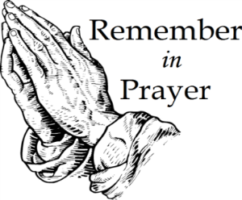
People for Whom We are Praying
Members
James & Marie Adams; Amanda Bowles
Annie Boyd; Adam Lefevre; Ruth Long;
Alice Pierce; Bett Warner; Connie Wester

Friends
Cheryl Bain, Olive Moore, friends of Ruth Long and MaryAlice Adams
Emily Burge
Rosemary Stewart
Donna Tesh, Michael’s mother
Revelle Washburn, friend of Beth Kiger Mabe
Renee Webb, friend of Chris Lefevre

Welcome to Ardmore Moravian Church
“Where Communion and Community Come Together”

We are a Christ-centered fellowship of people bound by love of Jesus and one another. Our greatest hope is that God will be glorified through the power and presence of the Holy Spirit among us. We have gathered to worship; celebrating the eternal life won for us by Christ through His death and resurrection as promised in the Bible.

God has created and called us into relationship with Himself (communion) and with one another (community). We need the Lord, and we need each other. As you draw close to God, may you also grow in friendship with those around you. We believe God has gifted people in every age. So our worship is marked by a variety of styles and expressions of music, liturgy, prayer and proclamation. We seek to blend these expressions in a way that pleases God and edifies one another.

The Moravian Church, while unfamiliar to many, is actually one of the oldest Protestant denominations in the world. Our roots and heritage run deep, even one hundred years prior to the Great Reformation. Yet our sense of mission is alive and active today as we serve the Lord in ministry together.

Jesus said to His disciples, “…you shall be My witnesses both in Jerusalem, and in all Judea, and Samaria, and even to the remotest part of the earth.” At Ardmore Moravian we sincerely strive to live that promise. We worship, study the Holy Scriptures, fellowship and grow as Disciples of Christ together here at the corner of Hawthorne and Academy. We ask the Lord then to send us out and employ us for His glory as we share the Gospel - the Good News of Christ - locally, regionally and globally.

If you are searching for a meaningful relationship with God and productive friendships with other people, you’ve come to the right
place, “Where Communion and Community Come Together”.

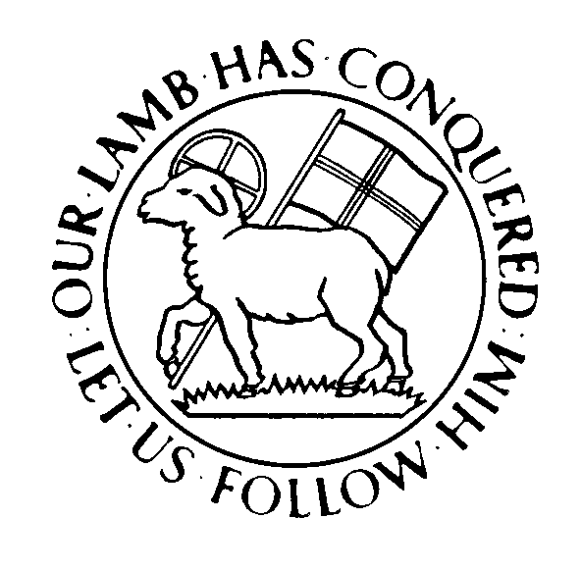

Director of Music: Brian Haskell
Organist/Accompanist: Chris Heckman
Office Administrator: Cyndi Stuemke
Address: 2013 West Academy Street
Winston-Salem, NC 27103
Church office: 336-723-3444

Office: office@ardmoremoravian.org
Online: ArdmoreMoravian.org
@ArdmoreMoravian

(All songs printed under CCLI# 1007661)

