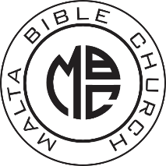
Malta Bible Church
Registration/Medical/Photography Release Form
Child’s Information (Please Print):
Name: ______________________________________________________ Age: ______ Grade ______
Address: ______________________________________________________ Birthdate: ____________
City/State/Zip: ______________________________________________________________________
Parent or Guardian 1: __________________________________ Phone: ________________________
Parent or Guardian 2: __________________________________ Phone: ________________________
Church attending on Sundays: (If none, leave blank) _______________________________________
I understand that Malta Bible Church will make a reasonable effort to assure the safety of my child during Malta Bible Church meetings and activities. In consideration of this, I release and hold harmless Malta Bible Church and its leaders of any liability in regard to any illness or injury which might occur to my child in any respect of this activity, including transportation to and from the church and its activities.
I hereby give the adult supervisor of this activity my permission to order preliminary medical care for my child in case of illness or injury with the understanding that I will be contacted as soon as possible.
I give permission to have my child’s picture used for publicity for Malta Bible Church. I understand the photos will not be released to any other person/party for any other use.
______________________________________________ Date: ____________________
Parent/Guardian Signature

Please not any existing medical conditions which may limit your child’s ability to participate in active games: ________________________________________________________________________
Please list any allergies: _______________________________________________________________
Please list anyone who is allowed to pick up your child: (Please Print) ____________________________________________________________________________________

