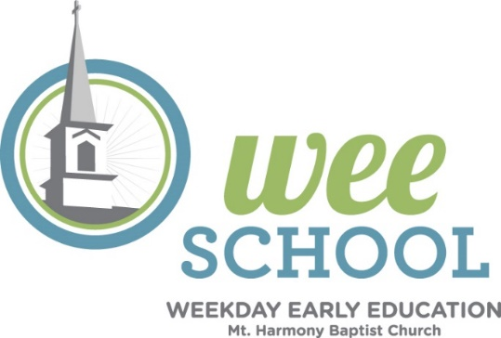

Special Events, Holidays, and Parties
2026-2027
Open House
Back to school Bash 12pm after church service
August 3rd 1st Day of School
August 24th Martial Arts starts
Way to Play
Jitterbug Starts
September 2nd Gymnastics
Start of Little Caesars Pizza Fundraiser
September 7th Labor Day (No School)
End of Little Caesars Pizza Fundraiser
September 10th Grandparents Day
September 21st– 25th Fall Break (No School)
Little Caesars Delivery During Afternoon Carpool
October K4 and K Sleepy Hollow Farm Visit
October Fall Pictures
October 3’s/K4/K Discovery Stage Company Performance
October 25th Fall Festival/Trunk or Treat
November 3rd Election Day/Student Holiday/Staff Workday
November Smyrna Recycling Center Demonstration
November 23rd-27th Thanksgiving Break (No School)
December 5th Breakfast with Santa/Holiday Market
December 10th Santa’s Workshop (9:30am)
December Staff Christmas party
December 17th Christmas Program (9:30am) and Christmas Parties 2-K
December 21st – Jan 1st Christmas Break (No School)
January 18thth MLK JR. Day (No School)
January Nothing Bundt Fundraiser
January 21st 1’s-K Donuts with Dads (after morning drop-off)
February Dr. Swartz visiting

February Nothing Bundt Cake Delivery

February 15th-19th Winter Break (No School)
March 1st-5th Spirit Week (Dr. Seuss) Read Across America
March Spring Pictures
March 25th 1’s – K Easter Egg Hunt/Parties (11am) Parents to attend
March 26th Good Friday (No School for K)
March 28th Easter
April 5th-9th Spring Break
May 3rd-7th Teacher Appreciation Week
May 9th Mother’s Day
May 13th Muffins with Moms (after morning drop-off)
May 19th Last Day of School (T/Th) 1’s -3’s
May 20th Graduation K4 & K (9:30am)

