Davis Community Church
Annual Report
2025
Belong, believe, and build a better world

Our Leadership-

Core Staff:

Rev. Wes Nordman, Interim Pastor
Emma Turnbull, Minister of Music and Liturgy
Lisa Schultz, Director of Operations
Deborah Jory, Office Administrator
Brett Kersten, Finance Manager

Current Session:

Kwabena Asante
Sallie-Grace Tate
Carl Linvill
Rachel Dyer
Darlene Comingore
Alisha Woo
Lee Riggs
Alf Brandt
Elena Fuchs
Vai Ramanathan
Zoe Tilton
Ryan Baum
Susan Yun-- Clerk

Our Ministries:

- Buildings & Grounds
- Children & Youth
- Community Life
- Compassion, Peace, & Justice
- Congregational Care
- Financial Support Ministry
- New Expressions
- Worship Ministry
- Adult Christian Formation

        - Table of Contents:

- Our mission statement
- Pastor’s report
- Director of Operation’s report
- Minister of Music report
- Statistical report
- Buildings & Grounds
- Children & Youth
- Community Life
- Compassion, Peace, & Justice
- Congregational Care
- Financial Support Ministry (report & numbers)
- New Expressions
- Worship Ministry
- Adult Christian Formation
- Closing Scripture

-1-
Mission Statement

We are a welcoming community, nurturing the wellbeing of people and place, and helping
all to flourish—body, mind, and soul—as we embody the love of Christ. We embrace
diversity, cultivate a wide array of spiritual practices, and steward our resources
sustainably for the common good. Through deep partnerships based on companionship,
cultural humility, and co-development, we extend our mission beyond our walls, working
together to create a more just, compassionate and connected world.
We will:

- Become more diverse as an embodiment of God’s dream for the world
- Cultivate spiritual practices that promote experiences of soulful flourishing
- Leverage new economic practices that foster sustainability, resilience, and involvement
- Broaden active participation through a myriad of pathways to community
- Recover and extend the moral actions of Jesus in ways that shape a better world
- Steward our land and buildings responsibly for the sake of the future

-2-
Pastor’s Report—2025

Much was accomplished at DCC in 2025 through the faithful ministry of the church
ministry teams, volunteers and staff. In this annual report, you will read about some of
the many accomplishments. I am very thankful for all the creative, self-giving people
who responded to God’s call to serve the people of this church, the larger community
and the world. I am deeply appreciative for the vision, energy and faith that people
brought to their work.

I am most thankful though, not for anything that can be quantified, but for the quality of
our life together in 2025, the joyous spirit that seemed to bubble up in every worship
service and in so many other events, from meetings to parties. I am thankful for the trust
people placed in church leadership, staff, and one another, as evidenced in a successful
capital campaign and in so many other ways.
There’s a saying in organizational theory: “Culture trumps strategy.” This seems so true.
Unless we get the quality of our life together right, all our plans for ministry will seem like
a grind and will be less effective. But if we bring love, patient listening, mutual
forbearance, trust and joy to this community experience, there is nothing that can stop
DCC as we endeavor to bring healing to a suffering world. May God’s Spirit continue to
empower us to do so in 2026.

-3-
Director of Operations Annual Report

I began serving as Director of Operations in April 2025, starting by taking over HR
responsibilities from the Personnel Committee. This transition allowed the committee to
morph into the Personnel Advisory Committee, which currently has one member. We would
love to welcome two more—so if you have an HR background, especially in the nonprofit
world, and are open to a light, occasional advisory role, I’d be delighted to hear from you.

A significant part of the DO role is partnering with our Buildings &amp; Grounds ministry. Working alongside Lisa Nelson and her dedicated team has been a joy as we care for our large and complex campus through both preventive and restorative maintenance—their work is never-ending and never dull.

I’ve also been supporting the Facilities Task Force as they move toward the final phase of
their 20year campus modernization project. Renovations to the office building are now
underway, with completion expected in May—an exciting milestone for all of us and a real
feather in FTF’s cap!

This year also included work in risk management, security, emergency preparedness,
insurance, IT infrastructure, cybersecurity, and coordination with our many on campus
partners.

But truly, the highlight of 2025 has been getting to know the people of this church—our
talented, committed volunteers and staff. Thank you for welcoming me so generously. It’s an
honor to support the work of DCC and to serve alongside you in this community.

--Lisa

-4-
Minister of Music Report

Our Music Ministry at DCC has been very active in the past year. We recruited a student-led jazz band from UC Davis for our Mardi Gras service in March. Our Holy Week and Easter services were led by Emma Turnbull with the Chancel and Chamber Choirs along with our organist, Michael Glick and Curvd'Aire Brass Ensemble. In May 2025, we presented our Spring Concert to a busy sanctuary. Collaborating with local musicians, the Chancel Choir sang an Argentinian Mass setting in Spanish by Ariel Ramirez, "Missa Criolla." It was accompanied by Argentinian instruments, such as the Charango and Bombo Criolla, harpsichord and double-bass. The Bell Choir and C Street Ukulele Band joined us as well as the Ovation String Quartet.
In September we brought together young musicians from UC Davis to create a new worship band. They are leading our Sunday service twice a month.
Our Christmas Concert in December 2025 included a jazz ensemble and three carols arranged for choir and jazz ensemble. The concert brought in a packed audience and was a great way to celebrate the Christmas Season.
We look forward to all that is in store for the coming year and beyond.

-5-
Statistical Report

Clerk’s Report –

Membership –
Beginning of 2025 – 429 church members
New members – 13
Total losses – 19
Deaths – 13
Deleted from rolls for other reasons – 6
End of 2025 – 423 church members

Friends of the congregation who worship with us or otherwise
participate in the life of DCC (New Expressions participants,
Mosaics participants, etc.) - 700
Baptisms in 2025 - 2

Worship attendance –
Average weekly worship attendance
143 in person + 60 online = 203

-6-
Buildings & Grounds

In 2025, Buildings & Grounds (B&G) experienced a major loss with our Ministry Chairperson and former Session Liaison, Roger Kingston, leaving his leadership role in January, and passing the responsibility to Lisa Nelson. Our team meets on the fourth (4th) Tuesday of every month at 6pm, in person or via Zoom.
We prioritize and schedule projects to enhance and maintain the buildings and grounds of the campus, as we’ve been called to do.
Additionally, early in 2025, DCC interviewed a number of candidates for the Director of Operations (D.O.) position, whose responsibility was loosely defined as 1/3 Finance, 1/3 Human Resources and 1/3 Buildings & Grounds. Dave Roberts and Aaron Statton-Quirk are the staff members who often assist or do projects for DCC, and help maintain the priority list.
Throughout 2025 the Facilities Task Force (FTF) was operating on the assumption that the Office Building would be renovated if the funds were raised and approved by Session. FTF and B&G worked together with Dennis Dahlin, Lisa Schultz and Lisa Nelson belonging to both teams. With the fundraising appeal success, we are moving forward with the renovation according to schedule.
Ministry members have a variety of skills and interests helping in multiple ministries, and not just B&Grelated. Elena Fuchs , Session liaison; Jerry Ito, Bob Johnson, Ed Barker, Susan Wilcox, Mike Silva, Maria Cartwright, Ron Rushford, Jim Soller and Rachel Dyer all provide help and/or Chair other ministries.

-7-
Children & Youth

DCC’s Children and Youth Ministry held Sunday school throughout the year for preschool and elementary grades, and, in September, 2025, added Youth group on Sunday mornings for 6th grade through junior high. Kids in the Kitchen expanded from quarterly to monthly, with children preparing a meal and eating together. Over a dozen volunteers helped with Sunday school in 2025, planning lessons, games, and crafts. The Ministry organized outdoor activities for DCC’s Easter celebration and Fall Festival, which drew many families to visit DCC. DCC’s Youth participated in monthly activities with the Davis Progressive Youth Collective, including a summer camp, Nativity play, cooking for Grace in Action, and a field trip to an escape room, among many others. The Ministry bid farewell to longtime director Kate Boxeth in July, and is interviewing for a new director. Davis Community Church values and welcomes all kids!

-8-
Community Life

2025 began with an unexpected but welcome doubling of the size of the Community Life
Ministry. New members brought ideas, enthusiasm, and energy that allowed our
ministry to grow and better serve our goal of making DCC a caring and welcoming
community. A core expression of this effort, the Holy Happy Hour held on the third
Thursday of the month during the spring and summer, moved to the D street patio,
adopted monthly themes, and found new ways to include other ministries and the
community. For example, we acknowledged the Juneteenth holiday with special
decorations, information provided by our Compassion, Peace & Justice ministry, and the
singing of songs of freedom led by our faithful musical partner, the C Street Ukulele
Band.

Congregational lunches following the service have grown in frequency and now
accompany many congregational gatherings such as annual meetings and discussions
of issues facing the congregation. These events help congregants and visitors to
become better connected to one another, as well as provide welcome nourishment as
DCC conducts its congregational business.

Community Life has also continued to support the work of other DCC ministries. We
provided lunch for the Buildings & Grounds team, scouts, and other workers at their two
annual workdays, and refreshments for the Spring and Winter choral concerts as well as
various other receptions throughout the year. Community Life played a substantial role
in the organization of DCC’s major event of the year – the highly successful Fall Festival
which included all our ministries and community partners and which attracted hundreds
of participants from the community.

We look forward to another exciting year under the direction of Rachel Dyer and
welcome even greater participation from DCC members to help us maintain and expand
our mission to the congregation and community.

-9-
Compassion, Peace, & Justice

CPJ, guided by the coordinating team that grew to 16 congregational members this
year, met monthly to oversee this ministry. We focused on two areas of service:
providing opportunities for the congregation to engage in CPJ issues and supporting our
community partners who champion these causes.

Congregational engagement programs included bi-monthly Advocacy Postcard Writing
sessions held during Coffee Connect, collaboration with the Yolo Interfaith Immigration
Network (YIIN) to provide an educational evening on immigration rights for vulnerable
community members, adult education class focused on climate change, and a Sunday
opportunity to pack food bags for students experiencing food insecurity, a project
sponsored by STEAC.

Our congregation supported community partners by joining Davis Pride Fest,
sponsoring a third trip to Frontera de Cristo, donating backpacks and supplies to
Empower Yolo youth, and serving hot dinners at the winter shelter.
Looking ahead to 2026, each coordinating team member is now a liaison to a
community partner to more effectively support these programs. This highlights DCC’s
revised Mission Statement and our increased involvement in the community. A new
initiative, “Adopt a Social Worker,” will launch in partnership with the Yolo County
Department of Social Services. Additionally, Nick Anderson’s documentary, “The Right
to Exist: Inside Camp Resolution the Housing Crisis,” will be screened in April, followed
by a facilitated discussion. CPJ will maintain the Advocacy Postcard Writing program
and continue to identify meaningful opportunities for congregational involvement with
our community partners and their missions. We are grateful for the congregation’s
support of this ministry.

-10-
Congregational Care

Congregational Care Ministry Focuses on providing care for individual members and
friends of DCC in times of special needs or important occasions. In addition to Pastor
Wes and Sallie Grace Tate, our session liaison, we have nine devoted and compassionate
members.
During the past year we provided meals (44) and rides (11), handed out six
prayer/comfort shawls (which were loving knitted by members of the congregation) sent
notes and cards to members mentioned i n All in the Family, and offered up prayers
through the Prayer Chain.
We trained new volunteers to offer extended communion to members who are no longer
able to attend church.
With the help of the congregation, we were able to provide holiday gifts to over 100
people.
Unfortunately, we had twice as many memorials this year as last year (10 vs 5). A
devoted group who bakes cookies, arranges flowers, does set up, clean up and serves,
allows the families to have a nice reception after the service.
Three times a year we provided approximately 85 flowers for delivery. We appreciate
the members of the congregation taking the time to drop off the flowers and perhaps
have a visit.
We are looking forward to continuing with the month of February as our Month of
Caring where we ask congregants to take a heart with an Act of Kindness.

Stephen Ministry has been paused until the arrival of a new pastor.

-11-
Financial Support Ministry

Purpose:

- The FSM oversees the financial health of DCC, along with the Treasurer,
assists in the wise use of financial resources, directs annual and special
fundraising campaigns, oversees budget processes, and maintains financial
policies appropriate to the use and investment of funds. FSM:
- Works with staff maintaining accounting books
- Analyzes regular financial results
- Interprets financial policies for various ministry activities
- Reports regular financial results to Session and Congregation
- Recommends action to Session

Membership during 2025:

- James (Jim) Soller – Chair
- Cheryl Essex
- Jim Rodgers
- Warren Grawemeyer
- Jeff May
- Jan Soller – Treasurer, Session Member
- Ryan Baum – Session Liaison
- Staff
- Brett Kersten – Finance Manager
- Lisa Schultz – Director of Operations
- Wes Nordman – Pastor &amp; ad hoc to all ministries

Key 2025 Activities:

- Conversion of proprietary software to Quick Books Online (more widely used
platform); full usage started 1/1/25
Consolidated old “stored funds” into fewer, and appropriately classified (as to
restrictions) “reserve funds;” approved by Session following months of research
by the Treasurer
- Joined with Facility Task Force members to lead a Special Joint Stewardship
Campaign for the 2026 Budget and an Office Renovation Capital Campaign
- Developed 2026 Budget for approval by Session in December
- Oversaw mailings of stewardship materials; and annual tax statements

Looking to 2026:

- Outside Review of 2025 Accounting Books (first outside review in five years)
- Presbyterian Foundation Analysis of DCC Resources (Assets &amp; Revenues)
- Review of FSM scope of work , related policies/procedures, and underlying
- controls

Summary Statements:

- 2025, described early in the year as a “watershed year” as the congregation was
apprised of 3+ years of a structural deficit wherein unrestricted revenues were
not enough to offset operational expenses
- Financial Results for 2025 shows a “turning point” from the 3+ year trough
as the congregation and staff combined to improve operating net income
by almost $100,000 compared to the prior year (2023-24). At the same
time the congregation provided estimates of 2026 unrestricted giving of
$718,000, $150,000 more than 2025, while also pledging $900,000 for
Office Renovation (over three years).

- 2026 Budget will still be yet another challenge, but with the generosity shown in
2025 and the continued congregational leadership the challenge can be met.
- The Financial Support Ministry, by the end of February, will publish a complete
report of 2025 Results, the 2026 Budget, the slides and charts to be presented in
the February 22nd Annual Meeting, along with the attached “Making Sense
(Cents) of DCC Finances” pages included in this report. Those four pages,
focused on 2025 results, and summary of 2026 operating budget are:

1. Financial Summary of 2025 Operating Fund (including comments)
and summary income statements of the 2025 actual and 2026
operating budgets along with the last prior full-year period 2023-24
2. Comments showing some of the underlying assumptions built into
the 2026 budget as seen and approved by Session in December,
2025
3. A cash-based income statement of the Office Renovation Funds
(not including pledges for 2026/27 that were accrued) and a look at
the $750k currently in the project budget – expected to be
completed by end of May (pending final City of Davis construction
permits)
4. The Statement of Financial Position (a.k.a. Balance Sheet) showing
assets, liabilities, and equity balances for the entire church. This
includes the accrued (and expected) 2026 &amp; 2027 gifts to the Office
Renovation Project

Final Note:

- Most of the Office Renovation Project’s $750,000 budget will be
spent by the end of June, 2026
- By using DCC’s reserve funds we will self-fund the project’s deficit
spending through 2026 and 2027. The expected pledge payments
will catch us up and ultimately lead to a surplus in 2027
- To support cash flow, early payments of 2026 (or 2027) pledges are
encouraged

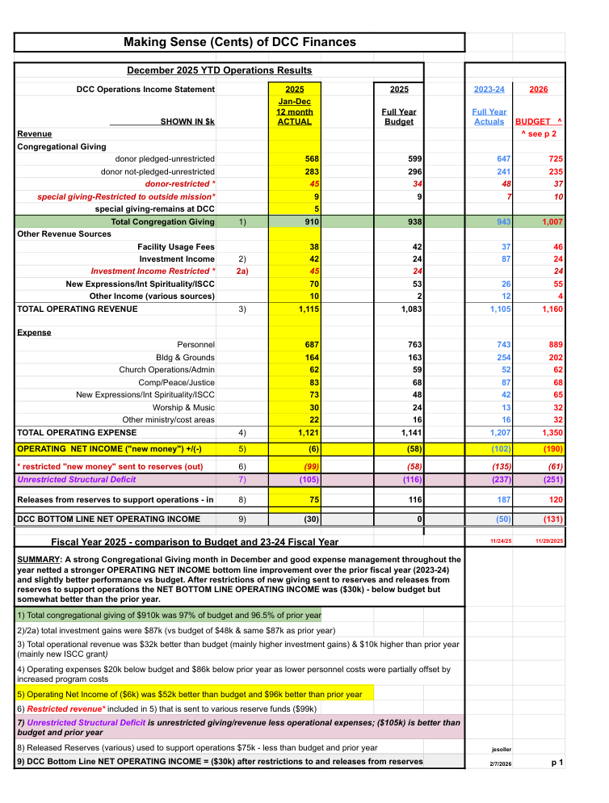

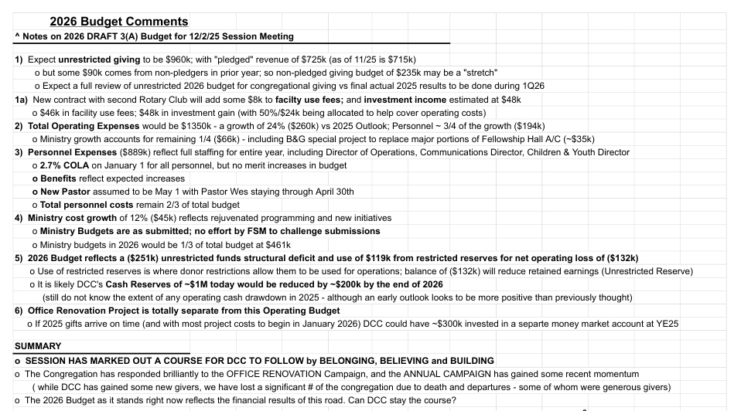

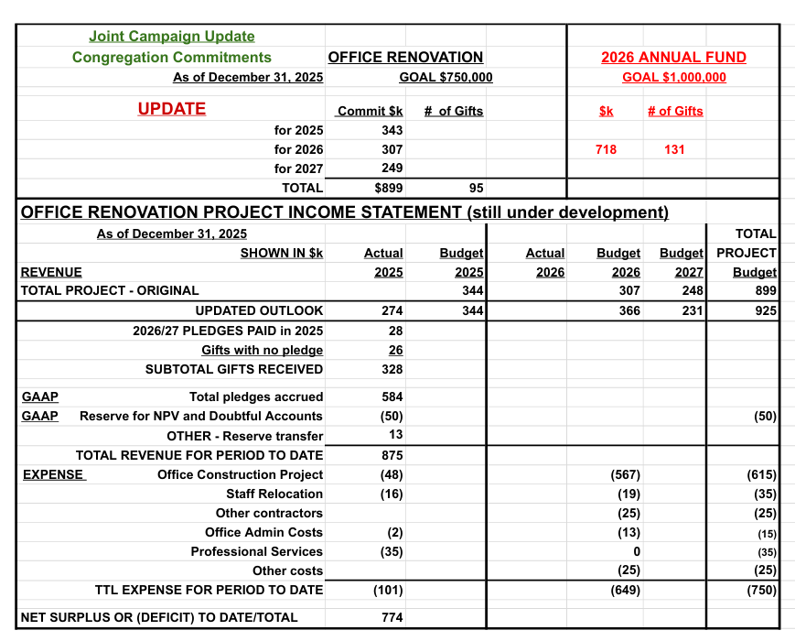

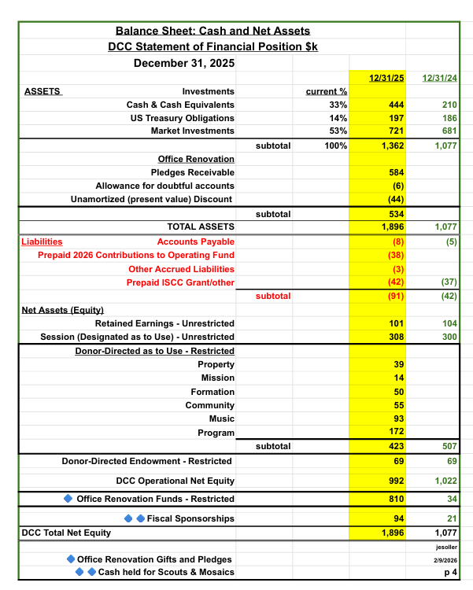

-12-
New Expressions

New Expressions Ministry (NE) lives into the DCC Mission Statement:
“Through deep partnerships based on companionship, cultural humility and
co-development we extend our mission beyond our walls”
● NE deepened DCC’s partnership with Poppy Preschool (formerly DCCNS) by
creating the monthly Parent Cafe and offering two Parent Retreats, and
collaborated with the Poppy Family Concert and Santa Fest events. NE and
Poppy staff met regularly throughout the year.
● NE held Parents with Teens gatherings and is meeting with DPYC leadership
and parents about providing a Parents of Teens retreat in 2026.
● NE Ministry sponsored the Holiday Gift and Art Fair, supporting DCC’s
non-profit partners: Do Good Shop, Purple Tree Cafe, Heifer International,
Metlakata Baskets, Resilient Threads and Acme Theatre Company as well as
ten local artisans.
● NE is a discerning place for people with ideas/passions to co-create offerings
outreaching and supporting the greater good. One current proposal is an
ecumenical rotating monthly worship experience designed to support
neurodivergent community and caregivers in Yolo county.
NE programs “help all to flourish - mind body and soul”
● NE offered an array of programs: Sacred Space, Kirtan Meditation, Centering
Prayer, Gentle Yoga, Tai Ji, Soundbath Evenings, Community Reiki Clinic,
Line Dancing, Parent Cafe, Here Together, Death Cafe, Artsplay, Caregiver
Support, Spiritual Direction sessions and special events. Programs are free
or offered with a sliding scale, tithing 10% of income to DCC’s operating budget.
NE Programs average 450 engagements per month.
● NE is excited to announce that Sacred Space gatherings will expand in 2026
with the addition of 4 seasonal evening offerings in conjunction with the
Second Friday Davis Art About.
New Expressions Team: Jennifer Terra (co-chair), Elizabeth Fulmer (co-chair), Brad
Barber, Marianne Kirkland, Donna Waterman, Kwabena Asante (Session liaison)
NE meets the first Monday of the month at 5:30 pm at Symposium Restaurant, 1620 8th
Street. Newcomers are welcome!

-13-
Worship Ministry

2025 was a year of growth for Worship. Live attendance has increased ( the average attendance for the first six weeks of the year in 2025 was 130 and this year, 2026, it is 160 . There is also a strong cohort who watch the live stream and have the option to meet in the Zoom Cafe afterwards. In addition the Worship Service video is available on You Tube and around 100 people watch it ​​asynchronously each week. Sacred Space is an alternative early service on the second Sunday of the month and has a very dedicated following as well.
A vibrant service takes many people to support it. Pastoral leadership is at the core but below are some of the teams that commit to helping each Sunday.

Music Ministry: This ministry has grown significantly this year under the direction of our Music Minister.The new band is a recent addition with the goal of building a connection point for younger members.

Liturgists and Readers: Every week folks commit to this vital part of the service. Both new participants, long-time members and youth participate regularly. Pastor Wes and Alf Brandt coordinate sign-ups.

Ushers: This ministry has a team of around 12 regular members who greet and assist folks attending worship as well as take the offering. Gayna Lamb-bang faithfully coordinates the teams.

Flower Guild: This dedicated team is led by Katie Kingston and provides beautiful flowers every Sunday. They coordinate with Congregational Care with the delivery and decoration of Easter Flowers and also the amazing Christmas decorations.

Communion Guild: This team prepares and cleans-up the communion elements the first Sunday of each month. Heather Carson coordinates the preparation volunteers, as well as elders past and present who serve the communion.

Sextons: This team is coordinated through Buildings and Grounds, it is an essential part of providing a welcoming campus for our service. They are very dedicated but could use more members. Mark Nelson is the coordinator.
It is a delight and privilege to witness the positive energy of all the volunteers who contribute to the Worship services

-14-
Adult Christian Formation

What Adult Christian Formation accomplished in 2025:
Co-chairs: Brad Barber, Vai Ramanathan
Our committee in 2025: P. Wes, Brad Barber, Marianne Kirkland, Jewel Payne, Vai Ramanathan
During this period, Adult Christian Formation at DCC worked intentionally to engage with faith, justice and the realities of the world around us. Our goal has been to create spaces where adults could wrestle honestly with difficult questions, deepen their spiritual lives, and seek Jesus together in ways that are both faithful and responsive to our times.

One of the central ways we did this last year was through sustained engagement with significant texts. With P. Wes, we read and discussed Reinhold Niebuhr’s Moral Man and Immoral Society, which helped us examine the tension between personal morality and social responsibility. This work invited congregants to think critically about power systems and ethical demands of Christian life in community.

We also studied Jamar Tisby’s The Color of Compromise. Stephanie Milton both offered a sermon and led discussions that had us reflect on the history of injustice and our own complicity within the church.

This was followed by P. Wes and other book group leaders facilitating our reading of Kurtz and
Kethcham’s The Spirituality of Imperfection, a text that offered a deeply pastoral and liberating vision of faith grounded in honesty, humility, and vulnerability. We also intentionally addressed forgiveness, so central to Jesus’ teachings, with several book groups reading Desmond Tutu and Mpho Tutu’s The Book of forgiving. This was accompanied by a workshop on forgiveness led by Brad Barber.

Beyond book studies, AF hosted workshops on immigration (with CPJ) and LGBTQIA rights, inviting knowledgeable leaders and practitioners to guide our thinking and conversations. These sessions both provided factual grounded and theological reflection, helping congregants connect Christian faith with contemporary moral and social issues (a position promoted actively by both PCUSA and known theologians).

At the heart of all our work is a shared commitment to seek Jesus in the midst of the world as it truly is, not as we wish it might be. AF and its decisions are continually shaped by this attentiveness, where we listen for and seek Christ’s guidance as we discern how to live faithfully, and respond thoughtfully to the challenges before us.

Closing Scripture:

Hebrews 10:23-25

“Let us hold unswervingly to the hope we profess, for he who promised is faithful. And let us consider how we may spur one another on toward love and good deeds, not giving up meeting together, as some are in the habit of doing, but encouraging one another—and all the more as you see the Day approaching.”

