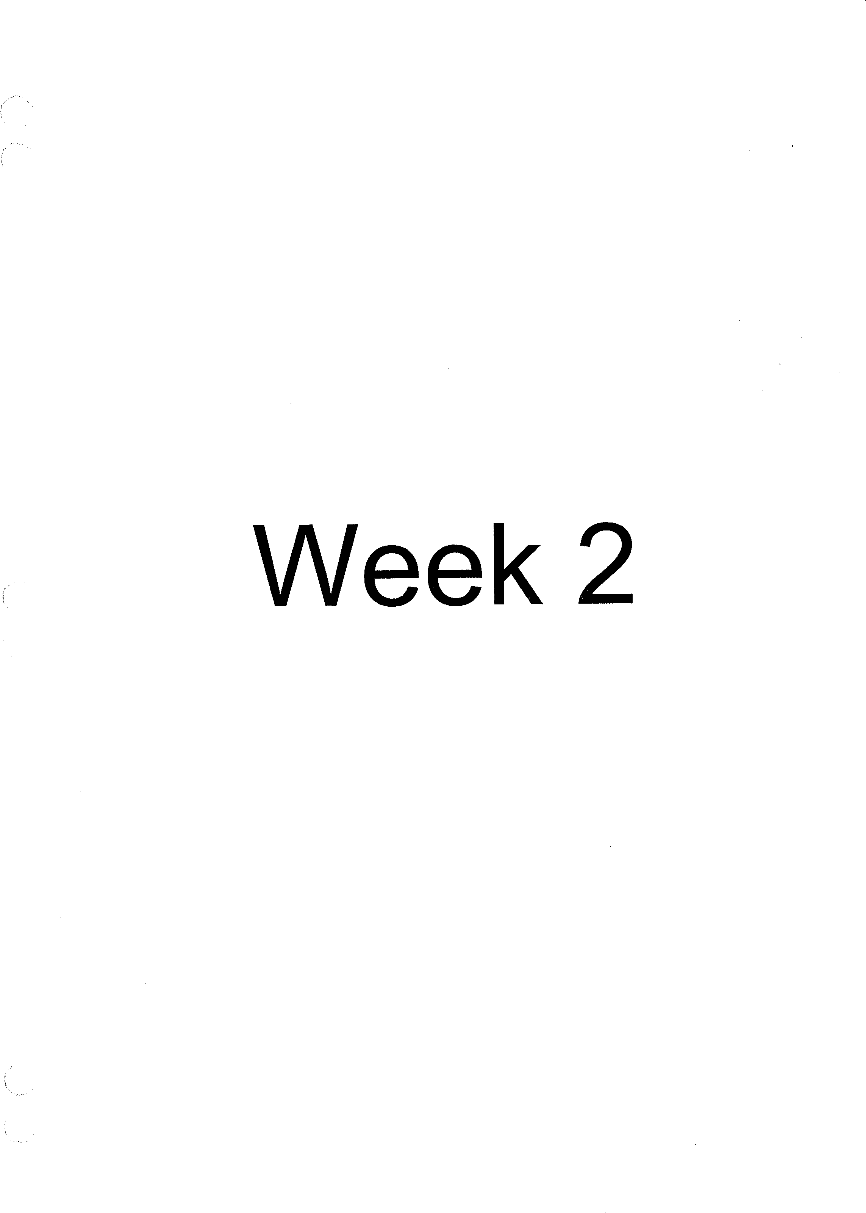

## Leaders Script - Week 2

**tv7'GENERATIONS**

# CHURCH.TV

Intro -Welcome Back Prayer

We will start by covering 3 areas *of* character in1a believer and a leader.

\,,.....,.,_,. · _,._,.,_,_,.,, ,,, /5

Leaders are:

## Flexible and Growth Oriented

1. **People of Integrity and Honesty**
2. **People who Exercise Discretion Leaders are flexible and growth oriented.**

We need sensitivity and honesty to know what needs opt change in our own lives to be the best servants we can possibly be.

What are the traits of growth oriented people?

1. They are life long **learners.**
2. Willing to address and **overcome weaknesses** in their life.
3. Open to new **ideas** and new ways of doing things.
4. They **adjust** graciously to unexpected developments.
5. They adapt to other people.
6. They are willing to embrace **new assignments,** relinquish old roles for the good of the church.
7. They continually seek **improvement.**
8. They experience **spiritual vitality** in their lives.

*"Even if you're on the right track you'll get run over if you just sit there."* Will Rogers

When the pastor or the director brings correction they receive it graciously instead of taking it as a personal attack they see it as an opportunity of growth.

Things change and surprises happen the unpredictable occurs and demands us to think on our feet so to speak. Sometimes we are required to make immediate adjustments because of changes that take place. When immediate adjustments are required some people get busy and make the adjustments while others get flustered and panic. There is an old saying the every person in ministry should take to heart, "he that is flexible shall not get bent out of shape."

One of the great skills the apostle Paul demonstrated in ministry was that of adapting to other people.

*I Car 9:22 "I have become all things to all man"*

# *ti?('*GENERATIONS CHURCH.TV

## Leaders are people of integrity and honesty.

Leaders exercise discretion. This involves having the wisdom to say and do the right things at the right time and avoiding things that are inappropriate and in poor taste. Maintaining confidentiality is also an important part of discretion.

*Proverbs 11:3 "The integrity of the upright will guide them, but the perversity of the unfaithful will destroy them."*

What are some of the traits of people who have integrity and honesty in their lives?

1. They are aboveboard, honorable, and **pure** in all of their dealings.
2. They are not **deceitful.** They don't do things in secret that they would be ashamed of in the light.
3. They tell the **truth.** If they are wrong and make a mistake, they admit it­ they accept responsibility for their actions.
4. They don't shift blame, spin, slant, or twist the story for their own

## advantage.

1. They don't say things that are technically true in one sense, but actually give a false **impression** of the overall situation.
2. They're accurate in stating the facts. They don't **embellish** or exaggerate the facts, and they don't withhold pertinent and appropriate information.
3. They keep their word; they do what they say they're gong to do. They don't make rash impulsive **promises** that they can't or don't intend to keep.
4. They say "yes" when they mean yes and they say "no" when they mean

no.

God wants us to be honest, virtuous, and have integrity in our dealings with one another. When honesty, virtue, and integrity exist in a church culture, and they exist among leaders, workers and volunteers, then the basis for **trust is created.**

## People who exercise discretion.

*Genesis 41:33 "Now therefore let Pharaoh look out* a *man discreet and wise, and set him over the land of Egypt."*

In the Hebrew language this word discreet means to understand, deal wisely, considerate, pay attention, regard, notice, discern, perceive, and inquire. It also means to separate mentally or distinguish or to understand.

**tif7'GENERATIONS**

**CHURCH.TV**

*1 Timothy 3:15 "but if I* am *delayed, I write so that you may know how you ought to conduct yourself in the house of God, which is the church of the living God, the pillar and ground of the truth."*

What are some of the traits of people who have discretion?

1. Their words and actions are in **good taste.**
2. They carry themselves with proper sense of **dignity and react ability.**
3. They conduct themselves with an appropriate level of professionalism in their work and in their dealings with others.
4. They **respect the boundaries** of others and don't **intrude inappropriately** into another persons "private space."
5. They demonstrate proper decorum, exhibiting politeness, courtesy, and good manners.
6. They understand and follow the chain of command; they **honor** proper protocol in their conduct and communication.
7. They show good **judgment** in handling difficult situations.

## Personal View

1. Review the traits of being a flexible, growth-oriented leader. Beside each of the statements, rate yourself on a scale 1-10 (with 10 being excellent). In which aspects are you strongest? Where can you improve?
2. Review the traits of being a person of honesty and integrity. Beside each statement, rate yourself on a scale 1-10 (with 10 being excellent). In which aspects are you the strongest? Where can you improve?
3. Review the traits of being a person of discretion. Beside each of the statements, rate yourself on a scale 1-10 (with 10 being excellent). Which aspects are you the strongest? Where can you improve?