|  |  |
| --- | --- |
| N:\OfficeDocs\Logos\Logo 2012\CBC logo 2012.png | **January 15, 2023**  144 Readington Road  Whitehouse Station, NJ 08889  (908) 534-9445  [office@calvarybiblechurchnj.org](mailto:office@calvarybiblechurchnj.org)  [www.calvarybiblechurchnj.org](http://www.calvarybiblechurchnj.org) |
|  |  |

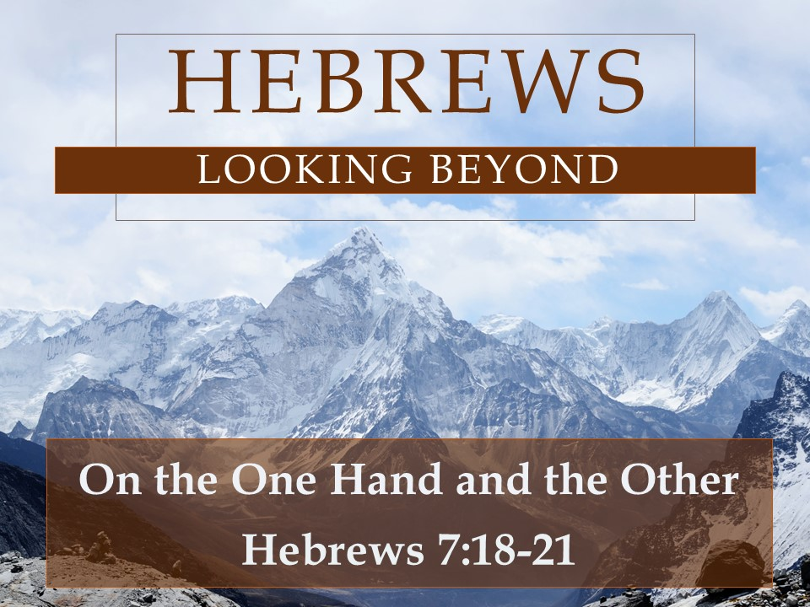

*Our Vision is to Glorify God in our Church, Home, and Community.*

*The purpose of Calvary Bible Church is to Equip our people*

*to Engage their gifts to Exalt God and Evangelize the world.*

**Order of Worship**

**Connect with Us**

**Pastor Ken Staples**

[kstaples@calvarybiblechurchnj.org](mailto:kstaples@calvarybiblechurchnj.org)

(908) 217-6868

**Pastor Steve DiBenedetto**

[pdetto@calvarybiblechurchnj.org](mailto:pdetto@calvarybiblechurchnj.org)

(732) 754-1314

**Eric Davis** Elder Chair

[edavis@calvarybiblechurchnj.org](mailto:edavis@calvarybiblechurchnj.org)

(732) 684-5144

**Drake Angle** Deacon Chair

[dangle@calvarybiblechurchnj.org](mailto:dangle@calvarybiblechurchnj.org)

(914) 715-8810

* Praise and Worship Music
* Welcome & Announcements
* Prayer
* Stewardship of Giving
* Message
* Closing Hymn
* Closing Prayer

**Giving & Attendance for January 8, 2023**

|  |  |  |
| --- | --- | --- |
|  | Last Week’s Giving | Year to Date Giving |
| General Fund | $6,825.00 | $10,687.00 |
| Good Will Fund | $50.00 | $70.00 |
| Mortgage Reduction | $200.00 | $400.00 |
| Total | $7,075.00 | $1,180.00 |

|  |  |
| --- | --- |
| Small Group Attendance | Worship Attendance |
| 73 | 142 |

**Ministry Opportunities for Teens**

Updated 01/10/23

Get weekly updates through “WhatsApp” – Contact Pastor Ken for an invite

**Sunday Small Groups:** JH in Room 002/003 & SH in Room 104 at 9:00 AM

**Wednesday Night Small Groups (except 1st Wednesday of the month):** 7:00-8:30 PM in the CBC Youth Room

**Children’s Ministry**

Contact: Kris Kaye ([childrensministry@calvarybiblechurchnj.org](mailto:childrensministry@calvarybiblechurchnj.org))

**Nursery:** Infant – Age 3, Sunday 9:00 AM & 10:45 AM

Contact: Casey Cattell ([cjcattell@gmail.com](mailto:cjcattell@gmail.com))

**Small Groups:** Pre-K – 5th Grade, Sunday 9:00 AM

Pre-K – 3rd Grade (Elevate), Sunday 10:45 AM

Elevate Contact: Kris Kaye

**Save the Date:** Easter Egg Hunt – April 1, 2023 – Volunteer Sign-Up on Website

VBS – July 10-14, 2023

**Announcements and Upcoming Significant Dates**

**Friendship Center Collection:** See bulletin insert

**Missions Committee Survey:** The Missions Committee put together a short survey for your feedback. Go to the Missions tab of the CBC website for the survey link.

**Missionary Prayer Sign-Up:** The Missions Committee encourages everyone to pick a missionary or two and commit to praying for them for the months of January, February, and March. Go to [calvarybiblechurchnj.org/missions](http://www.calvarybiblechurchnj.org/missions) for the sign-up.

**Q&A Session:** Immediately after the service on January 29, there will be a Q&A Session with the PNC. If you have any specific questions, please send them to the church office beforehand to help the PNC best prepare.

**Save the Date:** Souper Bowl Sundae – February 12, 2023

Men’s Breakfast – April 29, 2023

**New Members Class:** Interested in becoming a member at CBC? Join us for our next New Members Class starting Sunday, February 5 during the 9AM small group hour. Please sign up on our website or contact the CBC office.

**Baby/Child Dedication:** We are planning a baby/child dedication service in the spring. Please let the church office or Pastor Ken know if you are interested or have questions.

On the One Hand and the Other

*Hebrews 7:18-21*

On the One Hand – The insufficiency of the law (v. 18)

On the Other Hand – A better hope and drawing near to God (v. 19)

Greatness of the New Priest (v. 20-21)