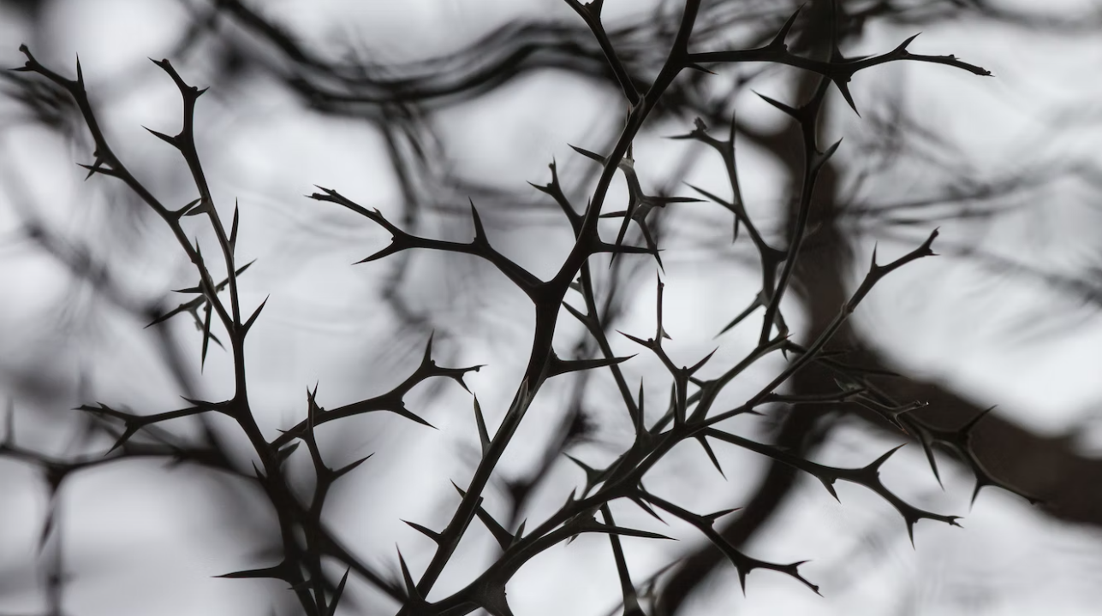
Christ’s crown of thorns has meaning for today that we may need to discover. A crown of thorns isn’t just a painful disgrace, although that’s the limited way in which we tend to think of it. Yes, Pilate’s soldiers intended savage mockery. In the crown of thorns, they achieved it. Thorns, though, are more than just painful points, and a crown woven from them is more than just ignominy.
A thorn is indeed a point, a pointer, and thus a purpose. A thorn is a writing instrument like a pen or pencil, with which one makes sense. A thorn is a sewing needle with which one pierces the fabric exactly where the fabric needs mending or pierces the flesh exactly where the flesh needs suturing. A thorn is a pin that holds a woman’s hair in place, holds two pieces of fabric together, or holds a note to the bulletin board, keeping things in their place. A thorn is not a bad thing but a good thing when put to its proper purpose.
Yet a crown of thorns, like a thornbush, is not a good thing. A bush becomes a thornbush when it has too many points rather than singleness of purpose. The pain of a thornbush isn’t that it has a point, for every bush should have its purpose, but that a thornbush has too many points, so many points that they snag, tangle, poke, poison, and injure. Likewise, a crown becomes a crown of thorns when its wearer can’t make sense of the wearer’s purpose. The king wearing a crown of thorns doesn’t have priorities, identity, impetus, point, reason, and objective. The king wearing a crown of thorns is a fatally confused and pointless leader or, more to the point, leading a people who don’t know their purpose.
Yet Christ carried that thorned crown of a pointless, pained, confused, corrupt, broken, and evil people to a crucifixion cross that had only one upward orientation with only one crossed center. Christ turned his people’s thorny corruption into perfect purity when he placed his figurative and literal bleeding heart over the cross’s center. Christ turned his people’s thorny confusion into perfect clarity when his head pointed his people’s thorny crown toward his Father in heaven. Without Christ, we are a deeply confused people with so many thorny points that we find no purpose. With Christ, we bear but one thorn, and that thorn does not injure but instead heals, joins, unites, and makes sense, as a pointer, pen, and fine needle.

