AIMS
*To affirm the uniqueness of
each child
*To encourage positive development socially, emotionally, and spiritually
*To help the child develop positive relationships with teachers and peers
*To offer creative play to learn academic skills

RELATIONSHIP TO THE CHURCH
The preschool is a non-profit organization sponsored by the Lampeter Church of the Brethren and is open to all children. We place an emphasis on values such as love, compassion, and understanding.

REGISTRATION
There will be a $65.00 registration fee, payable when the child is registered. The registration fee is non-refundable and is not credited toward tuition. Children are considered enrolled upon receipt of their application and registration fee unless otherwise notified that classes are filled, and a waiting list has been started. You will be notified regarding your child’s teacher assignment at a later date.
*After the first four weeks of preschool, no tuition refunds will be given.

For registration information, or for more details, contact the church office at 717-464-2050 or www.lampcob.com.

Lampeter Community Preschool

2026 - 2027
School Year
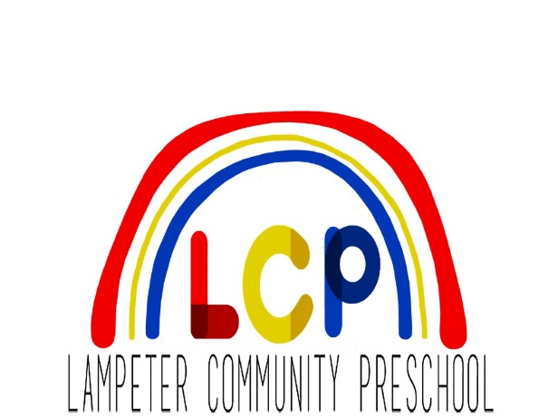

o

Watch us shine!

Located at
Lampeter Church of the Brethren
1900 Lampeter Road
Lancaster, PA 17602
717-464-2050
www.lampcob.com

MISSION
STATEMENT

Lampeter Community Preschool seeks to provide a loving and caring Christian environment in which the child can joyfully adjust to being away from home, grow socially and academically, and develop an enthusiasm for learning.

Lunch Bunch
Lunch Bunch will be offered for the
3/4-Year old and Pre-K classes on Monday through Thursday throughout the year. There will be a monthly sign-up genius for each day it is offered.

2026-2027 SCHOOL YEAR

2-Year-Old Classes
We offer classes for children who are working on potty training and are two years old by September 1.

2 mornings a week
Monday & Wednesday OR
Tuesday & Thursday
9:00 – 11:15 AM

3/4-Year-Old Class
Our school offers this class for children who are potty trained and are three years old by September 1.
2 mornings a week
Tuesdays & Thursdays
9:00 – 11:30 AM

Pre-K 1 Class
Our Pre-K 1 class is for children who are four years old by September 1.
3 mornings a week
Mon., Wed., & Fri. 9:00–11:30 AM

Pre-K 2 Class*
Our Pre-K 2 class is designed for children who have completed Pre-K1, but are not yet entering Kindergarten. This class will focus on enrichment for Kindergarten readiness.

4 mornings a week
Tuesday through Friday,
9:00 AM – 11:30 AM

*Must have completed Pre-K 1
(or equivalent at another preschool).

TUITION

Two Day Program
2-Year-Old Class
$900.00*

Two Day Program
3/4-Year-Old Class
$1025.00*

Three Day Program
Pre-K 1
$1250.00*

Four Day Program
Pre-K 2
$1,700.00*

Tuition may be paid in full at the beginning of the school year or in two payments. Tuition payments must be received by the first day of class in September and by the first day of class in January. Other payment options are available upon request. All classes will be held upon pending enrollment.

*Included in tuition: field trip
expenses, student memory book,
spirit T-shirt, special art
projects, community helper
visits.

