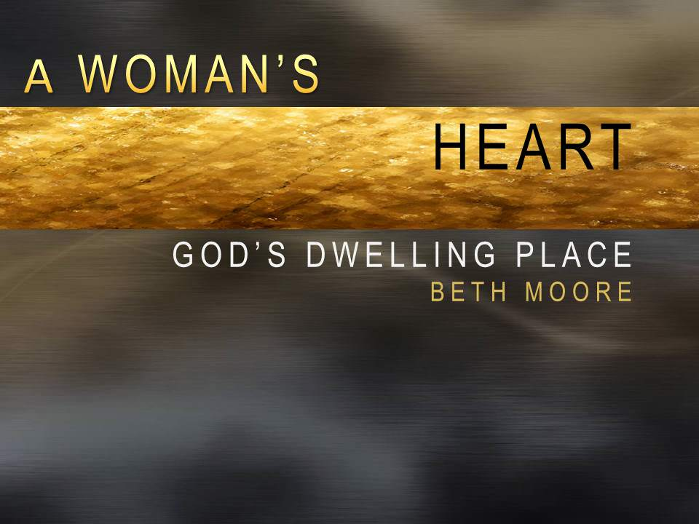

Women's Bible Study

Tuesdays 7-9pm beginning Sept. 22

Via Zoom

*It was while the Israelites roamed the wilderness that God had them build a tabernacle, in order that He Himself might come and dwell with them. This strange time of the COVID pandemic has put each of us in a wilderness-like experience where we each face uncertainty, change, and anxiety. We each desperately need God Himself to come and tabernacle with us. We invite each woman to join us as we study the tabernacle and press into God together as a community.*

RSVP to jenniferalbertson6@gmail.com

Buy your book here <https://www.lifeway.com/en/product/a-woman-s-heart-bible-study-book-P005076821> Coupon code 20FORYOU for 20% off your order.

Informational Video about the study here <https://www.youtube.com/watch?v=TRTk8-A3BYk>

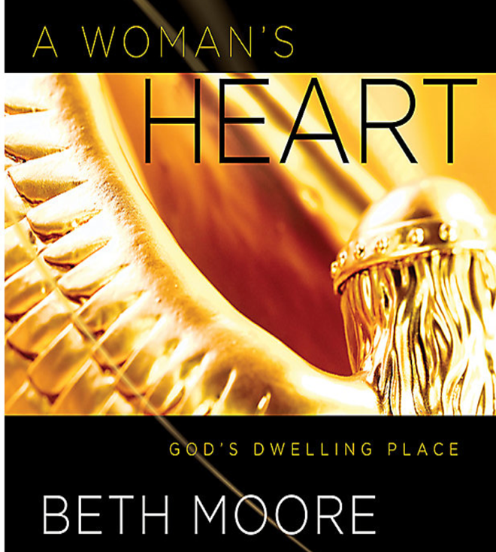**Women's Bible Study Fall 2020 Schedule:**

**Tuesdays 7-9pm via Zoom**

*9/22 - Session Introduction*

*9/29 - Session 1*

*10/6 - Session 2*

*10/13 - Session 3*

*10/20 - Session 4*

*10/27 - Session 5*

*11/3 - Session 6*

*11/10 - Session 7*

*11/17 - Session 8*

*11/24 - Thanksgiving Break*

*12/1 - Session 9*

*12/8 - Session 10*