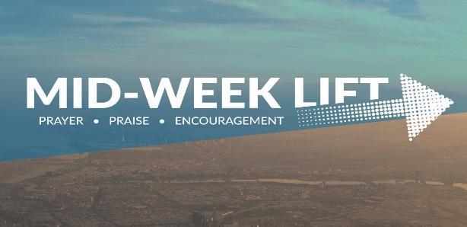
Bermudian Church
April 12, 2023 #981

“The grass is greener on the other side”
“The grass is greener on the other side,” is a well-known proverb. The phrase dates back to the Greek poet Ovid, who lived in the first century B.C. It is a proverb about envy and perception. We are so quick to see the negative in our own situation, so everything else looks better. The proverb is meant in a tongue-in-cheek sense. It’s a way of saying, “Is there really greener grass over there? Is it really as perfect as it seems?” Sometimes, instead of saying “the grass is always greener,” you might hear people phrase it as a warning instead: “the grass isn’t always greener on the other side.” No matter which way you hear the saying, know that the meaning is the same.The grass isn’t always greener. Every job has problems, every family has drama, every neighborhood has its downsides, every church has hypocrites.
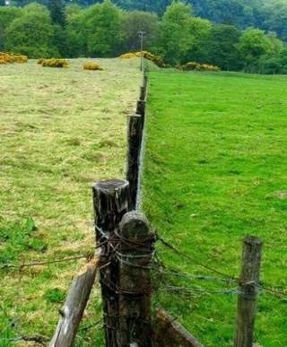
However, there are times when the grass is greener and more lush and better on the other side of the fence. Our horses found that out yesterday. We keep them in one pasture during the winter and feed them hay. During the winter they will eat whatever grass is left in that pasture and then in the Spring it is pretty barren until the grass is able bounce back. Yesterday, they managed to break through a rope fence and found themselves in the next pasture where there was some good grass growing. Because I was not ready to move them there yet, because I wanted to give it another week or so, I returned them to the barren pasture and their hay. This morning, one of them kept walking up and down the fence line looking over it at the pasture with the lush grass. There definitely was greener grass there.
There are times in our walk with Christ that our lives become like that barren pasture. We are not feeding on the Word like we should. We are not taking the time to pray like we should. We are allowing ourselves to be influenced and persuaded by temptation to sin against God. Therefore, we do not receive the joy and blessing from God that he wants to give us. And we look almost with envy at those Christ followers who have what we do not have because of their faithful walk. Like me with the horses, the devil is very happy for us to stay there in the barren wasteland. Christ on the other, through the work and power of the Holy Spirit, has the gate wide open and is calling us to come over to the green pasture.
What does it take to go to this greener pasture? It takes remembering our first love for Christ.
Remembering what it was like when we were walking in the green pastures. And then doing what we did then.
Start praying, even when you don’t feel like it. Get into the Word so the Word can get into you. Spend time with other Christ followers, especially those who are feeding in the green pastures. For when we are feeding in greener pastures we will be satisfied and content.

In Christ Alone
Pastor Gary

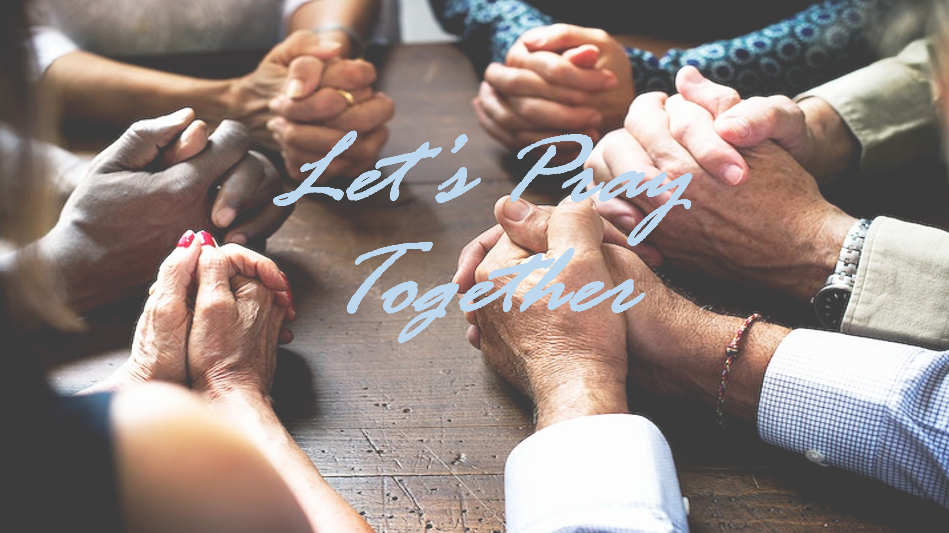
Prayer & Praises

- Sharon Stepp is having cataract surgery today.
- Barb Becker is in the Gettysburg Hospital in ICU for a pacemaker procedure on Thursday. Please keep Barb & Randy in your prayers.
- Mary Titzell requested prayer for a friend, Kathy Neiman who has been receiving cancer treatments, but fell and is now in the hospital on blood thinners. Please pray for healing and peace & comfort for the family members.
- Bonnie Tyson’s grandson Josh is having a procedure on 4/8, please keep this family in prayer. Josh is doing well and was able to join Easter Dinner
- Colin and Amy Staples neighbors Steve and Denise. Denise was awake and aware.
And Colin’s friend Carl Riley battling throat cancer

- Charmaine Hoke thanks everyone for all of the prayers for her!

Ongoing Health Concern Prayers
*Kathy McWilliams *Sarah Sabold (Smeltzer) *Ken Warren *Mary Fisher *Alyssa Leakway
*Jeff Deardorff *Gloria Gerber *Missy Braden *Bryce Baublitz
*Julie Waggoner *Bill Barley *Brandon Little *Derek Meck *Mark Lipsitz
*Josh (Bonnie Tyson’s Grandson) *Ruth Cook

Cancer Special Prayers
*Julia McCartney *Greg & Sandy George *Butch Warren’s brother *Chris Betts (Smeltzer friend) *Ted Erb (Traci Kauffman family) *Carolyn Kimmel *Kathy McWilliams brother-in-law Phillip *Tom Kimmel *Bob (Ron Engle, friend) *Sandy Harlacker *Ellie Basko *Mark Yonker
*Keith Kauffman (Kerry Kauffman’s brother) *Jean Beck

CBC and CBC Region 3 Prayer Requests

- Maple Spring Congregation in Eglon, WV and Pastors Robert Spaid and Lindsey Teets
- Maranatha Congregation in Democratic Republic of Congo, Africa and Pastor Lewis Ponga Umbe
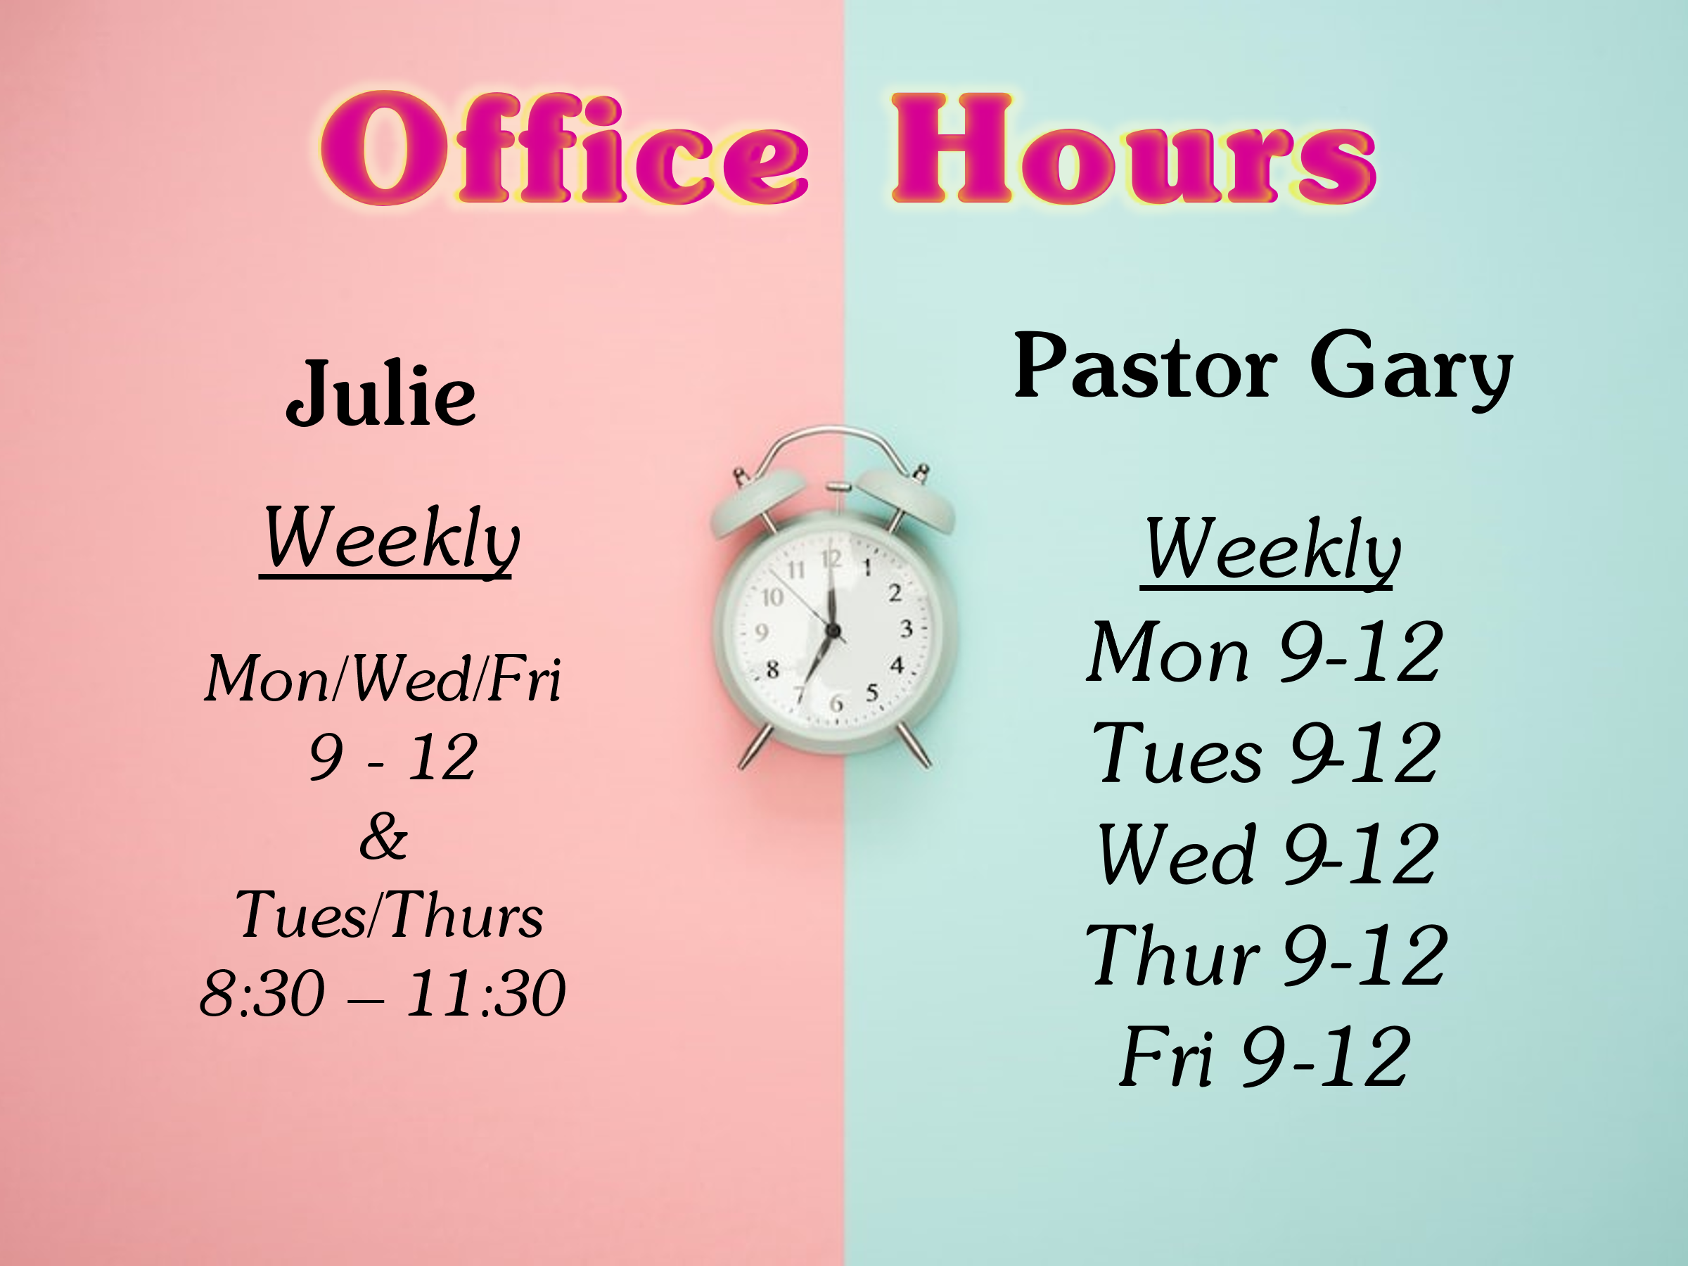
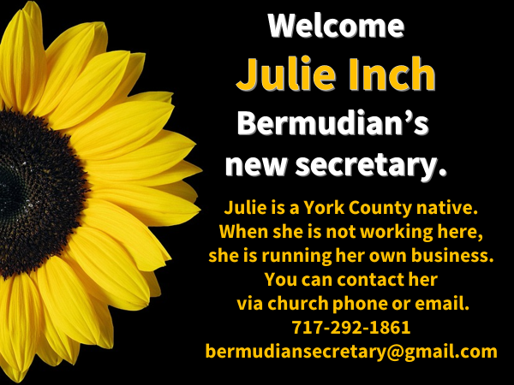



This week
Wednesday 4/12
*Life Group @ 6:30pm
Saturday 4/15
*Men’s Breakfast @7am
Sunday 4/16
*Congregational business meeting @ 10:15am

Next Week
Wednesday 4/19
*Life Group @ 6:30pm
Sunday 4/23
Youth 6pm -8pm
Widows & Widowers Lunch 12 pm






