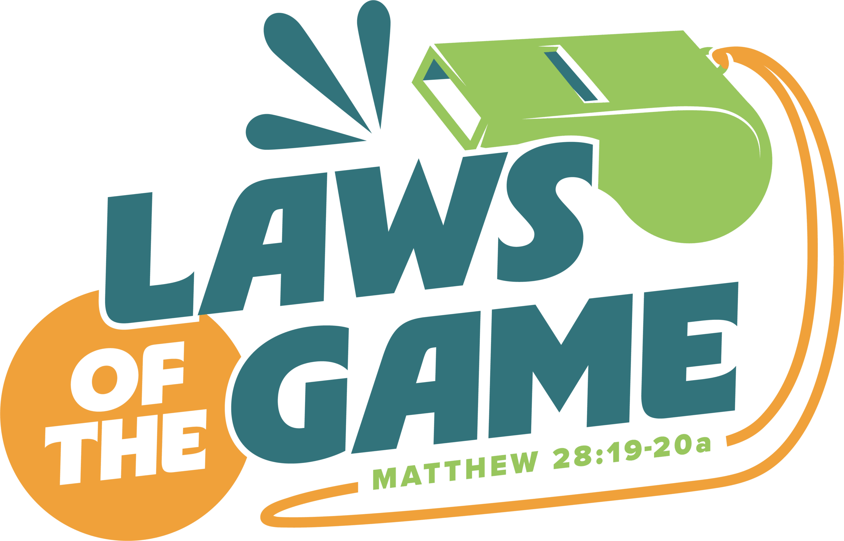
“Laws of the Game” Sports and Arts Camp is June 22 –26! Camp will be held right here at First Pres, from 5:30 – 8 pm each day. The cost is $15 per camper and all campers get a camp T-shirt. For more information or to register, go to: https://www.myvbs.org/first-presbyterian-church-vbs-2026

