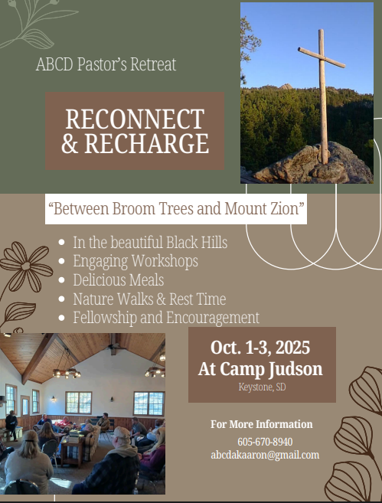

ABC Dakotas Pastors’ Retreat
October 1-3, 2023
Camp Judson, Keystone, SD

_____ I will be attending

Name: _________________________________________

_____ My spouse will be attending.

Name: _________________________________________

_______ I/we would prefer our own room.

_______ I would be willing to room with: ____________________________

I/we will need the following meals/lodging:
_____supper Wednesday night
_____lodging Wednesday night
_____breakfast Thursday morning
_____lunch Thursday noon
_____supper Thursday night
_____lodging Thursday night
_____breakfast Friday morning

Home Church/City: __________________________________________

Email: ____________________________________________________

Phone: ____________________________________________________

Return with $50 to:
ABC of the Dakotas
1101 W. 22nd Street
Sioux Falls, SD 57105
Email: abcdakoffice@gmail.com
Fax: 605-575-2073

2025 ABC DAKOTAS PASTORS’ RETREAT
October 1-3, 2025
Camp Judson, Keystone, SD
Theme: Between Broom Trees and Mount Zion
Retreat Leader: Rev. Dr. Aaron Kilbourn

Retreat Schedule

Wednesday, October 1st

3:00pm – 5:00pm - Check-in at Outreach Lodge

5:30pm – Dining Hall - Supper

7:00pm – Outreach Lodge - Fireside Fellowship – Connecting & Community Time

Thursday, October 2nd

8:00am – Dining Hall - Breakfast

9:00am – Outreach Lodge – Session 1
Personal Response: prayer, silence, Scripture work, or sharpening discussion

10:30am – Outreach Lodge – Session 2
Personal Response: prayer, silence, Scripture work, or sharpening discussion

12:00pm – Dining Hall - Lunch

1:00 pm - Retreat, enjoy the camp, take a drive, relax, and listen

5:30pm – Dining Hall - Supper

6:30pm – Outreach Lodge – Worship and Fellowship

Friday, October 3rd

8:00am – Dining Hall - Breakfast

9:00am – Outreach Lodge – Session 3
Personal Response: prayer, silence, Scripture work, or sharpening discussion

*Go in peace according to your schedule

