2026 Men’s Roundup Program & Schedule

Friday, September 28, 2026
3:00 – 5:30 pm – Check-in and Register
6:00 – 7:00 pm – Supper Meal at Dining Hall
7:00 – 8:30 pm – Worship and Session 1/Luis Coca
9:00 pm – Camp Store and Fellowship

Saturday, September 29, 2026
7:00 am – Wake-up Bell
7:45 am - Flag Raising & Morning Devotion
8:00 am – Breakfast at Dining Hall
9:00 am – Worship and Session 2/Luis Coca
10:00 am – Break
10:30 am – Business and Reports: 1000 Club; Camp Judson;
Holy Cow; CJ Offering
Noon – Lunch at Dining Hall
1:00 pm - Free Time for relaxation and fun!
Skeet Shooting across the road
5:30 pm – Steak Fry at the Pond
7:00 pm – Worship and Session 3/Luis Coca
8:15 pm – Camp Store and Fellowship
9:00 pm – Camp Fire Circle (conditions permitting)

Sunday, September 30, 2026
7:00 am - Wake-up Bell
7:45 am – Vespers Service and Communion
8:30 am – Breakfast at Dining Hall
9:30 am – Farewell and Safe Travels Fellas!

Guest Speaker: Pastor Luis Coca
Pastor Luis V. Coca Jr. serves at First Baptist Church in Fargo, North Dakota. Born in Belleville, Illinois, he grew up in a military family and moved frequently throughout his childhood, living in Arizona, Nevada, California, Wyoming, Texas, and spending three years in Germany.

In 1967, Pastor Coca entered the United States military and faithfully served for 20 years before retiring in 1987 as a Master Sergeant/E-7. During his military career, he served in Security Police/Forces and was stationed in California, Nevada, North Dakota, Korea, Thailand, Vietnam, and Germany.

Following his military service, Pastor Coca continued his commitment to public service through a career in law enforcement in North Dakota. He served as Chief of Police in Burlington and later worked with the Ward County Sheriff’s Office as an investigator, patrol supervisor, and member of the Narcotics Task Force. Throughout his law enforcement career, he also worked alongside agencies including the Sawyer Police Department, Rugby Police Department, North Dakota Bureau of Criminal Investigation, and the United States Marshals Service. He fully retired from law enforcement in 2024.

Pastor Coca gave his life to Jesus during a revival at Sunrise Baptist Church in Las Vegas, Nevada, in 1984. After transferring to Minot Air Force Base, he became a member of Burlington Baptist Church. He was ordained through the Southern Baptist in 2009 and accepted the call to pastor Kief Baptist Church, where he served faithfully for 12 years.

After moving to Moorhead, Minnesota, to be closer to his daughter, Pastor Coca was called in 2023 to serve at First Baptist Church in Fargo, where he continues to minister. His life and ministry reflect a deep commitment to faith, service, leadership, and community.

Holy Cow Project

Since the Holy Cow Project began 32 years ago, some cattle ranchers continue to run a “Holy Cow” with their herd, donating the proceeds of the calves to Camp Judson. This support has been vital for Camp Judson through the years! Please consider your part in Holy Cow this year. Please contact the ABCD Region Office at 605-575-2071 or abcdakaaron@gmail.com for more information and away to help out!

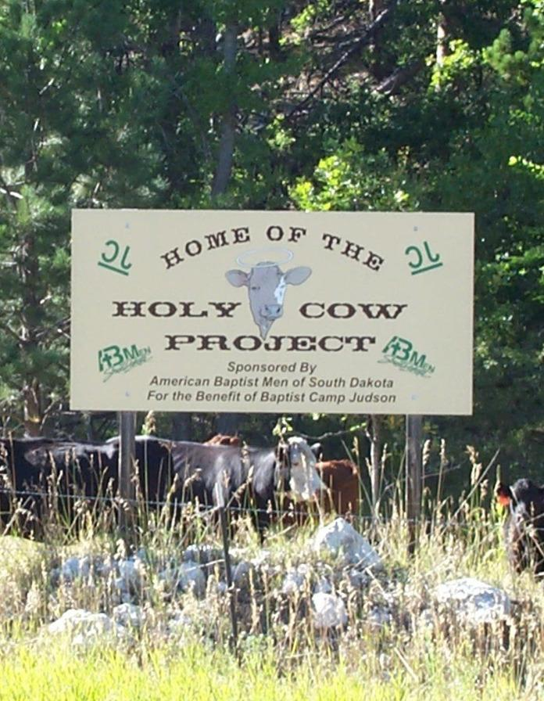

SD/ABM 1000 Club

The 1000 Club is a group of ABC Dakotas men in SD, who agree to support selected ministry projects with (at least) a $10 donation when a call goes out twice each year. Past offerings have helped support seminary students and Camp Judson. If you would like to partner, contact the ABC of Dakotas Office at
at 605-575-2071 or abcdakaaron@gmail.com.

