2025 Men’s Roundup Program & Schedule

Friday, September 22, 2025
3:00 – 5:30 pm – Check-in and Register
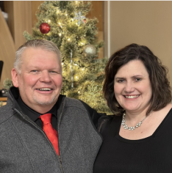
6:00 – 7:00 pm – Supper Meal at Dining Hall
7:00 – 8:30 pm – Worship and Session 1/Chuck Kranz
9:00 pm – Camp Store and Fellowship

Saturday, September 23, 2025
7:00 am – Wake-up Bell
7:45 am - Flag Raising & Morning Devotion
8:00 am – Breakfast at Dining Hall
9:00 am – Worship and Session 2/Chuck Kranz
10:00 am – Break
10:30 am – Business and Reports: 1000 Club; Camp Judson; CJ Campaign; Holy Cow; CJ Offering
Noon – Lunch at Dining Hall
1:00 pm - Free Time for relaxation and fun!
Skeet Shooting across the road
5:30 pm – Steak Fry at the Pond
7:00 pm – An Evening of Comedy with that Bill guy from
Sioux Falls
Offering: Camp Judson
8:15 pm – Camp Store and Fellowship
9:00 pm – Camp Fire Circle (conditions permitting)

Sunday, September 24, 2025
7:00 am - Wake-up Bell
7:45 am – Vespers Service and Communion
8:30 am – Breakfast at Dining Hall
9:30 am – Farewell and Safe Travels Fellas!

Guest Speaker: Pastor Chuck Kranz
Chuck Kranz has worn several hats in North Dakota: youth mentor, program coordinator, teacher, principal, assistant principal of the year, non-profit founder, and Minot citizen of the year nominee. As pastor of Bethel Baptist Church in Powers Lake, MN, Chuck is heavily invested in the life of his congregation as well as our ABCD Camp Bentley where he and his wife Sue served as Camp Managers this past summer.
Since being called to Bethel Baptist in Powers Lake, ND, Chuck has continued to pour into the lives that God brings him. God has also blessed Chuck with his wife, Sue, and six daughters. Sue is just as dynamic as Chuck and serves as Superintendent and Elementary Principal of the Powers Lake School District.

Feature Speaker: Rev. Bill McCready
Bill McCready has served Jesus as a pastor, coach, consultant, comedian, speaker, and encourager for over 30 years. With a passion for changed lives, he has served churches in Idaho, Nevada, California, Washington, and now South Dakota, always aiming for God’s people to be empowered, equipped and encouraged as they grow and serve. He is an engaging preacher, drawing the truth of
God’s Word into the lives of listeners in real and practical ways.

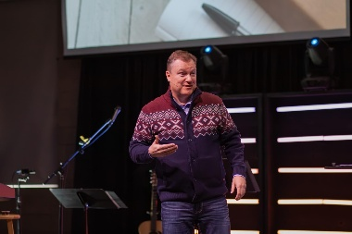
His consulting work has been with both churches and for-profit companies, and he has led and spoken at leadership conferences, church celebrations and comedy shows - always with an authentic, practical, and humorous approach for the moment at hand.

Bill and his wife Beth have two children, Mac and Rachel.

SD/ABM 1000 Club
The 1000 Club is a group of ABC Dakotas men in SD, who agree to support selected ministry projects with (at least) a $10 donation when a call goes out twice each year. Past offerings have helped support seminary students and Camp Judson. If you would like to partner, contact the ABC of Dakotas Office at
at 605-575-2071 or abcdakaaron@gmail.com.

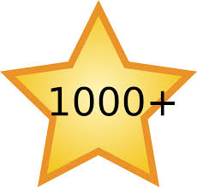

Holy Cow Project
Since the Holy Cow Project began 32 years ago, some cattle ranchers continue to run a “Holy Cow” with their herd, donating the proceeds of the calves to Camp Judson. This support has been vital for Camp Judson through the years! Please consider your part in Holy Cow this year. Please contact the ABCD Region Office at 605-575-2071 or abcdakaaron@gmail.com for more information and away to help out!

