

CONNECT

GROW

LEAD

There are many items around the church that

need attention. Why not ask Allan or Pastor if there is a job you can do around the church

or in one of our ministries!

NEXT WEEK IS AWANA KICK-OFF

AWANA begins September 9th! We will be in need of both helpers and leaders as the club has been growing each year. See Dave Burk for details and register your children on line at our Web Site!

SERVE

Be sure to take advantage of the many

growth opportunities we have here at

Grand Heights. These include our

Adult Bible Fellowship’s on Sundays at 9:15 A.M., several weekday Bible Studies, and our Sunday morning study at 10:30 A.M. in Ephesians

Next Sunday we will continue to look at our identity in Christ by examining Ephesians 2:11-22 in a message entitled “I Am Reconciled”. As people, we naturally build barriers that shut people out. Sin has separated us from God. God extends to us His love, grace, forgiveness and mercy to reconcile us to Him.



**During September we will have a gift card drive to help with expenses. Look at the service Bulletin Board for ideas!**

Missionary of the Month: Trish Sexton (& Foxy)

Trish is the Chief of Operations at Women at Risk, Grand Rapids, MI

She receives no salary! God is providing her needs.

Her prayer request is for wisdom in dealing with people & situations that arise.

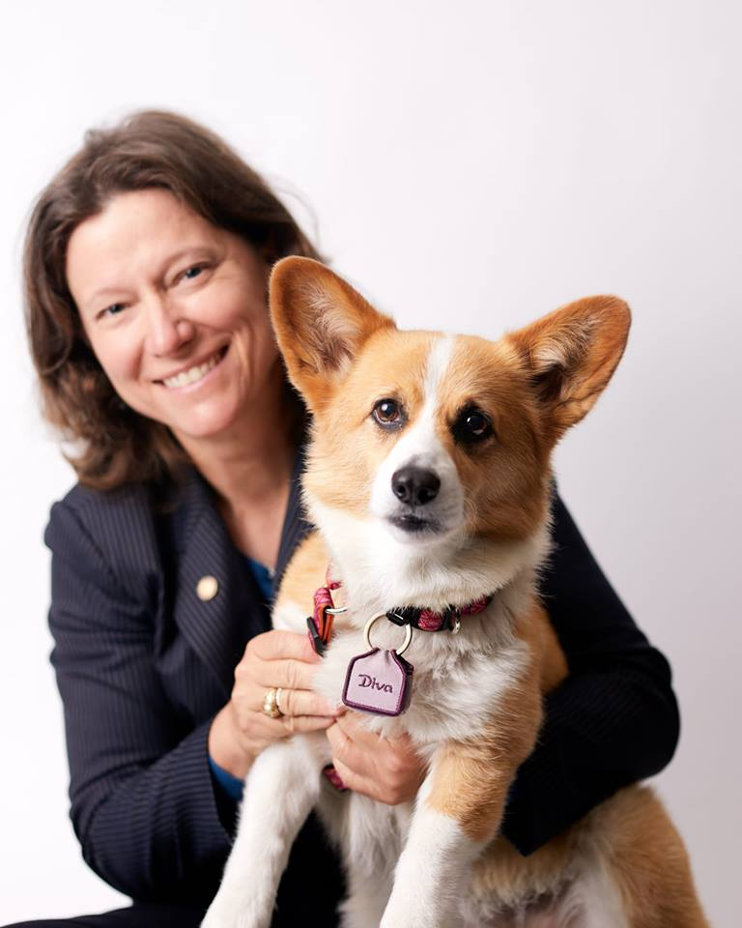

Ladies Movie Night

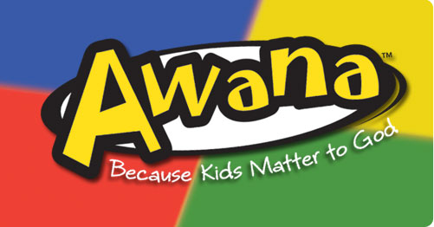

Grand Heights Baptist Church

**www.grandheights.org**



**Hot Dog Roast**

**July 22 @ 6:00 p.m.**



Men’s & Women’s

Bible Study

Kick-Off

September 16th

5:30 – 7:00 p.m.

Bring snacks to share!

August 26th

Putt Putt Golf, Driving Range. Petting Zoo and More! Meet at 7:00 p.m. for Ice Cream

September 21st

“I Can Only Imagine”

Plan now to come and invite a friend.

*Welcome to* ***GRAND HEIGHTS***

We are so glad you are here! You will find Grand Heights to be a diverse community of people dedicated to impacting our community and the world with the Gospel of Jesus Christ!

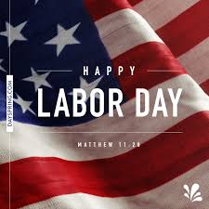

LADIES UPCOMING EVENTS

Sep 9 Fall Bible Study Kickoff

Sep 21 Movie Night “I Can Only Imagine”

Oct 2 Potato Supper

Prayer Partners (Exchange)

Oct 30 Gospel Mission

Dec 1 War Brunch with Trish Sexton

**SEPTEMBER/OCTOBER/NOVEMBER EVENTS**

Sep 1-30 Food Donations for Fish

Sep 9 Awana Kickoff/Youth BBQ Kickoff

Sep 16 Family Growth Group Kickoff

Sep 21 Ladies Movie Night – I Can Only Imagine

Sep 23 Special Business Meeting

Oct 2 Service Night @ Dayton Gospel

Oct 6 Men’s Prayer Breakfast

Oct 12-14 Ladies Retreat @ Skyview Ranch

Oct 30 Service Night @ Dayton Gospel Mission

Nov 3 Men’s Prayer Breakfast

Nov 4 Daylight Savings Time Ends

Nov 10 Kate & Matt Gaudin Wedding Reception

Nov 18 Thanksgiving Feast

***Our Mission: We exist to glorify God as we help people move closer to Jesus in their spiritual journey.***

***Pastor Tom Waldo* (937-416-6923)**

TODAY

Sharing At Grand Heights

Josh & Stephanie Witry

Guest Service Director At Skyview Ranch

Sharing in 10:30 Service

BIRTHDAYS/ANNIVESARIES

Sep 7 Susan Coleman (B)

September 2, 2018

**Grand Heights Baptist Church**

1611 Armstrong Road

Fairborn, OH 45324

(937)878-7971

E-mail: ghbcnet@grandheights.org