There are many items around the church that

need attention. Many have picked up the challenge and picked up jobs around the church. Why not ask Allan or Pastor if there is a job you can do around the church or in one of our ministries!

Thanksgiving Feast

November 18th

@ 5:00 p.m.

Meat, dinnerware and drinks will be provided!

Bring sides and desserts

to share.

SAVE THE DATE

CHURCH FAMILY

FALL FESTIVAL

October 27th

At the Hartong’s Home

* Please come and bring a side dish to share
* Invite your friends to come with you

ADULT GROWTH GROUPS

Men’s & Ladies’ groups are underway on Sunday Nights @ 5:30-7:00 p.m.

LADIES–Fruit of the Spirit

MEN-Becoming an Influencer

All are invited to come!

Sunday’s

5:30 – 7:00 PM

Ages 4 thru

6th grade

NATIONAL COLLECTION WEEK Nov. 12-18, 2018

GOOD NEWS!

GREAT JOY!

is Nov 12–19, 2018National Collection Week is Nov 12–19, 2018

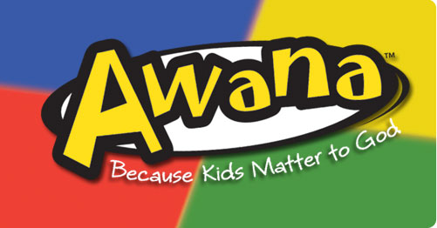



MISSIONS OF THE MONTH

LEAD

We will be needing one more person to cook a turkey and one to cook a ham for our Thanksgiving Feast. Ask Pastor for details.

GROW

SERVE

Be sure to take advantage of the many

growth opportunities we have here at

Grand Heights. These include our

Adult Bible Fellowship’s on Sundays at 9:15 A.M., several weekday Bible Studies, and our Sunday morning study at 10:30 A.M. in Ephesians

Ephesians 4:11 as we discover we are each gifted by God to glorify Him and be an encouragement to the Church. How are you gifted and are you using your gifts for Him?

CONNECT

**Hot Dog Roast**

**July 22 @ 6:00 p.m.**

August 26th

Putt Putt Golf, Driving Range. Petting Zoo and More! Meet at 7:00 p.m. for Ice Cream

*Welcome to* ***GRAND HEIGHTS***

We are so glad you are here! You will find Grand Heights to be a diverse community of people dedicated to impacting our community and the world with the Gospel of Jesus Christ!

LADIES UPCOMING EVENTS

Oct 30 Gospel Mission

Dec 1 WAR Brunch with Trish Sexton

I Am Gifted – Ephesians 4:11



BIRTHDAYS/ANNIVESARIES

Oct 14 Brian & Beth Hetzel (A)

Oct 18 Madison Prosser (B)

***Our Mission: We exist to glorify God as we help people move closer to Jesus in their spiritual journey.***

***Pastor Tom Waldo* (937-416-6923)**

**OCTOBER/NOVEMBER/DECEMBER EVENTS**

Oct 14 Teens to Skyzone - Centerville

Oct 27 All Church Fall Festival @ Hartongs

Oct 30 Service Night @ Dayton Gospel Mission

Nov 3 Men’s Breakfast & Study

Nov 4 Daylight Savings Time Ends

Nov 10 Kate & Matt Gaudin Wedding Reception

Nov 14 Budget Meeting

Nov 18 Thanksgiving Feast

Nov 22 Thanksgiving Day

Nov 21 & 25 No Evening Activities

Dec 1 WAR Brunch with Trish Sexton @10:00

Dec 16 Teen Christmas Party

Dec 23 & 30 NO Awana - Christmas Break

A SPECIAL THANK YOU

To the ladies who cleaned up the church flower

beds and planted Mums last week.

They look terrific.

**Grand Heights Baptist Church**

1611 Armstrong Road

Fairborn, OH 45324

(937)878-7971

E-mail: ghbcnet@grandheights.org

October 14, 2018