Thanksgiving Feast

November 18th

@ 5:00 p.m.

Meat, dinnerware and drinks will be provided! Bring sides and desserts

to share.

*Welcome to* ***GRAND HEIGHTS***

We are so glad you are here! You will find Grand Heights to be a diverse community of people dedicated to impacting our community and the world with the Gospel of Jesus Christ!



Next Saturday is our Fall Cleanup Work Day

from 9:00 – 12:00. We have much to do and need your help. We will have donuts, juice and

coffee for all who help!

SERVE

LEAD

We have just one more week to get our Operation Christmas Child boxes ready. They will be shipped following our Thanksgiving Feast next week. Be sure to get yours in on time.

CONNECT

Paul tells us that in Christ we are new! This morning we will look at eleven things that become new when we trust Christ as our Lord and Savior. Our passage today is Ephesians 4:20-24.

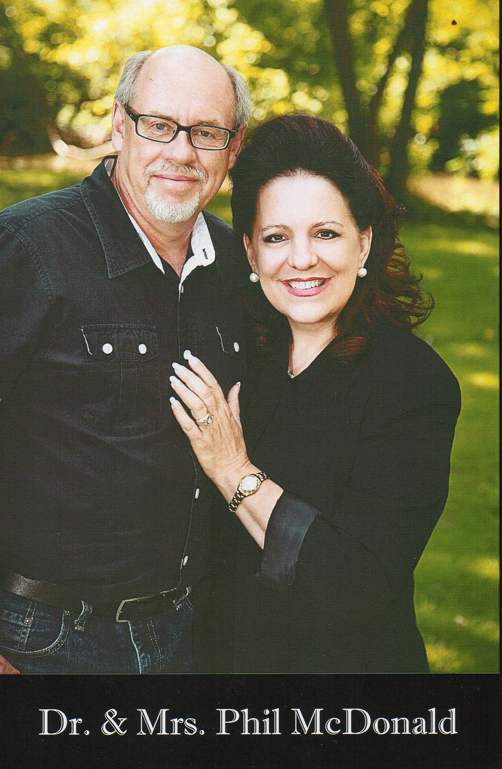

*Closed Door Ministries* works mostly in the middle east. 29 Countries.

*Women At Risk* provides safe place to heal from abuse, trafficking, exploitation & more!

Missionaries for NOVEMBER

Phil & Becky McDonald

**CLOSED DOORS MINISTRIES & WAR**



SPECIAL SPEAKER – TRISH SEXTON

OPPORTUNITY

to buy from the War Store:

Jewelry, Clothing,

Personal Care

Items.

SAVE THE DATE

Be sure to take advantage of the many

growth opportunities we have here at

Grand Heights. These include our

Adult Bible Fellowship’s on Sundays at 9:15 A.M., several weekday Bible Studies, and our Sunday morning study at 10:30 A.M. in Ephesians

GROW

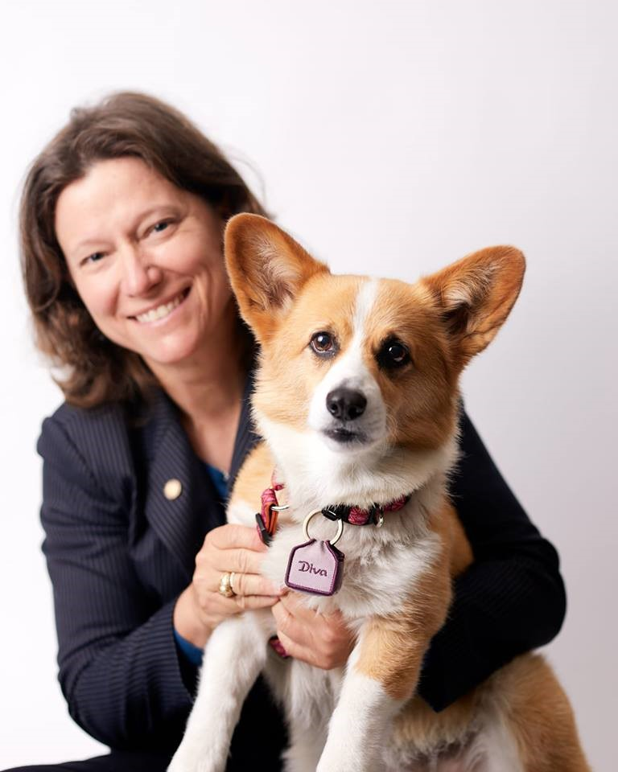

WAR BRUNCH

DECEMBER 1ST

10:00 AM

BRUNCH

PROVIDED

Bring in your filled Shoeboxes or donate money for shipping!

Collection Week is

November 12-18

BIRTHDAYS/ANNIVESARIES

Nov 17 Vickie Lair (B)



**NOVEMBER/DECEMBER/JANUARY EVENTS**

Nov 14 Budget Meeting

Nov 17 Church Work Day

Nov 18 Thanksgiving Feast

Nov 21 & 25 No Evening Activities

Nov 22 Thanksgiving Day Holiday

Dec 1 WAR Brunch with Trish Sexton @10:00

Dec 6 Teen Christmas Party

Dec 23 Christmas Eve Eve Service (P.M.)

Dec 24-26 Church Office Closed(Christmas)

Dec 31-Jan 2 Church Office Closed(New Years)

Jan 5 Men’s Devotional Breakfast

Jan 23 Church Annual Meeting 7:00 P.M.

Jan 29 Serving at Gospel Mission

Sunday’s

5:30 – 7:00 PM

Ages 4 thru

6th grade



**BUSINESS MEETING**

**November 14**

**7:00 p.m.**

* Budget
* Selection of Pulpit Committee

**We need you at this meeting!**

**Fellowship with others!**

**Please bring a dessert to share after the meeting.**

**Grand Heights Baptist Church**

1611 Armstrong Road

Fairborn, OH 45324

(937)878-7971

E-mail: ghbcnet@grandheights.org

November 11, 2018

***Our Mission: We exist to glorify God as we help people move closer to Jesus in their spiritual journey.***

***Pastor Tom Waldo* (937-416-6923)**