**CHRISTMAS EVE EVE SERVICES**

*Welcome to* ***GRAND HEIGHTS***

We are so glad you are here! You will find Grand Heights to be a diverse community of people dedicated to impacting our community and the world with the Gospel of Jesus Christ!

CHRISTMAS CARD DONATION

The Missionaries, Scott & Nicki Russell, are to be the recipients of the Christmas Card Savings Project! Please put your donations in the offeratory plate and a check will be sent to the Russells.

CHURCH TAILGATE PARTY

February 3, 2019 – 5:30 P.M.

Come and Enjoy the

Super Bowl Football Game

Bring your favorite

Snacks to Share!



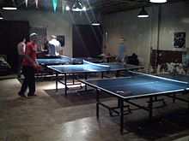

December 30, 2018

6:00 - ? P.M.

Bring snacks to share, games and your friends.

GAME NIGHT

**Sunday, Dec. 23rd 6:00 pm**

**Christmas Eve Eve Service**

**Message: JOHN 3:16**

**Communion**

**Finger Foods, Desserts**

**Sunday, Dec. 23rd 10:30 am**

**Message: INCARNATION:**

**GOD COMES DOWN**

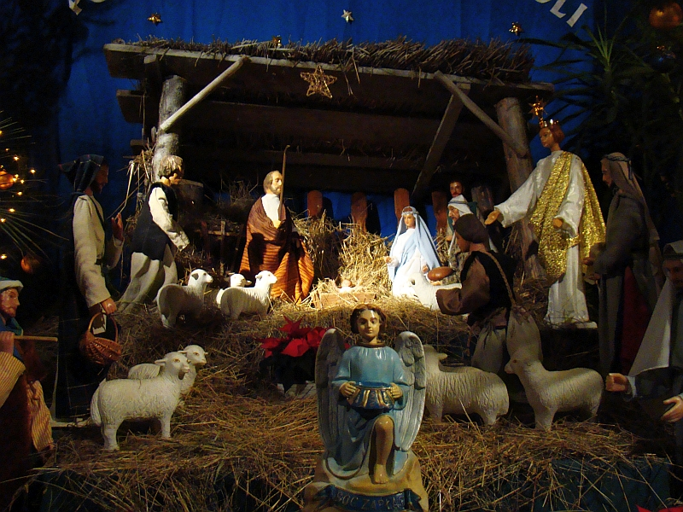

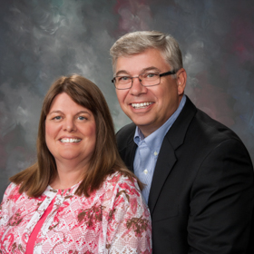

DECEMBER MISSIONARIES OF THE MONTH

Scott & Nikki Russell

Scott and Nikki serve in the home office. They serve as Executive Director for Latin America and the Caribbean and help missionaries by providing resources and daily encouragement.

LEAD

SERVE

We have many growth opportunities for all ages available here at Grand Heights. These include our Adult Bible Fellowship’s and Children’s Sunday School Classes on Sunday mornings at 9:15 A.M. There are several weekday Bible Studies, Awana for children on Sunday evenings at 5:30 P.M. and our Sunday morning study at 10:30 A.M.

As we draw close to Christmas, we must realize that the emphasis God places on that day is that Jesus came down to earth as a man

to be offered up as a sacrifice for our sins.

NO greater gift could ever be given

CONNECT

GROW

Continue to pray for the Pulpit Committee

As they begin to organize and set their goals for the search. Prayer is essential

In this process

BIRTHDAYS

Dec 29 Shirley Barrett (B)

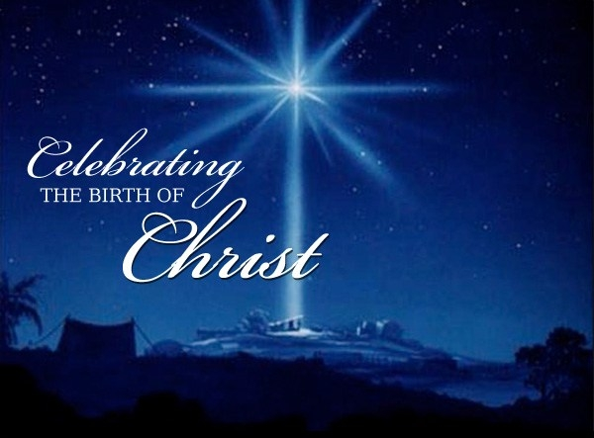

**DECEMBER/JANUARY EVENTS**

Dec 23 Christmas Eve Eve Service (6:00 P.M.)

Dec 23 Christmas Communion (P.M.)

Dec 24-26 Church Office Closed(Christmas)

Dec 30 Game Night 6-? P.M.(Snacks to share)

Dec 31-Jan 2 Church Office Closed(New Years)

Jan 5 Men’s Devotional Breakfast

Jan 6 Deacon Stand-up Meeting

Jan 19 Interior Church Work Day

Jan 20 Board Meeting 12:00 Noon

Jan 23 Church Annual Meeting 7:00 P.M.

ANNUAL BUSINESS MEETING

January 23rd at 7:00 P.M.

Plan to come and bring a dessert to share

Pastor Waldo and the Church Staff wish you a very wonderful Christmas and a fantastic New Year. Thank you for allowing us to Serve.

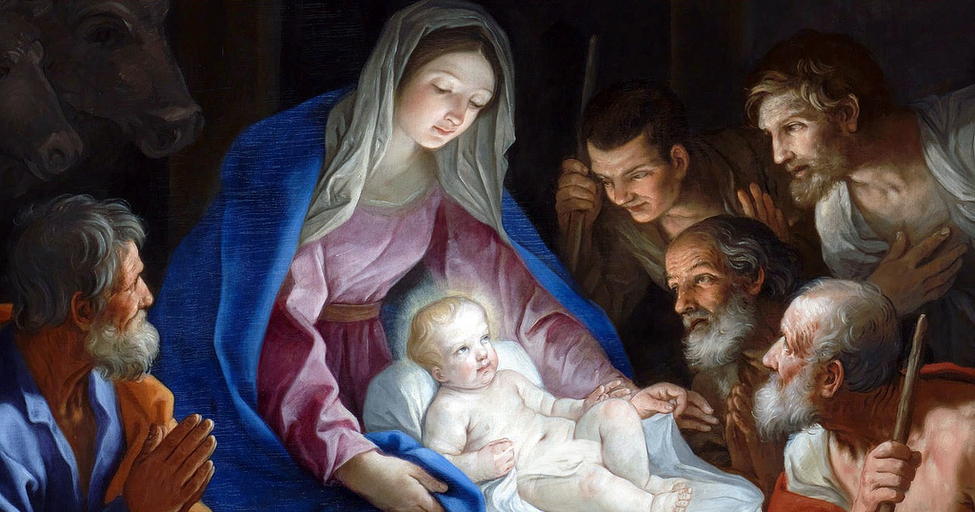

**Grand Heights Baptist Church**

1611 Armstrong Road

Fairborn, OH 45324

(937)878-7971

E-mail: ghbcnet@grandheights.org

December 23, 2018

***Our Mission: We exist to glorify God as we help people move closer to Jesus in their spiritual journey.***

***Pastor Tom Waldo* (937-416-6923)**