



HOT DOG ROAST

July 22nd @ 6:00 P.M.

TEENS – Cookout at the Hartongs

Date: July 15th Time: 2:00 p.m. Place: Hartong’s

LADIES PLANNING MEETING

A Planning Meeting is scheduled for July 22nd at 4:00 pm. This meeting is for all the ladies of the church that would like to be involved in helping plan the ladies events for the coming fall. If you have any ideas or questions, contact Cindy.



Pastor and Diane are on vacation this week.

If you have a need, please contact your Deacon

Be sure to invite your friends and neighbors to our many activities this summer. This is a great opportunity to expose them to our Church in a low stress atmosphere.

LEAD

AWANA is just eight weeks away! We will be in need of both helpers and leaders as the club has been growing each year.

See Dave Burk for details and to sign up!

SERVE

GROW

Be sure to take advantage of the many

growth opportunities we have here at

Grand Heights. Those include our

Adult Bible Fellowship’s on Sundays at 9:15 A.M. and several weekday Bible Studies

CONNECT

**Hot Dog Roast**

**July 22 @ 6:00 p.m.**

Today we welcome Gary & Leesa Adams from Skyview Ranch where Gary serves as Director. He will be sharing in both Sunday School and morning services. Skyview Ranch is our camp in Millersburg, Ohio and ministers to more than 7500 campers each year. Be sure to give them a great

Grand Heights Welcome

*Welcome to* ***GRAND HEIGHTS***

We are so glad you are here! You will find Grand Heights to be a diverse community of people dedicated to impacting our community and the world with the Gospel of Jesus Christ!

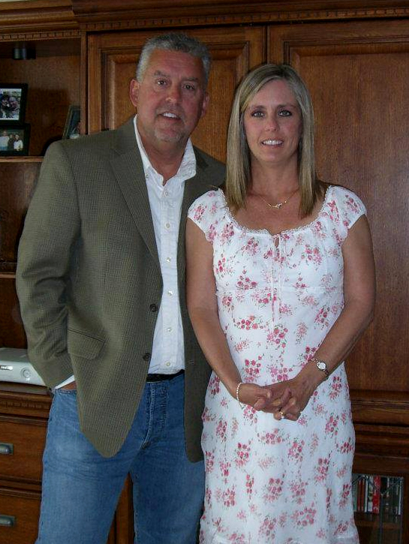

Parents of Teens:

We are still looking for sponsors for several of our teen activities this year.

Please see Pastor or Mark Coleman!

Gary & Leesa Adams

Director @ Skyview Ranch in Millersburg Ohio.



BIRTHDAY

July 15 Denise Derge (B)

August 5th Steve and Pam Schenk

Awana Missionaries

Sharing in A.M. Service

September 2nd Josh & Stephanie Witry

Guest Service Director SVR

Sharing in A.M. Service

**JULY/AUGUST/SEPTEMBER EVENTS**

July 1-31 Food Donations for FISH

July 15 Gary & Leesa Adams –Skyview Ranch Director

July 15 Teen Cookout @ Hartongs

July 22 Hot Dog Roast @ Dave & Anna Pensworth

July 31 Dayton Gospel – Serving Dinner

Aug 4 Men’s Prayer Breakfast

Aug 5 Steve Schenk – Awana Missionary

Aug 5 Deacon’s Flock Meetings

Aug 13 Teen’s @ King’s Island

Aug 26 Young’s Run – Activities early meet @ 7:00 P.M.

Sep 9 Awana Begins

Sep 16 Family Night

July 15, 2018

**Grand Heights Baptist Church**

1611 Armstrong Road

Fairborn, OH 45324

(937)878-7971

E-mail: ghbcnet@grandheights.org

***Our Mission: We exist to glorify God as we help people move closer to Jesus in their spiritual journey.***

***Pastor Tom Waldo* (937-416-6923)**