**We are looking for volunteers to help with this year’s Vacation Bible School during the week of June 11th-15th. If you can help, please see Deb Jones Today.**

**==================================================================================================================================================**

**Dayton Gospel Mission – May 29th**

**Meet at the Chuch to carpool. We will be serving meals at the Mission. See Cindy for additional info!**

**VACATION BIBLE SCHOOL**

VBS has a lasting impact in the lives of the young people who attend. Why not step-up and help make a difference in the lives of boys and girls this year.

Each Sunday morning at 9:15 we have great Bible studies for adults. The current classes are 1)Angels and 2)The Book of Acts.

Be sure to join us next week!

This morning we continue in our Trust series and will be examining Growing Through Adversity. We all face times of adversity in our lives. Does that just happen or does God have a deeper purpose for it. We will examine this question from James 1:2-4.

Supplies AND Workers Needed!

Lists have been posted on the LEAD Board.

Thank you in advance for helping out with

this years Vacation Bible School: Time Lab.

*VACATION BIBLE SCHOOL*

*June 11th–June 15th @ 9 am – Noon*

*Discovering Jesus from*

*Eternity Past to Eternity Future!*



We have rented Shelter #3 in Bath Twp. Picnic area. Each family should bring a (main dish, side, and dessert) to share and their own beverage. Plates and dinnerware will be supplied. Bring lawn games to play and lawn chairs for your comfort. Join us for a great time. (In case of bad weather, picnic will be held at the church!)

**Picnic In The Park**

TODAY **– 1:00 pm**

Missionary for the Month

Of May, 2018

Dan & Valerie Woods

Serving in

Sao Paulo, Brazil

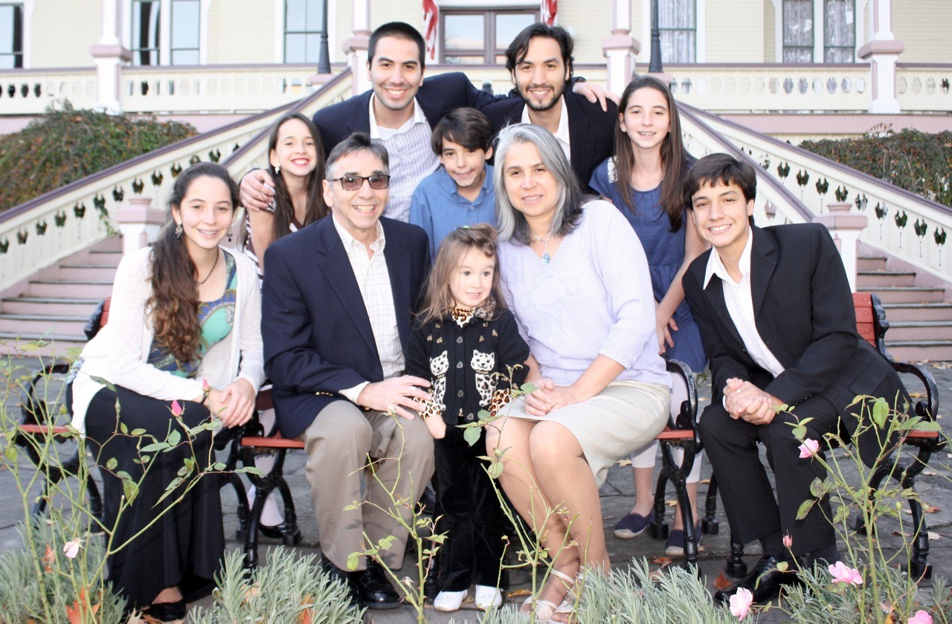



*Welcome to* ***GRAND HEIGHTS***

We are so glad you are here! You will find Grand Heights to be a diverse community of people dedicated to impacting our community and the world with the Gospel of Jesus Christ!

***Connect:***

***Grow:***

***Serve:***

***Lead:***



**VBS WORKERS MEETING**

**& DECORATING PARTY**

**Will be on June 1st at 6:00 p.m.**

**Dinner will be served. Please come out and help!**

JUNE 24TH – 1:00 p.m.

All church picnic at the Waldo’s! There will be food, fun and games, main dish and drinks provided.

Please bring a side dish

and dessert to share. See You There!

LADIES - SAVE THE DATE

Ladies Hike @ Oakes Quarry Park

Tuesday, June 19th, 6:45 p.m. at Church to carpool

Hike begins at 7 p.m. at the park

**MAY/JUNE/JULY EVENTS**

May 29 Dayton Gospel Mission

June 1 Decorating for VBS/Workers Meeting

June 2 Men’s Prayer Breakfast – 7:30 AM

June 3 Honoring our Graduate

June 11-15 Vacation Bible School (9:00 – Noon)

June 17 Father’s Day – NO PM Activities

June 18 Skyview Summer Camp for Juniors

June 19 Ladies Hike

June 24 Picnic @ Pastor & Diane’s Home

July 1 Ice Cream Social P.M.

July 15 Gary Adams, Sunday School & Service

July 22 Hot Dog Roast P.M.



***Our Mission: We exist to glorify God as we help people move closer to Jesus in their spiritual journey.***

***Pastor Tom Waldo* (937-416-6923)**

**Grand Heights Baptist Church**

1611 Armstrong Road

Fairborn, OH 45324

(937)878-7971

E-mail: ghbcnet@grandheights.org

May 27, 2018