**Sunday School Classes**  
 **Room**

**Adults 216**

**Young Men 300**

**Young Women 121**

**Children 1 102**

**Children 2 304**

**Nursery 113**

**Come encourage one another as you grow in your faith.**

**We welcome Carol Miller as our new Office Administrator and pray Josh Burk has a smooth transition to his new job.**

**Child Abuse Prevention Training has been rescheduled for October 8 at 4pm in the Fellowship Hall. Contact Cindy Sudduth if you have any questions.**

**Sunday School Sunday at 9:15 A.M.**

**Sunday Morning Service Sunday at 10:30 A.M.  
AWANA Clubs Sunday at 5:30 P.M.**

**Men’s Book Study Tuesdays at 7:00 A.M.**

**Ladies’ Prayer Meeting Tuesdays at 9:30 A.M.**

**Stitches and Stuff Tuesdays at 10:30 A.M.  
Prayer Meeting Wednesdays at 7:00 P.M.**

**Stitches and Stuff Saturdays at 10:00 A.M.**

**CAP Training October 8th at 4:00 P.M.**

**Church Staff**

**Pastor: Mark Warren: warren@grandheights.org**

**Office Admin: Carol Miller info@grandheights.org**

**(937) 878-7971**

**Congregational Service Opportunities**

**a**

**October 1, 2023**

H:2.12”

W:2.34”

H:3.22”

W:4.46”

Calendar Events

**If your family is in need, please contact   
your deacon or the church office.**

Welcome!

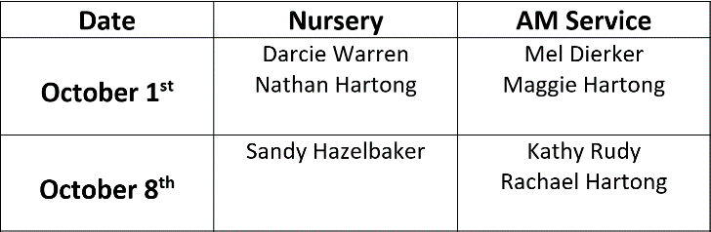­­­­1 ­­

**Awana Clubs**

**Oct 12 Darcie Warren  
Oct 21 Kylie Burk  
Oct 25 Keegan Dierker**

**Oct 11 Vincent Matthews  
Oct 14 Brian and Beth Hetzel**

**Oct 22 Lincoln Hartong**

**Oct 29 Thelma Hughes**

**Children’s Activity Packets Available on the small table by the back doors**

**The Sewing Club meets every Tuesday at 10:30 AM and on Saturdays at 10:00 AM.  
To learn more, please contact Carol Miller.**

**Every Sunday Night at 5:30 PM!**

**Missions of the Month:  
Operation Christmas Child**

**National Collection week is**

**November 13th – 20st.**

**Start collecting items for shoeboxes now. All boxes must be ready by Sunday November 18th.**

**Speak with Brendon Dierker for more information.**

**Ascribe to Yahweh, oh families of the peoples,  
Ascribe to the LORD glory and strength!  
Ascribe to Yahweh the glory due His name;  
Bring an offering and come before Him,  
Worship the LORD in the splendor of holiness!**  
 **-1 Chronicles 16:28-29**

Welcome to the gathered expression of praise! We are called into God’s presence to celebrate God’s provision in the redeeming sacrifice of the Lord Jesus. Look to the Lord as we turn to the Temple. From the book of 2 Chronicles, Solomon will lead the people in a prayer of dedication.

We also broadcast the service **live on our Facebook page.** Please visit our page at **Facebook.com/GrandHeightsBaptistChurch**

Order of service packets are available in the entryway.

If you would like to learn more, please visit our website at **Grandheights.org**Completed connection cards received from the welcome desk can be dropped into the offering plate during the morning service.

Welcome to **Grand Heights Baptist Church!**

**GHBC Sewing Club – Stitches and Stuff**

Birthdays & Anniversaries

**Nursery Volunteer Schedule**

**Thank you for your ministry. Contact Kathy Rudy if you  
 cannot work or find a substitute.**

Our Mission: We exist to **glorify God** as we help people **move closer to Jesus** in their spiritual journey

H:2.03”

W:2.19”

H:2.03”

W:2.33”