FISH for Fairborn  
October 1st – 31st  
Please leave all food out in the hall by the kitchen

**October Congregational Service Opportunities**

**Sunday Morning Service every Sunday at 10:30 A.M.**

Sunday School every Sunday at 9:15 A.M.

AWANA Clubs every Sunday evening at 5:30 P.M.

Men’s Book Study every Tuesday at 7:00 A.M.

Ladies Prayer Meeting every Tuesday at 9:15 A.M.

Prayer Meeting every Wednesday at 7:00 P.M.

Men’s Bible Study every Thursday at 7:30 P.M

**October 9, 2022**

**Prayer Meeting**

Come join us every Wednesday in room 216 at  
7:00 PM, for a time of prayer and fellowship.

H:2.12”

W:2.34”

H:3.22”

W:4.46”

Calendar Events

**If your family is in need, please contact   
your deacon or the church office.**

Welcome!

**1611 Armstrong Road**

**Fairborn, Ohio, 45324**

**937.878.7971**

**ghbcnet@grandheights.org**

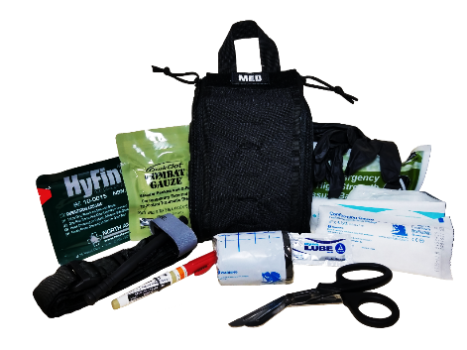­­­­­1

**Nursery Volunteer Schedule**

**Thank you for your ministry. Contact Kathy Rudy if you cannot work or find a substitute.**

**October 11** Vincent Matthews

**October 14** Brian and Beth  
 Hetzel

**October 22** Lincoln Hartong

**October 12** Darcie Warren

**October 21** Kylie Burk

**October 25** Keegan Dierker

**GHBC Trauma Kit Classes**

There will be a free class demonstrating the use of the church trauma kit. Sign up on the bulletin board by the kitchen if interested.  
  
The class will take place on October 22nd from 9:30 AM to 11:00 AM.

**Missions of the Month:  
Operation Christmas Child**

National Collection week is

November 14th – 21st.

Start collecting items for shoeboxes now. All boxes must be ready by Sunday November 16th.

Speak with Brendon Dierker for more information.

Youth group activities will also be taking place at the same time in the teen room.

Birthdays & Anniversaries

Our Mission: We exist to **glorify God** as we help people **move closer to Jesus** in their spiritual journey

**Thanks for joining us for our Sunday Service today!** If you are a first-time visitor, please register at our   
**Welcome Center**.

We also broadcast the service **live on our Facebook page.** Please visit our page at: **Facebook.com/GrandHeightsBaptistChurch**

Order of service packets are available in the entryway.

**AWANA Clubs  
Sunday Nights at 5:30**

Pastor  
Mark Warren

Sunday Morning Service

October. 9th at 10:30 A.M.

H:2.03”

W:2.19”

H:2.21”

W:2.14”

H:2.03”

W:2.33”

Welcome to **Grand Heights Baptist Church!**