

Today we welcome Steve, Pam, & Peter Schenk. Steve has been an Awana Missionary representative from Ohio for 20 years. This past club year, they visited over 70 churches and spoke to over 7,000 young people and their families. He will be sharing in both Sunday School and Morning Services.

GROW

Be sure to take advantage of the many

growth opportunities we have here at

Grand Heights. Those include our

Adult Bible Fellowship’s on Sundays at 9:15 A.M. and several weekday Bible Studies

CONNECT

If your Deacon has not already done so, he will be contacting you soon to let you know the details of your flock gathering. This is a great time to get to know other Flock members and to minister to one another.

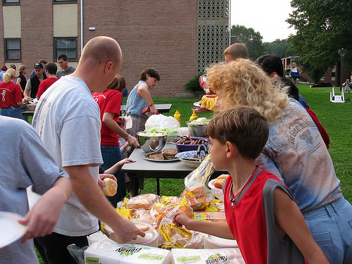

DEACON FLOCK MEETINGS

LADIES PLANNED ACTIVITIES

Events coming up for the next months:

* July 31 – Gospel Mission
* August 14 – Hike at Quarry – 7:00 p.m.
* August – Becky & Scott Starks baby due – Meals planned for the family
* September 21–Movie Night–“I Can Only Imagine”
* Retreat @ Skyview - $125 (9/28-30 or 10/12-24)
* October 2 - Potato Supper/Prayer Partners
* October 30 – Gospel Mission
* November 3 or 17 or December 1- WAR Party
* January 11 or 18 – Ladies Game Night

*Welcome to* ***GRAND HEIGHTS***

We are so glad you are here! You will find Grand Heights to be a diverse community of people dedicated to impacting our community and the world with the Gospel of Jesus Christ!

SERVE

AWANA is just five weeks away! We will be in need of both helpers and leaders as the club has been growing each year.

See Dave Burk for details and to sign up!

LEAD

Pastor and Diane are away this week, pray that they are refreshed in their time away.

If you have a need, please contact the office or one of our Deacons!

**Hot Dog Roast**

**July 22 @ 6:00 p.m.**

logo2002_color_tag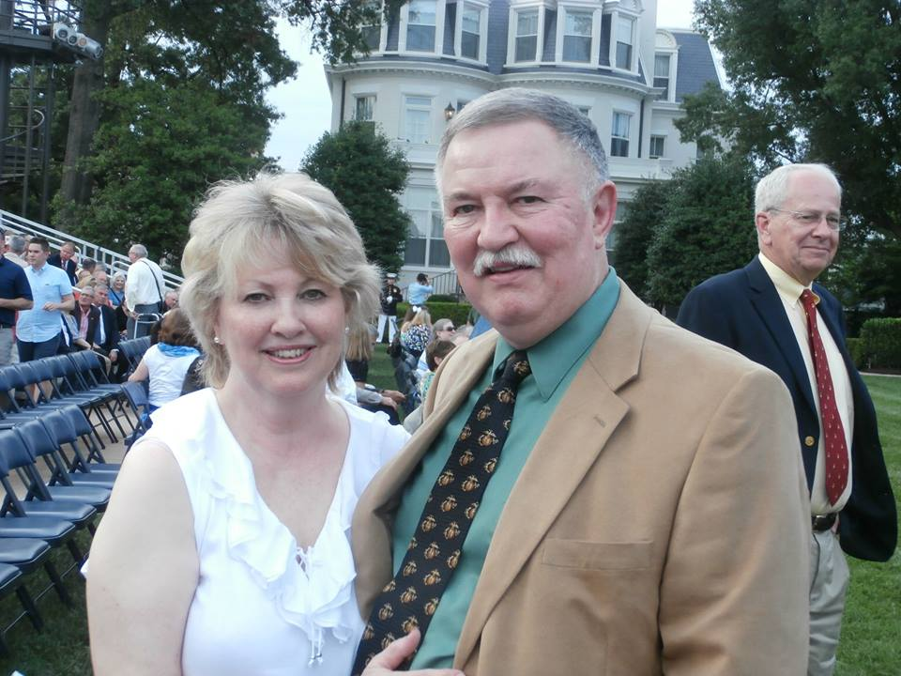

Parents of Teens:

We are in need of some sponsors to help us get the Teens to Kings Island August 13th. See Pastor or Mark Coleman to volunteer!

BIRTHDAYS

Aug 5 Juliana Coleman (B)

Aug 9 Mary Hulbert (B)

Aug 10 Deb Jones (B)

Sharing At Grand Heights

September 2nd Josh & Stephanie Witry

Guest Service Director SVR

Sharing in 10:30 Service

September 23rd Tom Hoyle

Dinosours/God In America

Sunday School & 10:30 Service

**AUGUST/SEPTEMBER EVENTS**

Aug 5 Steve Schenk – Awana Missionary

Aug 5 Deacon’s Flock Meetings

Aug 13 Teen’s @ King’s Island

Aug 26 Young’s Run – Activities early meet @ 7:00 P.M.

Sep 1 No Men’s Breakfast

Sep 2 Josh Witry–Dir.@ Skyview Ranch/10:30 Service

Sep 1-30 Food Donations for Fish

Sep 9 Awana Kickoff/Youth BBQ Kickoff

Sep 16 Family Growth Group Kickoff

Sep 23 Tom Hoyle – Sunday School & 10:30 Service

August 5, 2018

**Grand Heights Baptist Church**

1611 Armstrong Road

Fairborn, OH 45324

(937)878-7971

E-mail: ghbcnet@grandheights.org

***Our Mission: We exist to glorify God as we help people move closer to Jesus in their spiritual journey.***

***Pastor Tom Waldo* (937-416-6923)**