**DUSTAN HORST**

**BETH**

**PETER**

**ANNA**

**EMMETT**

**SEPTEMBER/OCTOBER BIRTHDAYS & ANNIVERSERIES**

**Sep 30 Donovan Dierker (B) Oct 1 Pauline Fischer (B)**

**Oct 4 Jim Howard (B) Oct 6 Barbara Howard (B)**

**Oct 11 Michael Coleman (B) Oct 14 Brian & Beth Hetzel (A)**

**Oct 21 Kylie Burk (B) Oct 22 Lincoln Hartong (B)**

**Oct 25 Keegan Dierker (B) Oct 29 Thelma Hughes (B)**



**Jason K. Lee has served as the Dean of the School of Biblical and Theological Studies at Cedarville University since 2013.** **We are glad to have Dr. Jason Lee as Interim Pastor. Dr. Lee would like everyone to read Joshua Chapter 3 before today’s Sunday service.**

*Welcome to* ***GRAND HEIGHTS***

**Welcome to our Sunday Service Today – RAIN or SHINE! In compliance with current safe distancing we are having our indoor/outdoor service. Dr. Jason Lee, as our Interim Pastor, will be with us the next several months. His sermon this week is from Joshua Chapter 3. He would like you to read this Chapter prior to today’s service. You have the option of coming into the church or staying in your car in the church parking lot for the church message. It will be broadcasted on the 88.1 FM station. To pick up the Audio, you need to have a vehicle with a working FM radio.**

**A packet of information is available upon arrival. Arrive at 10:15 to allow time to park. Service is scheduled to begin at 10:30. This Indoor/Drive-in service will allow those in our fellowship with health issues to safely come and worship the way they would be most comfortable. The Order of Service Packet is available Sunday morning or on the Church Web Site. Allan Hartong @ 937-718-0533.**

**PULPIT COMMITTEE REPORT- September 21**

**"The Pulpit Committee thanks everyone for taking the time and effort to get to know the Hines family last weekend.  Eric and Tonya were also most appreciative of Grand Heights' hospitality and earnestness in seeking a pastor.  Remember that we will have a special church business meeting following the morning worship service next Sunday (October 4) to discuss and vote on whether to extend a call to Eric to be our pastor.  In the meantime, pray for wisdom for the church, and please plan to attend."**

**I learned of Word of Life's ministry to local churches in America, and of the great need for the Gospel to reach the youth of America. We were accepted as missionaries with Word of Life in June 2010 and have been serving in Ohio since September 2011. Since then, life has changed a lot, but our burden remains the same - reaching Ohio with the life-changing message of the Gospel of Jesus Christ!**

**During this 2020 year, it has been eventful. We had numerous FASCARS, two group leader trainings, and trained a new church. Dustan went to Denver for training with Dare 2 Share. A highlight of the time was hearing how student ministries across the country are seeing students come to Christ.**

***Our Mission: We exist to glorify God as we help people move closer to Jesus in their spiritual journey.***



MISSIONARY FOR THE MONTH OF SEPTEMBER

WORD OF LIFE

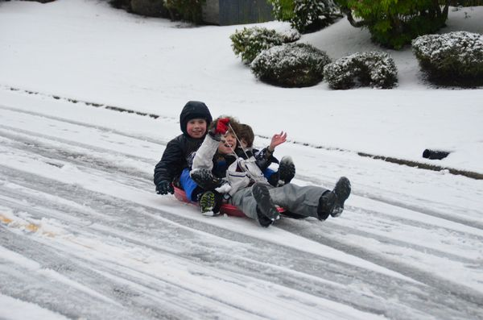

SEPTEMBER 27, 2020

IF YOUR FAMILY IS IN NEED IN ANY WAY, PLEASE CONTACT YOUR DEACON OR THE CHURCH OFFICE.

CALENDAR EVENTS

Tues. – 9:30 a.m. - Ladies Prayer Mtg.

Wed. – 7:00 p.m. – All Church Prayer Mtg.

Sun. – September 27 –Adults, Teens, and Children Sunday School Classes (9:15 A.M.)

Sun. - September 27 – Awana & Teens (5:30 P.M.)

Tue. – September 29 – Serving Dinner @ Dayton Gospel

Sun. - October 4 – Business Meeting @ 11:45

Wed. – October 14 – Board Meeting (7:30 P.M.) – Budget

Wed. – October 28 – Board Meeting (7:30 P.M.) - Budget

**Pre K – 6th Grades**

**AWANA Clubs of GHBC**

ALL CHURCH

All ladies are welcome to participate in the Tuesday Morning Prayers. The Church Prayer Meeting on Wednesday evening is for everyone. During this time period, we are honoring the recommendations of the State of Ohio on the Coronavirus Epidemic.

IF YOU WOULD LIKE TO HELP IN SERVING

DINNER AT DAYTON GOSPEL ON TUESDAY,

SEPTEMBER 29TH PLEASE CONTACT

ALLAN HARTONG @ 937-718-0533 FOR INFORMATION!



**THE AWANA CLUBS OF GRAND HEIGHTS BAPTIST CHURCH**

**Meets Sunday Nights**

**@ 5:30 p.m.**

**FOR MORE INFORMATION (please contact)**

**Grand Heights Baptist Church**

**937-878-7971 or www.grandheights.org**

A large sign in a field

Description generated with very high confidence

**Grand Heights Baptist Church**

**1611 Armstrong Road**

Fairborn, OH 45324

**(937)878-7971**

**E-mail: ghbcnet@grandheights.org**