***Welcome to Grand Heights!***

*We are glad you are here with us this morning! You will find Grand Heights to be a friendly and diverse community of people dedicated to impacting our community and the world with the Gospel of Jesus Christ!*

PLEASE CONTINUE TO **PRAY FOR THE PULPIT COMMITTEE** as they consider potential candidates for our next Senior Pastor. Pray for wisdom and unity.

**AWANA** – Kicks off the new year.

**TONIGHT FAMILY NIGHT KICK-OFF**

**5:30 P.M.**

Fall has arrived and most vacations are over. Our offerings decreased during the summer and it is time for us to “catch up” and get back on track. Thank you for your faithfulness.

**Teens** – Cookout at the Hartong’s

[](https://www.bing.com/images/search?view=detailV2&ccid=t88%2bPWPO&id=7387F37954BB639828A4D3B1A27DE64F4B65B8D9&thid=OIP.t88-PWPOwCEyuok48hEHYgHaFL&mediaurl=https://iscrapapp.com/wp-content/uploads/2014/05/pennies-for-scrap.jpg&exph=716&expw=1024&q=picture+of+pennies&simid=608025402043271171&selectedIndex=0)

**CONNECT**

Today we will be focusing on God’s Omniscient, He is all Knowing. He knows all things, past, present and future, real and potential and knows them all at the same time. He knows who we are and what He wants us to do.

**GROW**

Be sure to check out our Growth Group Bible Studies!

Ladies: Tuesday 9:30 AM at the Church

Men: Tuesday 7:00 AM at Fairborn McDonalds

Men: Thursday 7:00 PM at the Church

**SERVE**

AWANA opens TODAY. This is our children’s program for Kindergarten – age 4 thru 6th grade. We are still in need of helpers on Sunday 5:30-7:00 p.m. See Dave Burk for details.

**LOOKING AHEAD** – November 24

Our Thanksgiving Feast this year will have an international flair. Along with the traditional turkey as our main course, be thinking about your favorite international dish to bring as a side or dessert.

**THERE ARE A NUMBER** of tasks needing to be done throughout the Church. See Steve Bachowski for the details. A detailed list is posted on the CONNECT Board.

**A BAPTISMAL SERVICE** is planned for September 22nd. If you are interested, please see Pastor Waldo to be certain you are on the list of those being baptized! Looking forward to their Great Day!

**VERSES OF THE WEEK: Psalms 139:23-24**

**23**Search me, God, and know my heart;  
    test me and know my anxious thoughts.  
**24**See if there is any offensive way in me,  
    and lead me in the way everlasting.

**Adults** – Cookout at The Church

Hot Dogs & Hamburgers provided! Bring your favorite sides and/or a dessert.

**SIGN UP ON THE “GROW” BOARD**

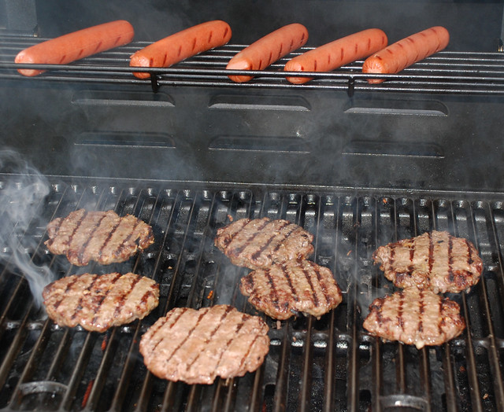

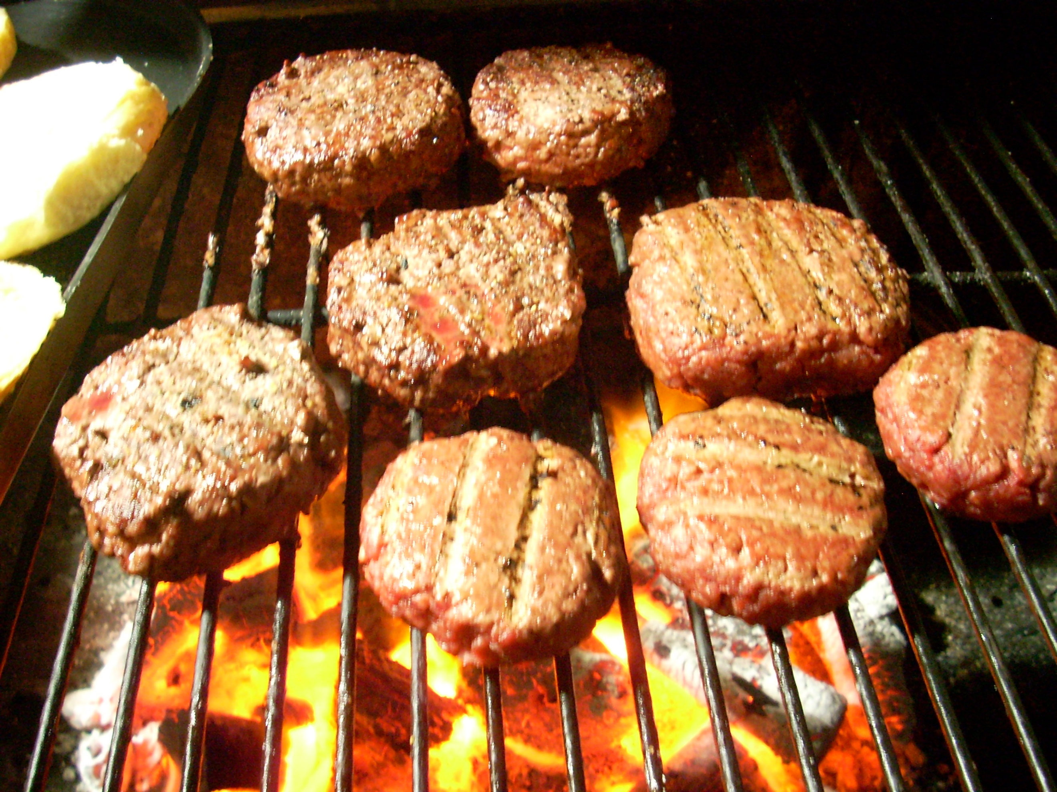



**MEN’S STUDY**

**NO MORE EXCUSES**

**SUNDAY’S 5:30-7:00**

**ALL MEN INVITED**

**PLAN TO BE THERE**

**BRING A FRIEND**

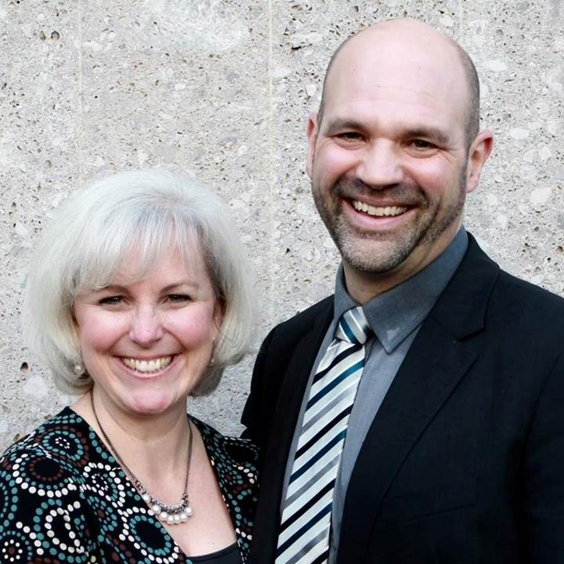

SERVING IN

GERMANY -

NOW ON FURLOUGH!

COMING TO GHBC

MISSIONARY FOR THE MONTH

Steve & Becky Dye

**LEAD**

Be in prayer for those in our leadership family as they minister – Our Staff: Pastor & Diane, Thelma & Bob, Mike & Amanda. We thank you all for your faithful ministry.

**Calendar of Events:**

Sep 1-30 FISH–Non-perishable Food Donations

Sep 8 AWANA & Adult Fall Kick-off

Sep 8 Youth BBQ Kick Off Night

Sep 15 The Dye Family–Missionary Speaker

Sep 22 Baptismal Service

Sep 28 Ladies South Bethel Conference

Oct 5 Men’s Devotional Breakfast

Oct 11-13 Ladies Retreat at Skyview Ranch

Oct 11 ASPIRE Conference 7:00 p.m.

Oct 13 Trustee’s Meeting 3:00 p.m.

Oct 19 Fall Festival @ Hartong’s home

Oct. 29 Gospel Missions

Nov 2 Men’s Devotional Breakfast

Nov 4 Ladies Potato Supper/Prayer Partners

Nov 13 2020 GHBC Budget Meeting

Nov 24 Thanksgiving Feast

Nov 28 Thanksgiving Holiday

Nov 28-29 Church office closed

Dec 1-31 FISH–Non-perishable Food Donations

Dec 2 Ladies Supper@Ellies in YellowSprings

Dec 7 Men’s Devotional Breakfast

Dec 22 Youth Christmas Party 5:30-7:00 p.m.

Dec 22 Christmas Eve Eve Eve Service

**BIRTHDAYS/ANNIVERSARIES**

Sept 9 Tyler Jones (B)

Sept 9 David Burk (B)

Sept 11 Joshua Burk (B)

Sept 14 Jim & Barb Howard (A)

**Grand Heights Baptist Church**

1611 Armstrong Road

Fairborn, Ohio 45324

937-878-7971

[www.grandheights.org](http://www.grandheights.org)

September 8, 2019

**OUR OMNISCIENT**

**GOD**

Psalms 139:1-6, 23-24

May 26, 2019

FRIDAY, OCTOBER 11, 2019 – 7:00 P.M.

Berachah Church in Middletown, OH 45042

1 night – 3 hours

Just for Women – an evening full of laughter, learning stories and music

Tickets online @ ASPIREWOMENSEVENTS.com



WOMEN’S RETREAT

October 11 – 13

Skyview Ranch

Great fun, food and fellowship

Activities include: Horseback riding, Bonfires, Zip lines, Giant swing, Shooting and much more.

Sign-up at Skyviewranch.org

**COMING SEPTEMBER 28TH**

**The South Bethel Women’s Missionary Group will be having their inaugural meeting here at Grand Heights!**

**Ladies: Please plan to attend.**

**Men & Ladies: Help will be needed for set-up, decorating, tear-down, and clean-up.**

**See Pastor to sign-up**

AUTHOR & SPEAKER***COMEDY **** WORSHIP WITH

**BARB ROOSE** ** **KRISTIN WEBER** ** **MIA KOEHNE**

***Our Mission:***

***We exist to glorify God as we help people move closer to Jesus in their spiritual journey.***