**A SPECIAL BUSINESS MEETING**

Is scheduled for October 20th during the morning service for the purpose of voting for our pastoral candidate. Be sure to be here.



***Welcome to Grand Heights!***

*We are glad you are here with us this morning! You will find Grand Heights to be a friendly and diverse community of people dedicated to impacting our community and the world with the Gospel of Jesus Christ!*

**NEXT WEEKEND October 4th thru 6th**

**PASTORAL CANDIDATE SCHEDULE**

**with TONY BARBER**

**Friday (October 4)**

7:00 PM Family Game Night @ Grand Heights

**Saturday (October 5)**

7:30-9:30 Men’s Breakfast @ Fairborn Diner

8:30-11:00 Ladies Hike with Sarah (Meet at GHBC)

9:45-10:30 Tony meet with Deacons (Fellowship Hall)

10:30-11:15 Tony meet with Trustees (Fellowship Hall)

11:15-12:00 Tony meet with Church Board in the Fellowship Hall

12:00-2:30 Ladies lunch & Fellowship @ Dave and Anna Pensworth’s Home

5:00-8:00 Youth Cookout @ the Hartong’s Home

**Sunday (October 6)**

9:14-10:15 Sunday School (Regular Classes)

10:30-12:00 Worship Service 0 Tony Barber will preach (Noah’s Park cancelled)

**12:00-1:00 Carry-in Luncheon after the service**

1:00-2:00 Question & Answer time

2:00-3:00 Awana Leaders meeting in the Fellowship Hall

[](https://www.bing.com/images/search?view=detailV2&ccid=t88%2bPWPO&id=7387F37954BB639828A4D3B1A27DE64F4B65B8D9&thid=OIP.t88-PWPOwCEyuok48hEHYgHaFL&mediaurl=https://iscrapapp.com/wp-content/uploads/2014/05/pennies-for-scrap.jpg&exph=716&expw=1024&q=picture+of+pennies&simid=608025402043271171&selectedIndex=0)

**VERSE OF THE WEEK – JEREMIAH 32:17**

**17**“Ah, Sovereign Lord, you have made the heavens and the earth by your great power and outstretched arm. Nothing is too hard for you.



Please bring sides and desserts to share and invite a friend to join you!

**FALL FESTIVAL - October 19th @ 5:30 p.m.**

**At the Hartong’s Home**

Come for a night of FUN and FELLOWSHIP.

Bonfire – Hayride - Games

**MEN’S STUDY**

**“NO MORE EXCUSES”**

**SUNDAY’S 5:30-7:00**

**ALL MEN INVITED!**

**BEGINS TONIGHT**

**SERVE -** AWANA is our children’s program for (Kindergarten age 4) thru 6th grade. We are still in need of helpers on Sunday 5:30-7:00 p.m. See Dave Burk for details.

**GROW -** Be sure to check out our Growth Group Bible Studies!

Ladies: Tuesday 9:30 AM at the Church

Men: Tuesday 7:00 AM at Fairborn McDonalds

Men: Thursday 7:00 PM at the Church

As well as our group that meets Sundays at 5:30 PM

**CONNECT –** You and I are limited in space and time but God is Omnipresent. Our knowledge is limited but God is Omniscient. We are aware of our weakness’s but God is Omnipotent or all powerful. Today we examine what this means in our day to day life.

MISSIONARY FOR THE MONTH

Steve & Becky Dye

SERVING IN

GERMANY -

NOW ON FURLOUGH!

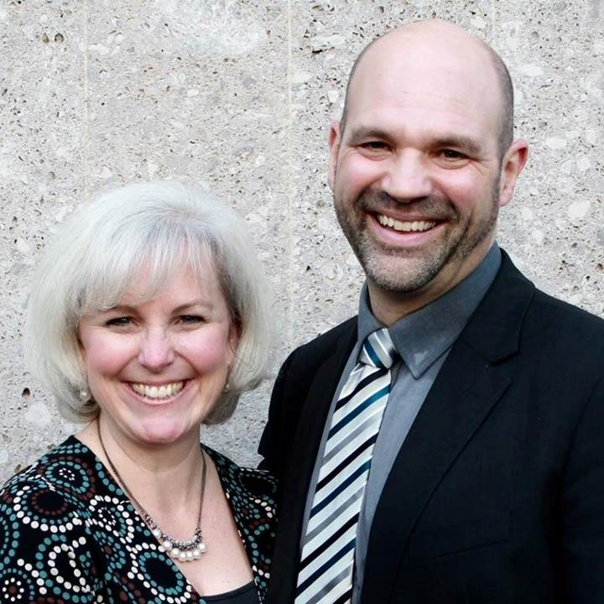

**LEAD -** Be in prayer for those in our leadership family as they minister on the Pulpit Committee: Alan Lair, Steve Bachowski, Mike Prosser, Anna Pensworth, Susan Coleman and Allan Hartong.

Great fun, food and fellowship

Activities include: Horseback riding, Bonfires, Zip lines, Giant swing, Shooting and much more.

Sign-up at Skyviewranch.org

WOMEN’S RETREAT October 11 – 13 Skyview Ranch

AUTHOR & SPEAKER***COMEDY **** WORSHIP WITH

**BARB ROOSE** ** **KRISTIN WEBER** ** **MIA KOEHNE**



FRIDAY, OCTOBER 11, 2019 – 7:00 P.M.

Berachah Church in Middletown, OH 45042

1 night – 3 hours

Just for Women – an evening full of laughter, learning stories and music

Tickets $20 –

See Cindy for tickets Cindy Sudduth

**OUR OMNIPOTENT GOD**

**Grand Heights Baptist Church**

1611 Armstrong Road

Fairborn, Ohio 45324

937-878-7971

[www.grandheights.org](http://www.grandheights.org)

September 29, 2019

**BIRTHDAYS/ANNIVERSARIES**

Sept 30 Donovan Dierker (B)

Oct 1 Pauline Fischer (B)

Oct 4 Jim Howard (B)

Oct 5 John & Connie Atchley (A) )

**CALENDAR OF EVENTS:**

Sep 1-30 FISH–Non-perishable Food Donations

Oct 4-6 Candidate Weekend

Oct 11-13 Ladies Retreat at Skyview Ranch

Oct 11 ASPIRE Conference 7:00 p.m.

Oct 13 Trustee’s Meeting 3:00 p.m.

Oct 19 Fall Festival @ Hartong’s home

Oct 20 Business Meeting on Sunday A.M.

Oct 29 Gospel Missions

Nov 2 Men’s Devotional Breakfast

Nov 4 Ladies Potato Supper/Prayer Partners

Nov 13 2020 GHBC Budget Meeting

Nov 24 Thanksgiving Feast

Nov 27 No Evening Activities

Nov 28 Thanksgiving Holiday

Nov 28-29 Church office closed

Dec 1-31 FISH–Non-perishable Food Donations

Dec 2 Ladies Supper@Ellies in YellowSprings

Dec 7 Men’s Devotional Breakfast

Dec 22 Youth Christmas Party 5:30-7:00 p.m.

Dec 24-25 Christmas Holiday

Dec 25 Christmas Day

Dec 31 Gospel Mission/Lunch

**SPECIAL THANKS**

**To ALL those who helped with the**

**South Bethel Conference yesterday.**

**The Conference was a great success!**

**Your work was greatly appreciated**

***Our Mission:***

***We exist to glorify God as we help people move closer to Jesus in their spiritual journey.***