



**A BAPTISMAL SERVICE IS PLANNED FOR TODAY.** This morning, in Pastor’s message “It Is More Than Getting Wet,” he will detail the meaning of Baptism.

***Welcome to Grand Heights!***

*We are glad you are here with us this morning! You will find Grand Heights to be a friendly and diverse community of people dedicated to impacting our community and the world with the Gospel of Jesus Christ!*

[](https://www.bing.com/images/search?view=detailV2&ccid=t88%2bPWPO&id=7387F37954BB639828A4D3B1A27DE64F4B65B8D9&thid=OIP.t88-PWPOwCEyuok48hEHYgHaFL&mediaurl=https://iscrapapp.com/wp-content/uploads/2014/05/pennies-for-scrap.jpg&exph=716&expw=1024&q=picture+of+pennies&simid=608025402043271171&selectedIndex=0)

**VERSES OF THE WEEK:**

**19**Therefore go and make disciples of all nations, **Baptizing** them in the name of the Father and of the Son and of the Holy Spirit, **20**and teaching them to obey everything I have commanded you. And surely I am with you always, to the very end of the age.”

**ASPIRE WOMEN’S CONFERENCE**

**Ladies see Cindy Sudduth if you are wanting to attend the Aspire Women’s Conference on Friday, October 11th. Cindy will check to see if there are more tickets available.**

**FALL FESTIVAL - October 19th @ 5:30 p.m.**

**At the Hartong’s Home**

Please bring sides and desserts to share and invite a friend to join you!

**THERE ARE A NUMBER** of tasks needing to be done throughout the Church. See Steve Bachowski for the details. A detailed list is posted on the CONNECT Board.

PLEASE CONTINUE TO **PRAY FOR THE PULPIT COMMITTEE** as they consider potential candidates for our next Senior Pastor. Pray for wisdom and unity.

**DIRECTORS**, be sure to give copies of your proposed budgets for 2020 to Steve Bachowski as quickly as possible. Our Budget Meeting is November 13th.

**MEN’S STUDY**

**“NO MORE EXCUSES”**

**SUNDAY’S 5:30-7:00**

**ALL MEN INVITED!**

**BEGINS TONIGHT**

MISSIONARY FOR THE MONTH

Steve & Becky Dye

SERVING IN

GERMANY -

NOW ON FURLOUGH!

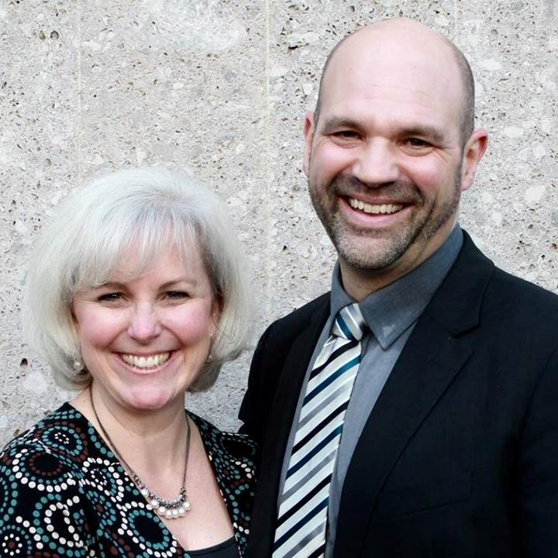

**CONNECT -** Today we have the privilege of celebrating in the **BAPTISM** of Kyleigh, Isabelle, Katelyn, Maggie, Lincoln and Augie. These have trusted Christ as their Lord and Savior and are boldly making public profession of their faith. Be sure to congratulate them on this next step of their Spiritual journey.

**GROW -** Be sure to check out our Growth Group Bible Studies!

Ladies: Tuesday 9:30 AM at the Church

Men: Tuesday 7:00 AM at Fairborn McDonalds

Men: Thursday 7:00 PM at the Church

**SERVE -** AWANA is our children’s program for (Kindergarten age 4) thru 6th grade. We are still in need of helpers on Sunday 5:30-7:00 p.m. See Dave Burk for details.

**LEAD -** Be in prayer for those in our leadership family as they minister in the Children’s Ministry: Kathy Rudy, Alisha Hartong, Brendon Dierker, Mark & Susan Coleman, Titus Hartong, and Allison Bachowski.

WOMEN’S RETREAT

October 11 – 13

Skyview Ranch

Great fun, food and fellowship

Activities include: Horseback riding, Bonfires, Zip lines, Giant swing, Shooting and much more.

Sign-up at Skyviewranch.org

**BIRTHDAYS/ANNIVERSARIES**

Sept 22 Kyle Smith (B)

Sept 23 Danielle Dierker (B)

Sept 25 Ian Wilson (B)

Sept 25 Connor Wilson (B)

**CALENDAR OF EVENTS:**

Sep 1-30 FISH–Non-perishable Food Donations

Sep 22 Baptismal Service

Sep 28 Ladies South Bethel Conference

Sep 29 Men’s Bible Study Begins (5:30 p.m.)

Oct 4-6 Candidate Weekend

Oct 11-13 Ladies Retreat at Skyview Ranch

Oct 11 ASPIRE Conference 7:00 p.m.

Oct 13 Trustee’s Meeting 3:00 p.m.

Oct 19 Fall Festival @ Hartong’s home

Oct. 29 Gospel Missions

Nov 2 Men’s Devotional Breakfast

Nov 4 Ladies Potato Supper/Prayer Partners

Nov 13 2020 GHBC Budget Meeting

Nov 24 Thanksgiving Feast

Nov 28 Thanksgiving Holiday

Nov 28-29 Church office closed

Dec 1-31 FISH–Non-perishable Food Donations

Dec 2 Ladies Supper@Ellies in YellowSprings

Dec 7 Men’s Devotional Breakfast

Dec 22 Youth Christmas Party 5:30-7:00 p.m.

Dec 22 Christmas Eve Eve Eve Service

Dec 25 Christmas Day

**SPECIAL THANKS**

**To those who have been doing work around the church. The building is looking great! Don’t forget to sign-up on the “CONNECT” Board to do**

**a specific task!**



**Grand Heights Baptist Church**

1611 Armstrong Road

Fairborn, Ohio 45324

937-878-7971

[www.grandheights.org](http://www.grandheights.org)

September 22, 2019

FRIDAY, OCTOBER 11, 2019 – 7:00 P.M.

Berachah Church in Middletown, OH 45042

1 night – 3 hours

Just for Women – an evening full of laughter, learning stories and music

Tickets $20 – See Cindy Sudduth

AUTHOR & SPEAKER***COMEDY **** WORSHIP WITH

**BARB ROOSE** ** **KRISTIN WEBER** ** **MIA KOEHNE**

***Our Mission:***

***We exist to glorify God as we help people move closer to Jesus in their spiritual journey.***