**AWANA** – Kicks off the new year. Register Online (grandheights.org)

**FAMILY NIGHT KICK-OFF**

**September 8 – 5:30 P.M. (Next Sunday)**

**[Sign up on Bulletin Board]**

PLEASE CONTINUE TO **PRAY FOR THE PULPIT COMMITTEE** as they consider potential candidates for our next Senior Pastor. Pray for wisdom and unity.

***Welcome to Grand Heights!***

*We are glad you are here with us this morning! You will find Grand Heights to be a friendly and diverse community of people dedicated to impacting our community and the world with the Gospel of Jesus Christ!*

With many vacations, the month of August has not been a good month financially. Often, our offering gets lost in the shuffle. Be sure to “make up” missed giving in September! Let’s work together to get back on track!

[](https://www.bing.com/images/search?view=detailV2&ccid=t88%2bPWPO&id=7387F37954BB639828A4D3B1A27DE64F4B65B8D9&thid=OIP.t88-PWPOwCEyuok48hEHYgHaFL&mediaurl=https://iscrapapp.com/wp-content/uploads/2014/05/pennies-for-scrap.jpg&exph=716&expw=1024&q=picture+of+pennies&simid=608025402043271171&selectedIndex=0)

**SIGN UP ON THE “GROW” BOARD**

**Adults** – Cookout at The Church

Hot Dogs & Hamburgers provided! Bring your favorite sides and/or a dessert.

**Teens** – Cookout at the Hartong’s

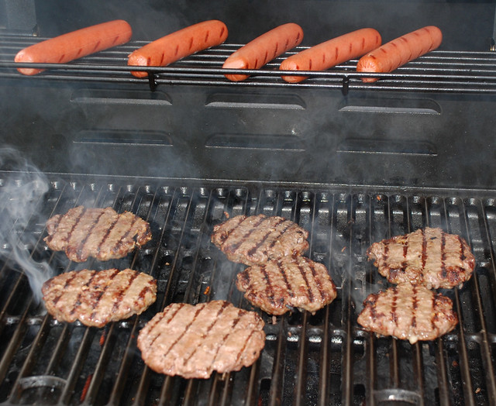

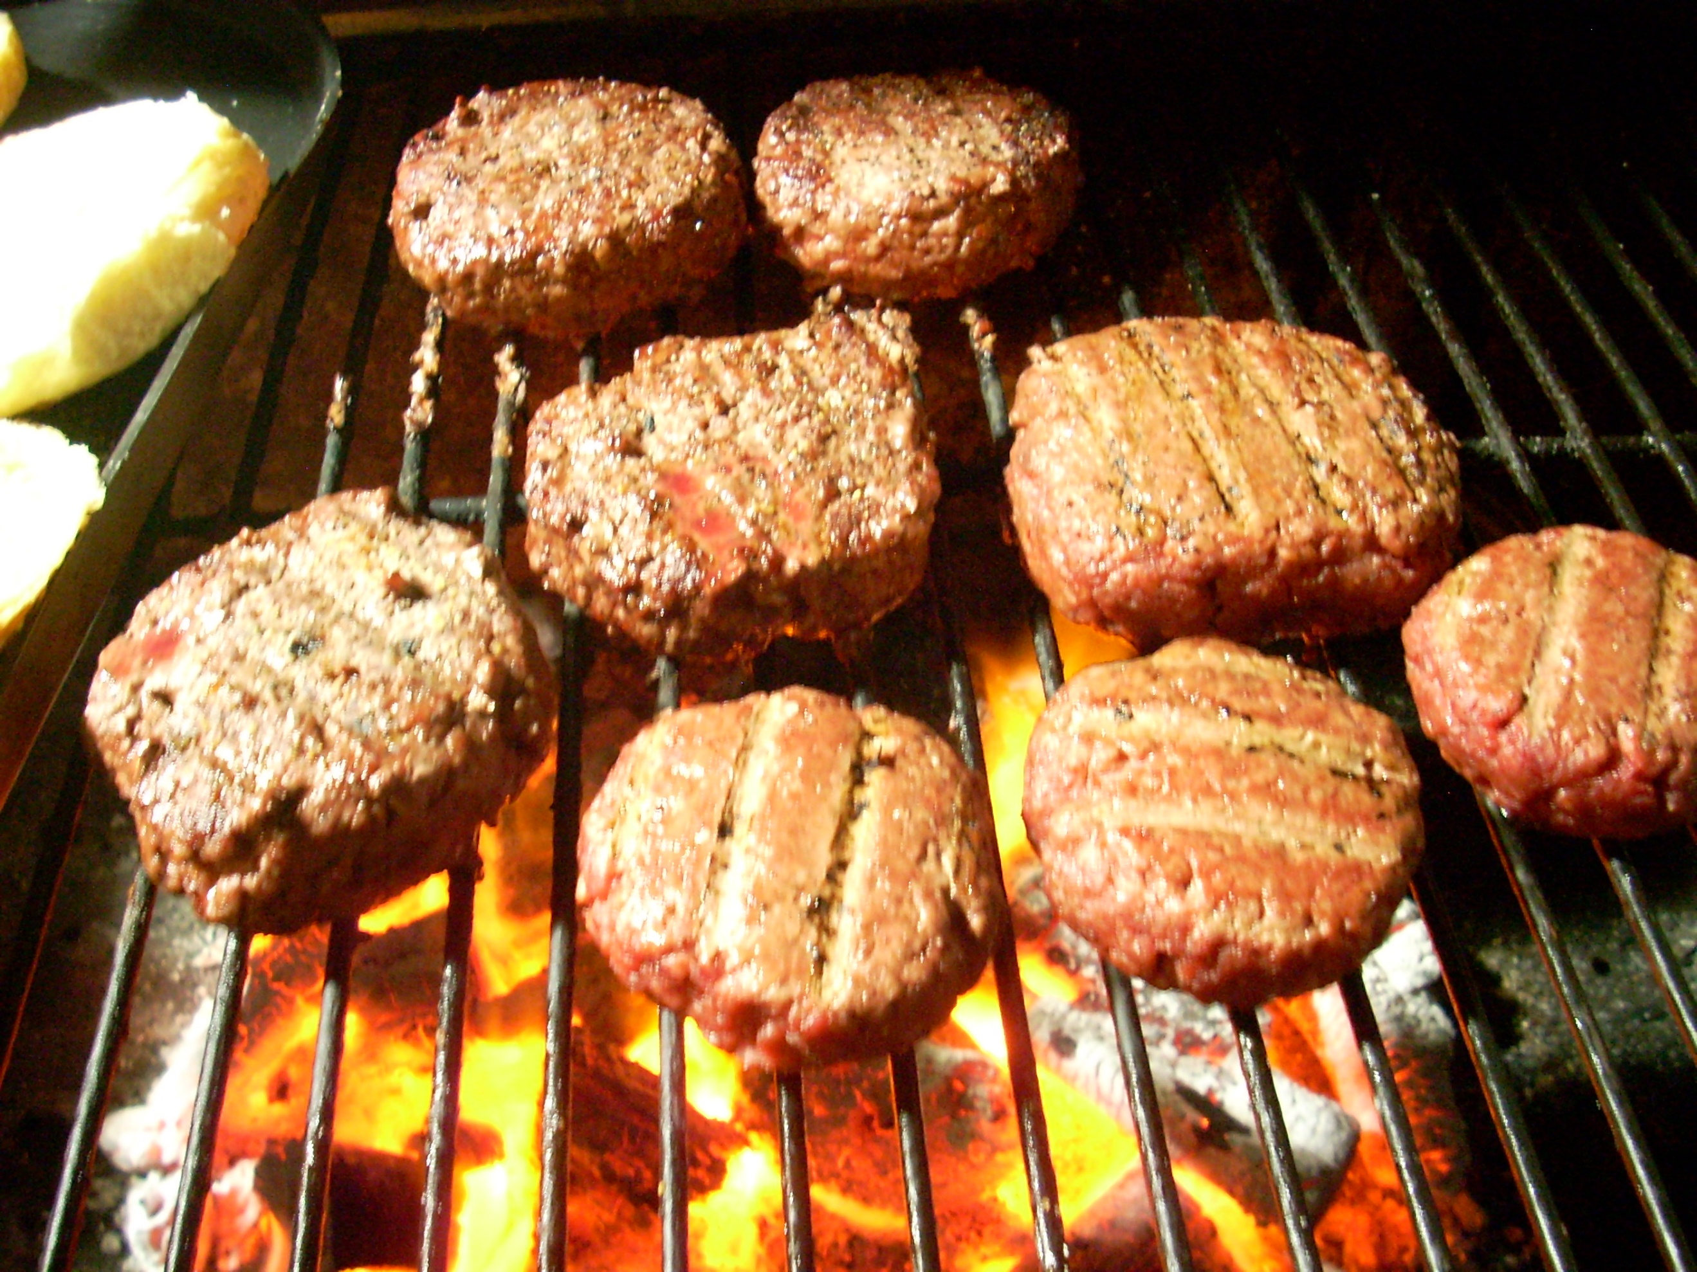



**MEN’S STUDY**

**NO MORE EXCUSES**

**SUNDAY’S 5:30-7:00**

**ALL MEN INVITED**

**PLAN TO BE THERE**

**BRING A FRIEND**

**A BAPTISMAL SERVICE** is planned for September 22nd. If you are interested, please see Pastor Waldo to be certain you are on the list of those being baptized! Looking forward to their Great Day!

**THERE ARE A NUMBER** of tasks needing to be done throughout the Church. See Steve Bachowski for the details. A detailed list is posted on the CONNECT Board.

**PASTOR AND DIANE** are away today as they celebrate their 44th Anniversary. They will be back in town on Tuesday (September 3rd).

**VERSES OF THE WEEK: Matthew 28:19-20**

Therefore go and make disciples of all nations, baptizing them in the name of the Father and of the Son and of the Holy Spirit, and teaching them to obey everything I have commanded you. And surely I am with you always, to the very end of the age.”

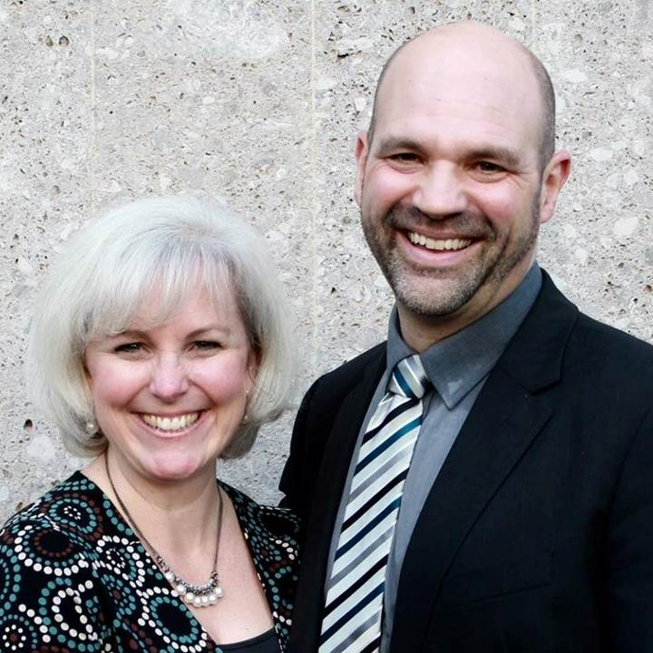

SERVING IN

GERMANY -

NOW ON FURLOUGH!

COMING TO GHBC

SEPTEMBER 15!

MISSIONARY FOR THE MONTH

Steve & Becky Dye

**CONNECT**

Today we welcome Gary and Betty Holtz back to Grand Heights Baptist Church. They launched their mission work with College Students from Grand Heights. They will be retiring from CBF at the end of the year. Well done good and faithful servants!

**GROW**

Be sure to check out our Growth Group Bible Studies!

Ladies: Tuesday 9:30 AM at the Church

Men: Tuesday 7:00 AM at Fairborn McDonalds

Men: Thursday 7:00 PM at the Church

**SERVE**

AWANA opens on September 8th. This is our children’s program for Kindergarten – age 4 thru 6th grade. We are still in need of helpers on Sunday 5:30-7:00 p.m. See Dave Burk for details.

**LEAD**

Be in prayer for those in leadership as they minister- Pulpit Committee: Alan Lair, Allan Hartong, Susan Coleman, Anna Pensworth, Steve Bachowski, Mike Prosser and Brian Hulbert.

**Calendar of Events:**

Sep 1-30 FISH–Non-perishable Food Donations

Sep 1 Gary Holtz – Missionary Speaker

Sep 2 Labor Day Holiday

Sep 7 Men’s Devotional Breakfast

Sep 8 AWANA & Adult Fall Kick-off

Sep 8 Youth BBQ Kick Off Night

Sep 15 The Dye Family–Missionary Speaker Sep 28 Ladies South Bethel Conference

Oct 5 Men’s Devotional Breakfast

Oct 11-13 Ladies Retreat at Skyview Ranch

Oct 11 ASPIRE Conference 7:00 p.m.

Oct 13 Trustee’s Meeting 3:00 p.m.

Oct 19 Fall Festival @ Hartong’s home

Oct. 29 Gospel Missions

Nov 2 Men’s Devotional Breakfast

Nov 4 Ladies Potato Supper/Prayer Partners

Nov 13 2020 GHBC Budget Meeting

Nov 24 Thanksgiving Feast

Nov 28 Thanksgiving Holiday

Dec 1 FISH–Non-perishable Food Donations

Dec 2 Ladies Supper@Ellies in YellowSprings

Dec 7 Men’s Devotional Breakfast

Dec 22 Christmas Eve Eve Eve Service

Dec 22 Youth Christmas Party

**Grand Heights Baptist Church**

1611 Armstrong Road

Fairborn, Ohio 45324

937-878-7971

[www.grandheights.org](http://www.grandheights.org)

September 1, 2019

FRIDAY, OCTOBER 11, 2019 – 7:00 P.M.

Berachah Church in Middletown, OH 45042

1 night – 3 hours

Just for Women – an evening full of laughter, learning stories and music

Tickets online @ ASPIREWOMENSEVENTS.com



WOMEN’S RETREAT

October 11 – 13

Skyview Ranch

Great fun, food and fellowship

Activities include: Horseback riding, Bonfires, Zip lines, Giant swing, Shooting and much more.

Sign-up at Skyviewranch.org

**COMING SEPTEMBER 28TH**

**The South Bethel Women’s Missionary Group will be having their inaugural meeting here at Grand Heights!**

**Ladies: Please plan to attend.**

**Men & Ladies: Help will be needed for set-up, decorating, tear-down, and clean-up.**

**See Pastor to sign-up**

**BIRTHDAYS**

Sep 1 Susan Coleman (B)

AUTHOR & SPEAKER***COMEDY **** WORSHIP WITH

**BARB ROOSE** ** **KRISTIN WEBER** ** **MIA KOEHNE**

GARY & BETTY HOLTZ

College Bible Fellowship

May 26, 2019

***Our Mission:***

***We exist to glorify God as we help people move closer to Jesus in their spiritual journey.***