

PLEASE CONTINUE TO **PRAY FOR THE PULPIT COMMITTEE** as they consider potential candidates for our next Senior Pastor. Pray for wisdom and unity.

***Welcome to Grand Heights!***

*We are glad you are here with us this morning! You will find Grand Heights to be a friendly and diverse community of people dedicated to impacting our community and the world with the Gospel of Jesus Christ!*



[](https://www.bing.com/images/search?view=detailV2&ccid=t88%2bPWPO&id=7387F37954BB639828A4D3B1A27DE64F4B65B8D9&thid=OIP.t88-PWPOwCEyuok48hEHYgHaFL&mediaurl=https://iscrapapp.com/wp-content/uploads/2014/05/pennies-for-scrap.jpg&exph=716&expw=1024&q=picture+of+pennies&simid=608025402043271171&selectedIndex=0)

**LADIES STUDY**

**PSALMS**

**SUNDAY’S 5:30-7:00**

**ALL LADIES INVITED**

**BEGINS**

**TONIGHT**

**MEN’S STUDY**

**NO MORE EXCUSES**

**SUNDAY’S 5:30-7:00**

**ALL MEN INVITED**

**BEGINS NEXT**

**SUNDAY**

MISSIONARY FOR THE MONTH

Steve & Becky Dye

**Pastor Steve** will be teaching at 9:15 a.m.in the Multipurpose Room to the Sunday School Classes. Then at 10:30 a.m. he will be giving the Sunday morning message in the Multipurpose Room.

SERVING IN

GERMANY -

NOW ON FURLOUGH!

HERE TODAY!

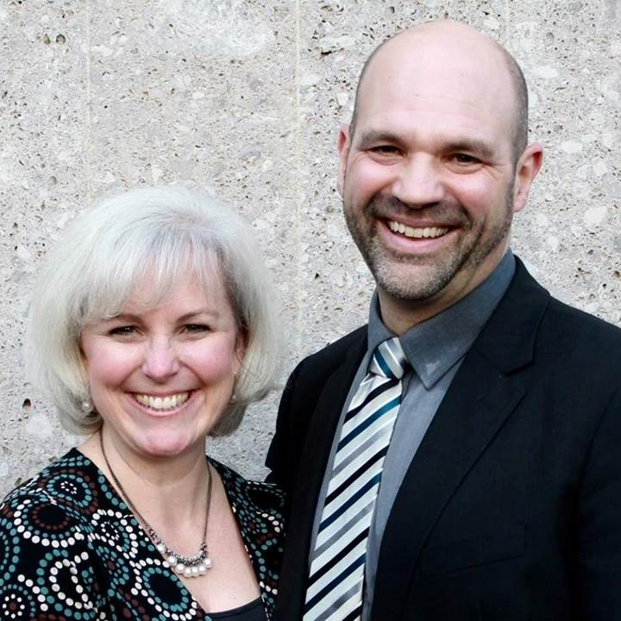

**DIRECTORS**, be sure to give copies of your proposed budgets for 2020 to Steve Bachowski as quickly as possible. Our Budget Meeting is November 13th.

**A BAPTISMAL SERVICE** is planned for September 22nd. If you are interested, please see Pastor Waldo to be certain you are on the list of those being baptized! Looking forward to their Great Day!

**PASTOR AND DIANE** are away today as they celebrate the 50th Annivesary of Grace Baptist Church in Washington, Indiana. They will be back in town on Monday, September 16th.

**THERE ARE A NUMBER** of tasks needing to be done throughout the Church. See Steve Bachowski for the details. A detailed list is posted on the CONNECT Board.

**CONNECT**

Today we welcome Steve and Becky Dye back to Grand Heights Baptist Church. They are ministering in Berlin, Germany and home for a year furlough. We are grateful that their schedule allowed them to be with us this morning.

**GROW**

Be sure to check out our Growth Group Bible Studies!

Ladies: Tuesday 9:30 AM at the Church

Men: Tuesday 7:00 AM at Fairborn McDonalds

Men: Thursday 7:00 PM at the Church

**SERVE**

AWANA opens TODAY. This is our children’s program for Kindergarten – age 4 thru 6th grade. We are still in need of helpers on Sunday 5:30-7:00 p.m. See Dave Burk for details.

**LEAD**

Be in prayer for those in our leadership family as they minister – Dave & Teresa Burk, Bob & Cindy Sudduth, Dave & Anna Pensworth, Brendon Dierker, Brian Hetzel and several parents.

**VERSES OF THE WEEK: Psalms 139:23-24**

**23**Search me, God, and know my heart;  
    test me and know my anxious thoughts.  
**24**See if there is any offensive way in me,  
    and lead me in the way everlasting.

**SPECIAL THANKS**

**To those who have been doing work around the church. The building is looking great! Don’t forget to sign-up on the “CONNECT” Board to do**

**a specific task!**



**Calendar of Events:**

Sep 1-30 FISH–Non-perishable Food Donations

Sep 15 The Dye Family–Missionary Speaker

Sep 15 Ladies Bible Study Begins (5:30 p.m.)

Sep 22 Baptismal Service

Sep 28 Ladies South Bethel Conference

Sep 29 Men’s Bible Study Begins (5:30 p.m.)

Oct 5 Men’s Devotional Breakfast

Oct 11-13 Ladies Retreat at Skyview Ranch

Oct 11 ASPIRE Conference 7:00 p.m.

Oct 13 Trustee’s Meeting 3:00 p.m.

Oct 19 Fall Festival @ Hartong’s home

Oct. 29 Gospel Missions

Nov 2 Men’s Devotional Breakfast

Nov 4 Ladies Potato Supper/Prayer Partners

Nov 13 2020 GHBC Budget Meeting

Nov 24 Thanksgiving Feast

Nov 28 Thanksgiving Holiday

Nov 28-29 Church office closed

Dec 1-31 FISH–Non-perishable Food Donations

Dec 2 Ladies Supper@Ellies in YellowSprings

Dec 7 Men’s Devotional Breakfast

Dec 22 Youth Christmas Party 5:30-7:00 p.m.

Dec 22 Christmas Eve Eve Eve Service

Dec 25 Christmas Day

**BIRTHDAYS/ANNIVERSARIES**

Sept 18 Brian & Jennifer Hulbert (A)

Sept 20 Emmy Hetzel (B)

WOMEN’S RETREAT

October 11 – 13

Skyview Ranch

Great fun, food and fellowship

Activities include: Horseback riding, Bonfires, Zip lines, Giant swing, Shooting and much more.

Sign-up at Skyviewranch.org

**STEVE & BECKY DYE**

ABWE - Germany

May 26, 2019

**Grand Heights Baptist Church**

1611 Armstrong Road

Fairborn, Ohio 45324

937-878-7971

[www.grandheights.org](http://www.grandheights.org)

September 15, 2019

FRIDAY, OCTOBER 11, 2019 – 7:00 P.M.

Berachah Church in Middletown, OH 45042

1 night – 3 hours

Just for Women – an evening full of laughter, learning stories and music

Tickets see Cindy Sudduth

AUTHOR & SPEAKER***COMEDY **** WORSHIP WITH

**BARB ROOSE** ** **KRISTIN WEBER** ** **MIA KOEHNE**

***Our Mission:***

***We exist to glorify God as we help people move closer to Jesus in their spiritual journey.***