**PULPIT COMMITTEE REPORT**

**We are glad to have Dr. Jason Lee beginning September 1 as Interim Pastor. We think he will continue to do the excellent job he has done as an occasional pulpit supply.  The committee presently has only one applicant for pastor.  We interviewed him via a conference call on Monday and look forward to finding out more about him as he finds out more about Grand Heights.  We have recently advertised our pastorate with the Southern Baptist Theological Seminary in Louisville, KY, and have received the resumes of five from that ad.  We have sent each an application form to complete and return to us.  Please continue to pray for wisdom for the committee as we seek the right man to bring as a candidate to the church**

***Our Mission: We exist to glorify God as we help people move closer to Jesus in their spiritual journey.***

We have supported the McDonalds since 1984.

**LEAD ministries to closed door nations,**

**WAR International!**

**Closed Door**

**Ministries works mostly in the**

**Middle east.**

***CLOSED DOOR MINISTRIES***

***AND***

***WOMEN AT RISK***

**GUEST SPEAKER   
 PASTOR ERIC HINES**

**August 30, 2020**

**Pastor Eric Hines received his bachelor's degree from Baptist Bible College in Springfield, MO, and master's from Detroit Baptist Theological Seminary.  He has previously served as pastoral assistant at Huron Baptist Church, Flat Rock, MI, and pastor of Faith Baptist Church, Oxford, OH.  He is presently serving as pastor of Kentwood Baptist Church in Kentwood, MI.**

**AUGUST/SEPTEMBER BIRTHDAYS & ANNIVERSERIES**

**Aug 30 Tom & Diane Waldo (A) Sep 09 Dave Burk (B)**

**Sep 11 Joshua Burk (B) Sep 14 Jim/Barb Howard (A)**

**Sep 20 Emmy Hetzel (B) Sep 22 Kyle Smith (B)**

**Sep 23 Danielle Dierker (B) Sep 30 Donovan Dierker (B)**

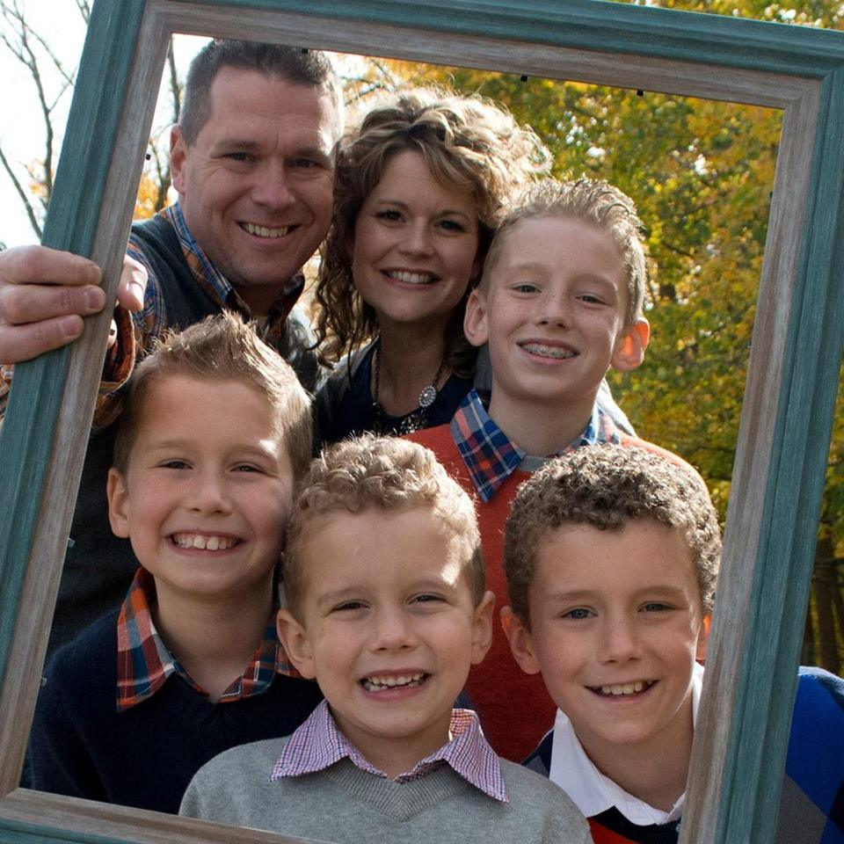

*Welcome to* ***GRAND HEIGHTS***

**Welcome to our Sunday Service Today – RAIN or SHINE! In compliance with current safe distancing we are having our indoor/outdoor service. Pastor Eric Hines will be our speaker for this Sunday’s message. You have the option of coming into the church or staying in your car in the church parking lot for the church message. It will be broadcasted on the 88.1 FM station. To pick up the Audio, you need to have a vehicle with a working FM radio.**

**A packet of information is available upon arrival. Arrive at 10:15 to allow time to park. Service is scheduled to begin at 10:30. This Indoor/Drive-in service will allow those in our fellowship with health issues to safely come and worship the way they would be most comfortable. The Order of Service Packet is available Sunday morning or on the Church Web Site. Allan Hartong @ 937-718-0533.**

MISSIONARY FOR THE MONTH OF AUGUST

PHIL & BECKY McDONALD

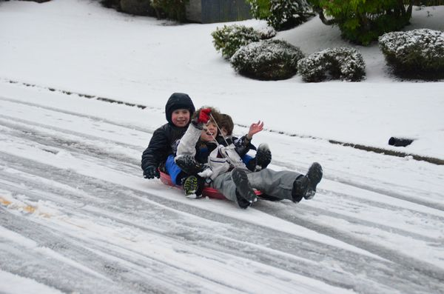

August 30, 2020

IF YOUR FAMILY IS IN NEED IN ANY WAY, PLEASE CONTACT YOUR DEACON OR THE CHURCH OFFICE.

CALENDAR EVENTS

Tues. – 9:30 a.m. - Ladies Prayer Mtg.

Wed. – 7:00 p.m. – All church Prayer Mtg.

Tues. – September 1 – Interim Pastor Begins

Sun. – September 13 –Adults & Children Sunday School

Classes (9:30 A.M.)

Sun. – September 13 – Stand-up Pre-budget Meeting

Sun. - September 13 - Awana Awards, (5:30 P.M.)

Wed. – September 16 – Board Meeting (7:30 P.M.)

**At this time, if you would like to help out Ed and Charlene Phillips with meals, it would be appreciated. Contact Mark Coleman if you can help.**

**IN AUGUST WE ARE TAKING DONATIONS FOR FOOD FOR FISH! BRING YOUR DONATIONS AND LEAVE THEM INSIDE THE CHURCH ENTRANCE. USHERS WILL PUT THEM IN THE HALLWAY!**

ALL CHURCH

All ladies are welcome to participate in the Tuesday Morning Prayers. The Church Prayer Meeting on Wednesday evening is for everyone. During this time period, we are honoring the recommendations of the State of Ohio on the Coronavirus Epidemic.

**AUGUST 1**

**THRU**

**AUGUST 31**

**NO FLOUR OR SUGAR DONATIONS!**

A large sign in a field

Description generated with very high confidence

**Grand Heights Baptist Church**

**1611 Armstrong Road**

Fairborn, OH 45324

**(937)878-7971**

**E-mail: ghbcnet@grandheights.org**