**GUEST SPEAKER   
 DR. MARK CALEB SMITH**

**August 23, 2020**Dr. Smith teaches courses in American politics, constitutional law, and research methodology/data analysis. He has authored numerous refereed journal articles, book chapters, and other publications. His primary research interest is in the field of religion and American politics.

**AUGUST/SEPTEMBER BIRTHDAYS & ANNIVERSERIES**

**Aug 28 Rose Sizemore (B) Aug 30 Tom & Diane Waldo (A)**

**Sep 09 Dave Burk (B) Sep 11 Joshua Burk (B)**

**Sep 14 Jim/Barb Howard (A) Sep 20 Emmy Hetzel (B)**

**Sep 22 Kyle Smith (B) Sep 23 Danielle Dierker (B)**

**Sep 30 Donovan Dierker (B)**

**PULPIT COMMITTEE REPORT**

We are glad to have Dr. Jason Lee starting September 1 as interim pastor; we think he will continue to do the excellent job he has done as an occasional pulpit supply.  The committee presently has only one applicant for pastor.  We interviewed him via a conference call on Monday and look forward to finding out more about him as he finds out more about Grand Heights.  We have recently advertised our pastorate with the Southern Baptist Theological Seminary in Louisville, KY, and have received the resumes of five from that ad.  We have sent each an application form to complete and return to us.  Please continue to pray for wisdom for the committee as we seek the right man to bring as a candidate to the church.

**\* MINISTRY UPDATES \***

**1) Dyes are in Germany.**

**2) Casey Kuang – Ministering to Chinese Scholars.**

**3) Scott & Nikki Russell – Helps missionaries by providing resources and daily encouragement**

**4) Mike & Kris Reed – New Awana Representatives**

We have supported the McDonalds since 1984.

LEAD ministries to closed door nations,

WAR International!

Closed Door

Ministries works mostly in the

Middle east.

***CLOSED DOOR MINISTRIES AND***

***WOMEN AT RISK***

*Welcome to* ***GRAND HEIGHTS***

Welcome to our Sunday Service Today – RAIN or SHINE! In compliance with current safe distancing we are having our indoor/outdoor service. Dr. Mark Caleb Smith will be our speaker for this Sunday’s message.You have the option of coming into the church or staying in your car in the church parking lot for the church message. It will be broadcasted on the 88.1 FM station. To pick up the Audio, you need to have a vehicle with a working FM radio.

A packet of information is available upon arrival. Arrive at 10:15 to allow time to park. Service is scheduled to begin at 10:30. This Indoor/Drive-in service will allow those in our fellowship with health issues to safely come and worship the way they would be most comfortable. The Order of Service Packet is available Sunday morning or on the Church Web Site. Allan Hartong @ 937-718-0533.

***Our Mission: We exist to glorify God as we help people move closer to Jesus in their spiritual journey.***

***Our Mission: We exist to glorify God as we help people move closer to Jesus in their spiritual journey.***

 ***Mission: We exist to glorify God as we help people move closer to Jesus in their spiritual journey.***

MISSIONARY FOR THE MONTH OF AUGUST

PHIL & BECKY McDONALD

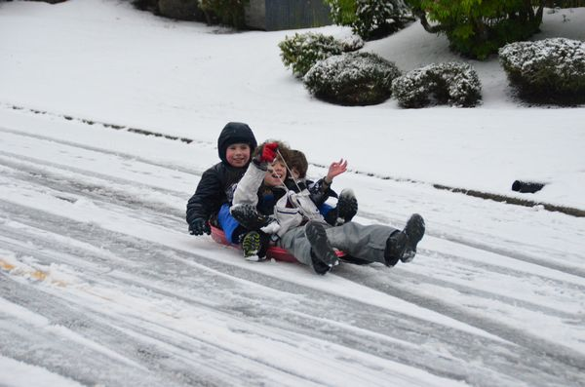

IF YOUR FAMILY IS IN NEED IN ANY WAY, PLEASE CONTACT YOUR DEACON OR THE CHURCH OFFICE.

A large sign in a field

Description generated with very high confidence

CALENDAR EVENTS

Tues. – 9:30 a.m. - Ladies Prayer Mtg.

Wed. – 7:00 p.m. – All church Prayer Mtg.

Tues. – September 1 – Interim Pastor Begins

Sun. – September 13 –Adults & Children Sunday School

Classes (A.M.) Awana Awards, Bible Studies (P.M.)

Sun. – September 13 – Stand-up Pre-budget Meeting

**IN AUGUST WE ARE TAKING DONATIONS FOR FOOD FOR FISH! BRING YOUR DONATIONS AND LEAVE THEM INSIDE THE CHURCH ENTRANCE. USHERS WILL PUT THEM IN THE HALLWAY!**

CONGRATULATIONS

To Lauren/Brant Holman on the birth of their daughter, Harper Ann. She was born on August 19th, weighed 7 lb 12 oz, and 20-1/4 inches long. She is the granddaughter of Dave/Tina Imes and great-granddaughter of George /Shirley Barrett. She has a very proud brother, Brodie.

ALL CHURCH

All ladies are welcome to participate in the Tuesday Morning Prayers. The Church Prayer Meeting on Wednesday evening is for everyone. During this time period, we are honoring the recommendations of the State of Ohio on the Coronavirus Epidemic.

**AUGUST 1**

**THRU**

**AUGUST 31**

**NO FLOUR OR SUGAR DONATIONS!**

August 23, 2020

**Grand Heights Baptist Church**

**1611 Armstrong Road**

Fairborn, OH 45324

**(937)878-7971**

**E-mail: ghbcnet@grandheights.org**