***Our Mission: We exist to glorify God as we help people move closer to Jesus in their spiritual journey.***

***Our Mission: We exist to glorify God as we help people move closer to Jesus in their spiritual journey.***

 ***Mission: We exist to glorify God as we help people move closer to Jesus in their spiritual journey.***

**PULPIT COMMITTEE REPORT**

The  Pulpit Committee continues its search for a pastoral candidate to present to the church.  On August 9th it was agreed on by the Church Board and the Congregation that an Interim Pastor would be put on staff until a new pastor is called.  “Dr. Jason Lee, Professor of Theological Studies at Cedarville University, has accepted Grand Heights Baptist Church’s invitation to become our Interim Pastor effective September 1. He will be our Interim Pastor for three months and may continue as our interim for three-month intervals so long as he and the church agree to it”.

**\* MINISTRY UPDATES \***

**1) Dyes are in Germany.**

**2) Casey Kuang – Ministering to Chinese Scholars.**

**3) Dan/Valerie Woods – Ministering in Sao Paulo, Brazil**

**4) Scott & Nikki Russell – Helps missionaries by providing resources and daily encouragement**

**5) Mike & Kris Reed – New Awana Representatives**

***CLOSED DOOR MINISTRIES AND***

***WOMEN AT RISK***

We have supported the McDonalds since 1984.

LEAD ministries to closed door nations,

WAR International!

Closed Door

Ministries works mostly in the

Middle east.

**AUGUST BIRTHDAYS & ANNIVERSERIES**

**Aug 16 Diane Waldo (B) Aug 19 Mark & Susan Coleman(A)**

**Aug 20 Dave & Bettina Imes (A) Aug 22 Auggie Hartong (B)**

**Aug 28 Rose Sizemore (B) Aug 30 Tom & Diane Waldo (A)**

**GUEST SPEAKER   
 DR. MARK CALEB SMITH**

**August 16, 2020  
  
Dr. Smith has been with us on several Sunday’s. We are very appreciative of his giving of his knowledge and time during this period of our lives.**

*Welcome to* ***GRAND HEIGHTS***

Welcome to our Sunday Service Today – RAIN or SHINE! In compliance with current safe distancing we are having our indoor/outdoor service. Dr. Mark Caleb Smith will be our speaker for this Sunday’s message.You have the option of coming into the church or staying in your car in the church parking lot for the church message. It will be broadcasted on the 88.1 FM station. To pick up the Audio, you need to have a vehicle with a working FM radio.

A packet of information is available upon arrival. Arrive at 10:15 to allow time to park. Service is scheduled to begin at 10:30. This Indoor/Drive-in service will allow those in our fellowship with health issues to safely come and worship the way they would be most comfortable. The Order of Service Packet is available Sunday morning or on the Church Web Site. Go to Grand Heights Baptist Church Fairborn Ohio and print a copy of this Packet. If you have a problem, please contact: Allan Hartong @ 937-718-0533.

MISSIONARY FOR THE MONTH OF AUGUST

PHIL & BECKY McDONALD

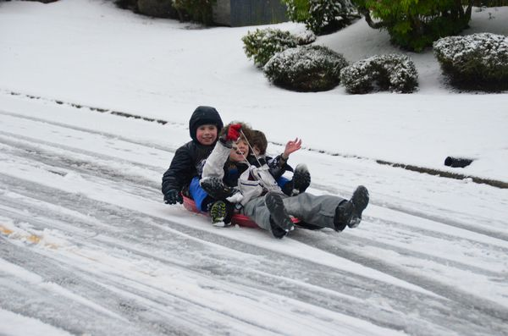

IF YOUR FAMILY IS IN NEED IN ANY WAY, PLEASE CONTACT YOUR DEACON OR THE CHURCH OFFICE.

A large sign in a field

Description generated with very high confidence

CALENDAR EVENTS

Tues. – 9:30 a.m. - Ladies Prayer Mtg.

Wed. – 7:00 p.m. – All church Prayer Mtg.

Sun. - August 16 – Church Board Mtg. after a.m. Service

Sun. – August 16 – Awana Mtg. – All interested people

Wed. – August 19 – Congregational Mtg. at 7:00 p.m.

Tues. – September 1 – Interim Pastor Begins

Sun. – September 13 – Stand-up Pre-budget Meeting

ALL CHURCH

All ladies are welcome to participate in the Tuesday Morning Prayers. The Church Prayer Meeting on Wednesday evening is for everyone. During this time period, we are honoring the recommendations of the State of Ohio on the Coronavirus Epidemic.

I'd like to invite everyone who is interested in AWANA (leaders, parents, workers, others) to a meeting this Sunday August 16th at 5:30 to discuss WHETHER, WHEN AND FORMAT for opening Club this fall.  We will meet either outdoors or in the fellowship hall.  Masks required. Thanks-Cindy **Sudduth** Christian Ed.Director

**AUGUST 1**

**THRU**

**AUGUST 31**

**NO FLOUR OR SUGAR DONATIONS!**

**IN AUGUST WE ARE TAKING FOOD DONATIONS FOR FOOD FOR FISH! BRING YOUR DONATIONS AND LEAVE THEM INSIDE THE CHURCH ENTRANCE. USHERS WILL PUT THEM IN THE HALLWAY!**

August 16, 2020

**Grand Heights Baptist Church**

**1611 Armstrong Road**

Fairborn, OH 45324

**(937)878-7971**

**E-mail: ghbcnet@grandheights.org**