**DR. JASON LEE**

**INTERIM PASTOR**

**Sunday Morning Service**

**August 15th at**

**10:30 A.M.**

**FREEDOM IN CHRIST**

**Colossians 2:16-23**

***Our Mission: We exist to glorify God as we help people move closer to Jesus in their spiritual journey.***

***WELCOME TO******GRAND HEIGHTS***

**Welcome to our Sunday Service Today – If you are visiting with us today for the first time and you are inside, please register at our Welcome Center.**

**RAIN or SHINE! In compliance with current safe distancing we are continuing our indoor/outdoor service. You have the option of coming into the church or staying in your car in the church parking lot for the church message. It will be broadcasted on the 88.7 FM station. An Order Of Service packet is available.**

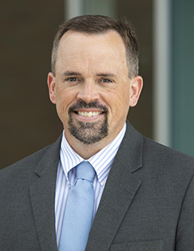

**PFP at Lunch**

**Pray for a Pastor**

**Please pray each day at lunch for a new pastor and for wisdom for the Pulpit   
Committee as it conducts the search on behalf of the church.**



**AUGUST BIRTHDAYS AND ANNIVERSARIES**

**Aug 19 Mark/Susan Coleman (A) Aug 20 Dave/Bettina Imes (A)**

**Aug 22 Auggie Hartong (B) Aug 28 Rose Sizemore (B)**

**Aug 30 Tom/Diane Waldo (A)**

**CHURCH SECRETARY POSITION**

Thelma will be retiring October 1, so we are looking for a new secretary.  In short, the position is part-time at 25 hours per week. The secretary handles a wide range of routine office tasks, part of which require proficiency in using email and common office management software such as Microsoft Word and Excel.  Pay is $12 to $16 per hour depending on education and experience. Benefits include paid time off for major holidays, vacation time, and sick leave.  The church also pays the employer half of social security.  If interested, please contact Alan Lair, Allan Hartong, or Bob Sudduth.

**YOUTH SUMMER ACTIVITIES @ THE PRICHARDS**

**All at 6:00-9:00 pm - September 10th**

Executive Director for Latin America and the Caribbean

Word of Life-Youth Ministries

* 2021 ministry activities
* Working on leadership training for small group leaders
* Missions trip with several churches in Cleveland. Doing evangelism training and evangelism.



**MISSIONARY FOR THE MONTH OF AUGUST**

**DUSTAN, BETH, PETER, ANNA, EMMETT HORST**





AUGUST 15, 2021

IF YOUR FAMILY IS IN NEED IN ANY WAY, PLEASE CONTACT YOUR DEACON OR THE CHURCH OFFICE.

**AUGUST CONGREGATIONAL OPPORTUNITIES**

**CALENDAR EVENTS**

**Tues – 9:30 am – Ladies Prayer Meeting**

**Wed – 7:00 pm – Prayer Meeting**

**Sun – August 15 Sunday School @ 9:15 am**

**Sun – August 15 –Sunday Morning Worship Service @ 10:30**

**August – Food Donations to FISH – Fairborn Food Pantry**

**Wed – August 18 – Quarterly Congregation Meeting 7:00 pm**

**Sun – August 22 – AWANA Meeting following A.M. Service**

**Sun – August 29 – Communion**

**Tue – August 31 – Dayton Gospel Mission – (5th Tuesday)**

**Mon – September 6 Labor Day & Tue – Office will be closed.**

**Fri – September 10 – Youth Activity @ the Prichard’s Home**

**Sun – September 12 – AWANA Begins@ 5:30 - 7:00 pm**

YOUTH ACTIVITY AT THE PRICHARD’S

Friday, September 10th at 6-9 pm

**Come & Bring Friends**

**Let Whitney know you and your friends are coming (720-232-6436)**

**SERVING AT DAYTON GOSPEL**

**August 31st – 5:00 pm**

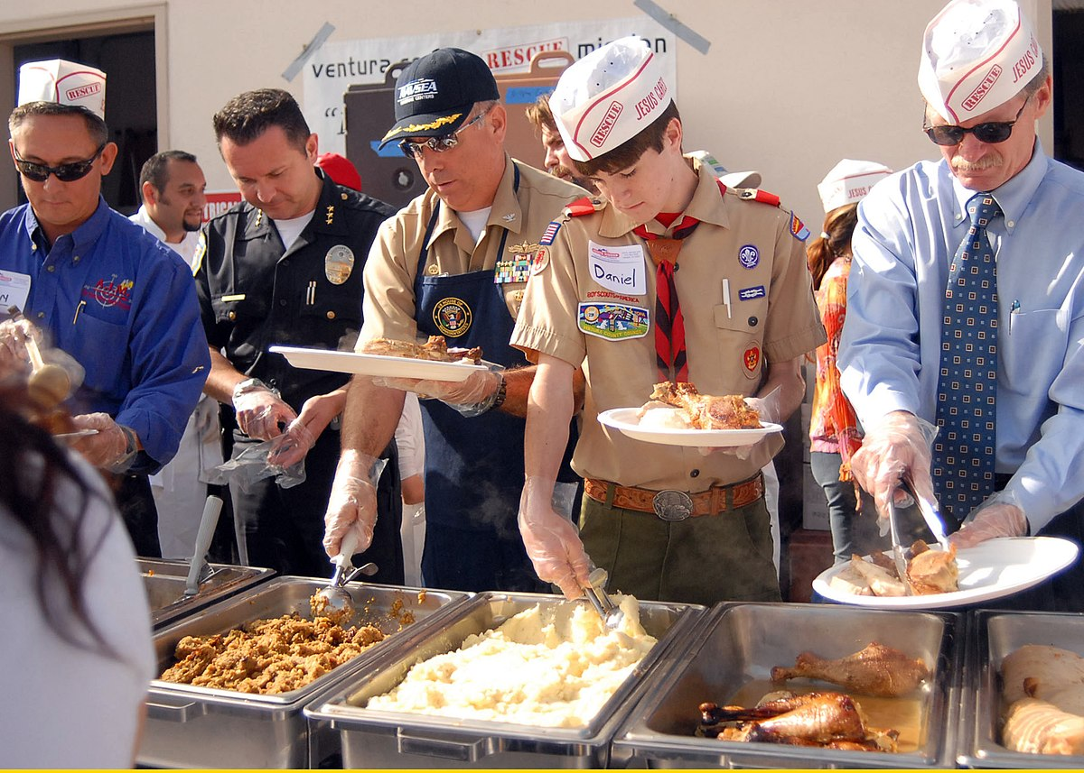

**FAIRBORN FOOD PANTRY**

**August 1 thru 31st**

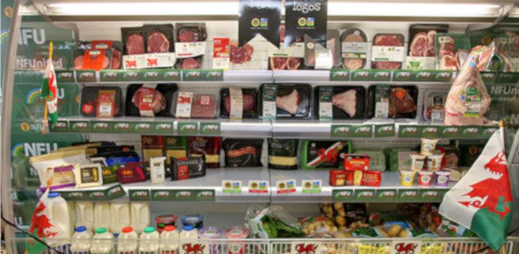



**Grand Heights Baptist Church**

**1611 Armstrong Road**

Fairborn, OH 45324

**(937)878-7971**

**E-mail: ghbcnet@grandheights.org**