**DEACON FLOCK MEETINGS**

On or around

August 4th

See your Deacon for details!



***Welcome to Grand Heights!***

*We are glad you are here with us this morning! You will find Grand Heights to be a friendly and diverse community of people dedicated to impacting our community and the world with the Gospel of Jesus Christ!*

**Summer Activities** are currently being planned so please save these dates:

August 4 Deacon Flock Meetings

August 12 Teens to Kings Island

August 18 Ladies Hike – Glen Helen

August 25 End of Summer - Young’s Run

Please continue to **pray for the Pulpit Committee** as they consider potential candidates for our next Senior Pastor. Pray for wisdom and unity!

[](https://www.bing.com/images/search?view=detailV2&ccid=t88%2bPWPO&id=7387F37954BB639828A4D3B1A27DE64F4B65B8D9&thid=OIP.t88-PWPOwCEyuok48hEHYgHaFL&mediaurl=https://iscrapapp.com/wp-content/uploads/2014/05/pennies-for-scrap.jpg&exph=716&expw=1024&q=picture+of+pennies&simid=608025402043271171&selectedIndex=0)



YOUNG’S DAIRY RUN

Sunday, August 25th

Meet for ice cream at 7:00 p.m. Head out earlier for a great evening of enjoyment: Driving Range, Putt-Putt Golf, Batting Cages, Train, Slide. Have fun and meet at 7:00 p.m.



**TEENS TO KINGS ISLAND**

August 12th

See Mark Coleman for ticket information

**There Are a Number** of tasks needing to be done throughout the Church. See Steve Bachowski for the details. A detailed list is posted on the CONNECT Board.

**Missionaries are coming!** Several missionaries will be visiting us the next few months! Save the dates:

Aug. 11-Steve Schenk

Sept. 1–Gary Holtz

Sept. 15–Steve & Becky Dye

**Pastor and Diane** are on vacation this week and will be visiting family in Michigan and Ohio. If you have a need, please contact your Deacon or the Church office.

**CONNECT**

This morning Pastor will be speaking in the series “Getting to Know God – Our Holy God.” When Isaiah got a sense of God’s majesty and holiness, he confessed his own ungodliness. We are to be holy, for God is Holy.

**GROW**

Be sure to check out our Growth Group Bible Studies!

Ladies: Tuesday 9:30 AM at the Church

Men: Tuesday 7:30 AM at Fairborn McDonalds

Men: Thursday 7 PM at the Church

**SERVE**

Every month that has a fifth Tuesday in it, a group from Grand Heights goes to the Gospel Mission in Dayton to help serve a meal. Plan to sign-up for the next month of serving which is October 29th.

**LEAD**

Be in prayer for those in leadership as they minister- Deacons: Alan Lair, Dave Pensworth, Bob Sudduth, Mark Coleman, Allan Hartong, Rick Pensworth (Emeritus).

**NEEDED:** We are now staffing the Nursery every Sunday Morning for our Service. Volunteers are needed. Please see Kathy Rudy to volunteer.

**Verse of the Week: Isaiah 6:3**

And they were calling to one another: “Holy, holy, holy is the LORD Almighty; the whole earth is full of his glory.”

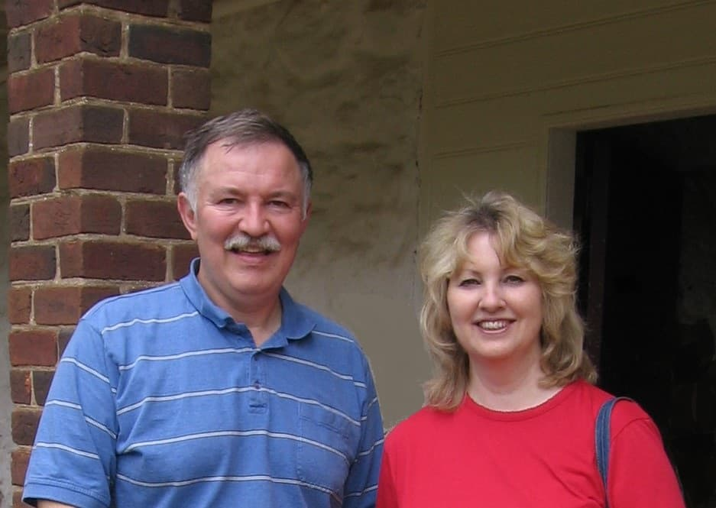

Serving churches in

Ohio as AWANA

Missionaries

MISSIONARY FOR THE MONTH

Steve and Pam Schenk



**LADIES’ HIKE**

Sunday, August 18

@ Glen Helen Park in Yellow Springs

Meet at church 3:30 p.m.

Hike begins at 4:00 p.m.

**BIRTHDAYS/ANNIVERSARIES**

Aug 5 Juliana Coleman (B)

Aug 5 Henry Stark (B)

Aug 9 Mary Hulbert (B)

Aug 10 Deb Jones (B)

**Calendar of Events:**

Aug 4 Deacon Flock Meetings

Aug 11 Steve Schenk – AWANA Missionary

Aug 12 Teens to Kings Island

Aug 18 Trustee’s Meeting 3:00

Aug 18 Ladies Hike/Glen Helen – 3:30 p.m.

Aug 23 Cedarville Involvement Fair

Aug 23 Overcomer Movie Opens

Aug 25 Young’s Dairy Run

Sep 1-30 FISH–Non-perishable Food Donations

Sep 1 Gary Holtz – Missionary Speaker

Sep 2 Labor Day Holiday

Sep 7 Men’s Devotional Breakfast

Sep 8 AWANA & Adult Fall Kick-off

Sep 8 Youth BBQ Kick Off Night

Sep 15 The Dye Family–Missionary Speaker Sep 28 Ladies South Bethel Conference

Oct 5 Men’s Devotional Breakfast

Oct 11-13 Ladies Retreat at Skyview Ranch

Oct 13 Trustee’s Meeting 3:00 p.m.

Oct 15 Ladies Potato Supper

Oct 19 Fall Festival @ Hartong’s home

Oct. 29 Gospel Missions

Nov 13 2020 GHBC Budget Meeting

**Grand Heights Baptist Church**

1611 Armstrong Road

Fairborn, Ohio 45324

937-878-7971

[www.grandheights.org](http://www.grandheights.org)

August 4, 2019

**OUR HOLY GOD**

**Isaiah 6:1-13**

May 26, 2019



Trustee Meeting – August 18 covering progress on projects and 2020 Budget. Meeting begins at 3:00 p.m.

GET READY! Parking lot repairs were completed this week. Also additional improvements! Be looking for them.



WOMEN’S RETREAT

October 11 – 13

Skyview Ranch

Great fun, food and fellowship

Activities include: Horseback riding, Bonfires, Zip lines, Giant swing, Shooting and much more.

Sign-up at Skyviewranch.org

FAMILY NIGHT KICK-OFF

September 8 – 5:30 P.M.

AWANA, TEENS, MEN & WOMEN

Plan to be there for a great

launch of our fall programs!

***Our Mission:***

***We exist to glorify God as we help people move closer to Jesus in their spiritual journey.***