**A Baptismal Service** is planned for September 22nd. If you are interested, please see Pastor Waldo to be certain you are on the list of those being baptized! Looking forward to their Great Day!

**Summer Activities** that are planned, so please save these dates:

August 25 End of Summer - Young’s Dairy Run

PLEASE CONTINUE TO **PRAY FOR THE PULPIT COMMITTEE** as they consider potential candidates for our next Senior Pastor. Pray for wisdom and unity!



***Welcome to Grand Heights!***

*We are glad you are here with us this morning! You will find Grand Heights to be a friendly and diverse community of people dedicated to impacting our community and the world with the Gospel of Jesus Christ!*

[](https://www.bing.com/images/search?view=detailV2&ccid=t88%2bPWPO&id=7387F37954BB639828A4D3B1A27DE64F4B65B8D9&thid=OIP.t88-PWPOwCEyuok48hEHYgHaFL&mediaurl=https://iscrapapp.com/wp-content/uploads/2014/05/pennies-for-scrap.jpg&exph=716&expw=1024&q=picture+of+pennies&simid=608025402043271171&selectedIndex=0)



Serving Churches

in

Ohio as AWANA

Missionaries

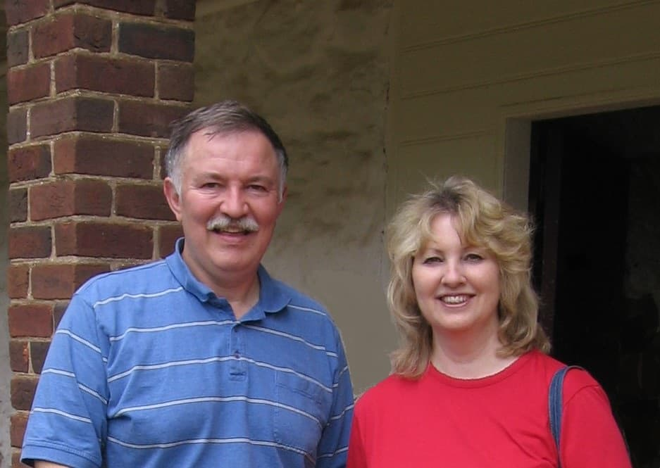

MISSIONARY FOR THE MONTH

Steve and Pam Schenk

**COMING SEPTEMBER 28TH**

**The South Bethel Women’s Missionary Group will be having their inaugural meeting here at Grand Heights!**

**Ladies: Please plan to attend.**

**Men & Ladies: Help will be needed for set-up, decorating, tear-down, and clean-up.**

**See Pastor to sign-up**



**CONNECT**

Today we welcome as Pulpit Supply, Tony and Sarah Barber. The Barbers live in Vassar, Michigan and have a daughter, Alyssa. It is a pleasure to share the pulpit with him this morning! Be sure to give them a hearty Grand Heights welcome.

**GROW**

Be sure to check out our Growth Group Bible Studies!

Ladies: Tuesday 9:30 AM at the Church

Men: Tuesday 7:00 AM at Fairborn McDonalds

Men: Thursday 7:00 PM at the Church

**SERVE**

AWANA opens on September 8th. This is our children’s program for Kindergarten – age 4 thru 6th grade. We are still in need of helpers on Sunday 5:30-7:00 p.m. See Dave Burk for details.

**LEAD**

Be in prayer for those in leadership as they minister- Sunday School Staff: Alicia Hartong, Brendon Dierker, Mark and Susan Coleman, Dave and Anna Pensworth, Alan Lair and Pastor Waldo

**THERE ARE A NUMBER** of tasks needing to be done throughout the Church. See Steve Bachowski for the details. A detailed list is posted on the CONNECT Board.

**MISSIONARIES ARE COMING!** Several missionaries will be visiting us in September!

Save the dates:

Sept. 1–Gary Holtz

Sept. 15–Steve & Becky Dye

**Today** we welcome a number of students from Cedarville University. We pray the service today is a blessing to you!

VERSES OF THE WEEK: HEBREWS 3:1-6

**1**Therefore, holy brothers and sisters, who share in the heavenly calling, fix your thoughts on Jesus, whom we acknowledge as our apostle and high priest.**2**He was faithful to the one who appointed him, just as Moses was faithful in all God’s house.**3**Jesus has been found worthy of greater honor than Moses, just as the builder of a house has greater honor than the house itself.**4**For every house is built by someone, but God is the builder of everything.**5**“Moses was faithful as a servant in all God’s house,”[[a](https://www.biblegateway.com/passage/?search=Hebrews+3%3A1-6&version=NIV#fen-NIV-30001a)] bearing witness to what would be spoken by God in the future.**6**But Christ is faithful as the Son over God’s house. And we are his house, if indeed we hold firmly to our confidence and the hope in which we glory.

**Calendar of Events:**

Aug 25 Young’s Dairy Run

Sep 1-30 FISH–Non-perishable Food Donations

Sep 1 Gary Holtz – Missionary Speaker

Sep 2 Labor Day Holiday

Sep 7 Men’s Devotional Breakfast

Sep 8 AWANA & Adult Fall Kick-off

Sep 8 Youth BBQ Kick Off Night

Sep 15 The Dye Family–Missionary Speaker Sep 28 Ladies South Bethel Conference

Oct 5 Men’s Devotional Breakfast

Oct 11-13 Ladies Retreat at Skyview Ranch

Oct 11 ASPIRE Conference 7:00 p.m.

Oct 13 Trustee’s Meeting 3:00 p.m.

Oct 19 Fall Festival @ Hartong’s home

Oct. 29 Gospel Missions

Nov 2 Men’s Devotional Breakfast

Nov 4 Ladies Potato Supper/Prayer Partners

Nov 13 2020 GHBC Budget Meeting

Nov 24 Thanksgiving Feast

Nov 28 Thanksgiving Holiday

Dec 1 FISH–Non-perishable Food Donations

Dec 2 Ladies Supper@Ellies in YellowSprings

Dec 7 Men’s Devotional Breakfast

Dec 22 Christmas Eve Eve Eve Service

Dec 22 Youth Christmas Party

**BIRTHDAYS/ANNIVERSARIES**

Aug 28 Rose Sizemore (B)

Aug 30 Tom & Diane Waldo (A)

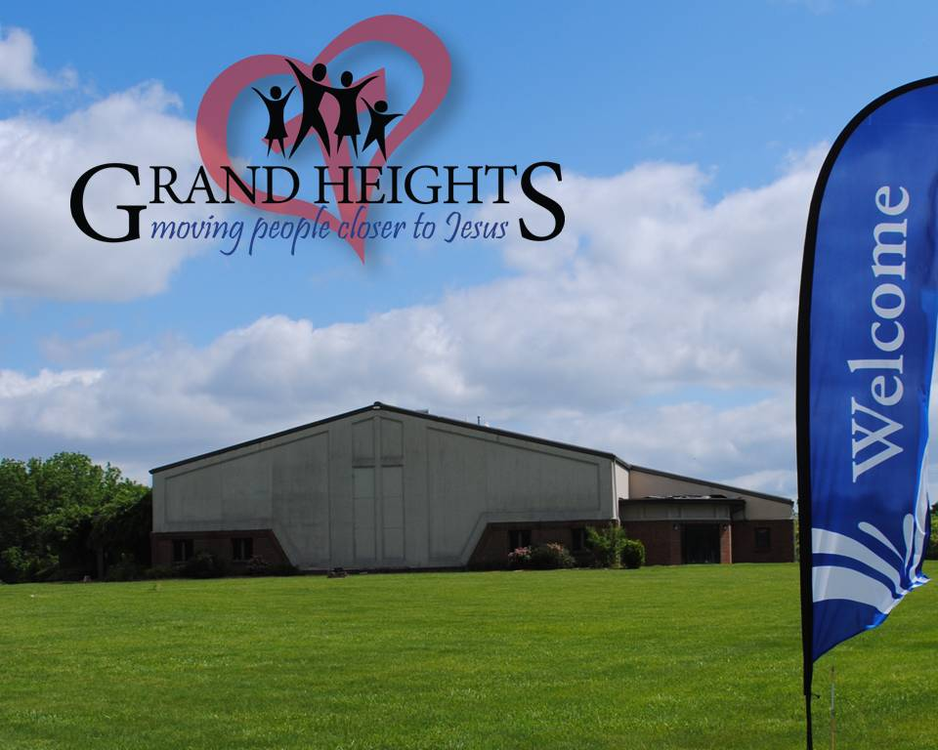

AUTHOR & SPEAKER***COMEDY **** WORSHIP WITH

**BARB ROOSE** ** **KRISTIN WEBER** ** **MIA KOEHNE**



FRIDAY, OCTOBER 11, 2019 – 7:00 P.M.

Berachah Church in Middletown, OH 45042

1 night – 3 hours

Just for Women – an evening full of laughter, learning stories and music

Tickets online @ ASPIREWOMENSEVENTS.com

WOMEN’S RETREAT

October 11 – 13

Skyview Ranch

Great fun, food and fellowship

Activities include: Horseback riding, Bonfires, Zip lines, Giant swing, Shooting and much more.

Sign-up at Skyviewranch.org

FAMILY NIGHT KICK-OFF

September 8 – 5:30 P.M.

AWANA, TEENS, MEN & WOMEN

Plan to be there for a great

launch of our fall programs!

IS HE WORTHY?

Hebrews 3:1-6

May 26, 2019

**Grand Heights Baptist Church**

1611 Armstrong Road

Fairborn, Ohio 45324

937-878-7971

[www.grandheights.org](http://www.grandheights.org)

August 25, 2019

***Our Mission:***

***We exist to glorify God as we help people move closer to Jesus in their spiritual journey.***