

**TEENS TO KINGS ISLAND**

August 12th

See Mark Coleman for ticket information

**Summer Activities** are currently being planned so please save these dates:

August 12 Teens to Kings Island

August 18 Ladies Hike – Glen Helen

August 25 End of Summer - Young’s Run

Please continue to **pray for the Pulpit Committee** as they consider potential candidates for our next Senior Pastor. Pray for wisdom and unity!

***Welcome to Grand Heights!***

*We are glad you are here with us this morning! You will find Grand Heights to be a friendly and diverse community of people dedicated to impacting our community and the world with the Gospel of Jesus Christ!*

[](https://www.bing.com/images/search?view=detailV2&ccid=t88%2bPWPO&id=7387F37954BB639828A4D3B1A27DE64F4B65B8D9&thid=OIP.t88-PWPOwCEyuok48hEHYgHaFL&mediaurl=https://iscrapapp.com/wp-content/uploads/2014/05/pennies-for-scrap.jpg&exph=716&expw=1024&q=picture+of+pennies&simid=608025402043271171&selectedIndex=0)

**COMING SEPTEMBER 28TH**

**The South Bethel Women’s Missionary Group will be having their inaugural meeting here at Grand Heights!**

**Ladies: Please plan to attend.**

**Men & Ladies: Help will be needed for set-up, decorating, tear-down, and clean-up.**





**There Are a Number** of tasks needing to be done throughout the Church. See Steve Bachowski for the details. A detailed list is posted on the CONNECT Board.

**Missionaries are coming!** Several missionaries will be visiting us the next few months! Save the dates:

Sept. 1–Gary Holtz

Sept. 15–Steve & Becky Dye

**Thank you** to all who have been working on Special projects around the church.

**Pastor and Diane** are attending the baptism of two of their grandchildren, Ryanne and P.J. Pray for a safe trip home.

**NEEDED:** We are now staffing the Nursery every Sunday Morning for our Service. Volunteers are needed. Please see Kathy Rudy to volunteer.

**CONNECT**

This morning we welcome the Schenk family. Steve and Pam have been our AWANA Missionaries for some time and minister to thousands of kids each year. They have also worked to establish AWANA Clubs in Egypt.

**GROW**

Be sure to check out our Growth Group Bible Studies!

Ladies: Tuesday 9:30 AM at the Church

Men: Tuesday 7:30 AM at Fairborn McDonalds

Men: Thursday 7 PM at the Church

**SERVE**

Every month that has a fifth Tuesday in it, a group from Grand Heights goes to the Gospel Mission in Dayton to help serve a meal. Think about signing up for the next Gospel Mission meal serving. Sign up on the SERVE Board!

**LEAD**

Be in prayer for those in leadership as they minister- Deacons: Alan Lair, Dave Pensworth, Bob Sudduth, Mark Coleman, Allan Hartong, Rick Pensworth (Emeritus).

**Verse of the Week: Isaiah 6:3**

And they were calling to one another: “Holy, holy, holy is the LORD Almighty; the whole earth is full of his glory.”

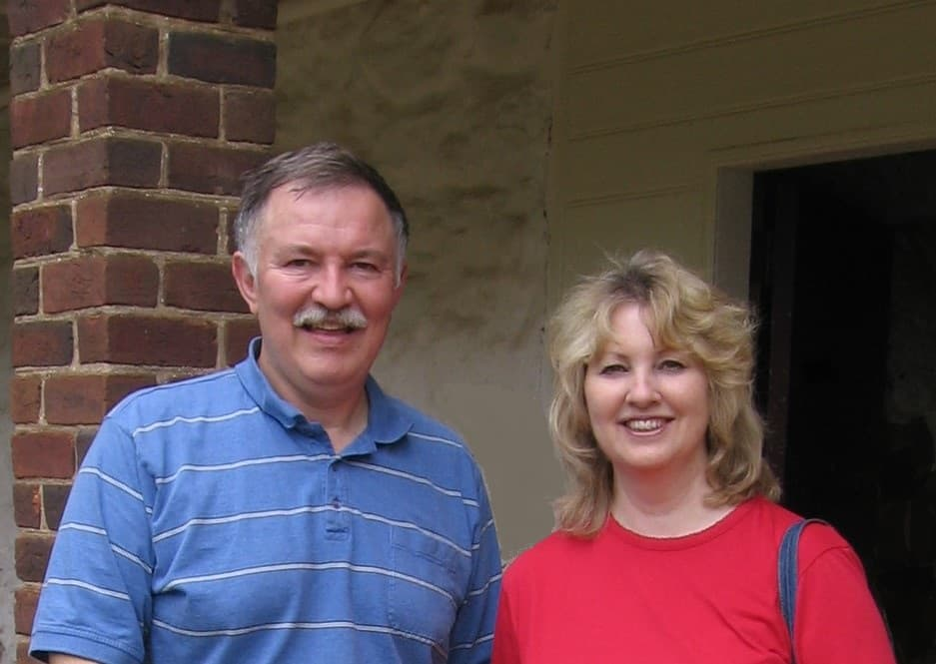

Serving churches in

Ohio as AWANA

Missionaries

MISSIONARY FOR THE MONTH

Steve and Pam Schenk

**BIRTHDAYS/ANNIVERSARIES**

Aug 12 Sandy Henry (B)

Aug 14 Allan Hartong (B)

Aug 16 Diane Waldo (B)

**Calendar of Events:**

Aug 12 Teens to Kings Island

Aug 18 Trustee’s Meeting 3:00

Aug 18 Ladies Hike/Glen Helen – 3:30 p.m.

Aug 23 Cedarville Involvement Fair

Aug 23 Overcomer Movie Opens

Aug 25 Young’s Dairy Run

Sep 1-30 FISH–Non-perishable Food Donations

Sep 1 Gary Holtz – Missionary Speaker

Sep 2 Labor Day Holiday

Sep 7 Men’s Devotional Breakfast

Sep 8 AWANA & Adult Fall Kick-off

Sep 8 Youth BBQ Kick Off Night

Sep 15 The Dye Family–Missionary Speaker Sep 28 Ladies South Bethel Conference

Oct 5 Men’s Devotional Breakfast

Oct 11-13 Ladies Retreat at Skyview Ranch

Oct 13 Trustee’s Meeting 3:00 p.m.

Oct 15 Ladies Potato Supper

Oct 19 Fall Festival @ Hartong’s home

Oct. 29 Gospel Missions

Nov 13 2020 GHBC Budget Meeting

Nov 24 Thanksgiving Feast

Nov 28 Thanksgiving Holiday

Steve & Pam Schenk

Serving Churches

In Ohio as

AWANA Missionaries

May 26, 2019

**Grand Heights Baptist Church**

1611 Armstrong Road

Fairborn, Ohio 45324

937-878-7971

[www.grandheights.org](http://www.grandheights.org)

August 11, 2019



Trustee Meeting – August 18 covering progress on projects and 2020 Budget. Meeting begins at 3:00 p.m.

GET READY! Parking lot repairs are coming soon! Also other improvements! Be looking for them.



WOMEN’S RETREAT

October 11 – 13

Skyview Ranch

Great fun, food and fellowship

Activities include: Horseback riding, Bonfires, Zip lines, Giant swing, Shooting and much more.

Sign-up at Skyviewranch.org

FAMILY NIGHT KICK-OFF

September 8 – 5:30 P.M.

AWANA, TEENS, MEN & WOMEN

Plan to be there for a great

launch of our fall programs!



***Our Mission:***

***We exist to glorify God as we help people move closer to Jesus in their spiritual journey.***

**LADIES’ HIKE**

Sunday, August 18

@ Glen Helen Park in Yellow Springs

Meet at church 3:30 p.m.

Hike begins at 4:00 p.m.