



**ICE CREAM SOCIAL**

July 7th - 6:00 p.m.

At the Church

Please bring your favorite ice cream to share. Also be sure to invite others to join you!

This is a great activity for inviting others!

**Summer Activities** are currently being planned so please save these dates:

July 7 Ice Cream Social @ the Church

July 21 Hot Dog Roast at Dave and Anna’s

August 4 Deacon Flock Meetings

August 25 End of Summer - Young’s Run

Please continue to **Pray for the Pulpit Committee** as they continue to look at resume’s and interview potential candidates for our next Senior Pastor. Pray for wisdom and unity!



***Welcome to Grand Heights!***

*We are glad you are here with us this morning! You will find Grand Heights to be a friendly and diverse community of people dedicated to impacting our community and the world with the Gospel of Jesus Christ!*

[](https://www.bing.com/images/search?view=detailV2&ccid=t88%2bPWPO&id=7387F37954BB639828A4D3B1A27DE64F4B65B8D9&thid=OIP.t88-PWPOwCEyuok48hEHYgHaFL&mediaurl=https://iscrapapp.com/wp-content/uploads/2014/05/pennies-for-scrap.jpg&exph=716&expw=1024&q=picture+of+pennies&simid=608025402043271171&selectedIndex=0)

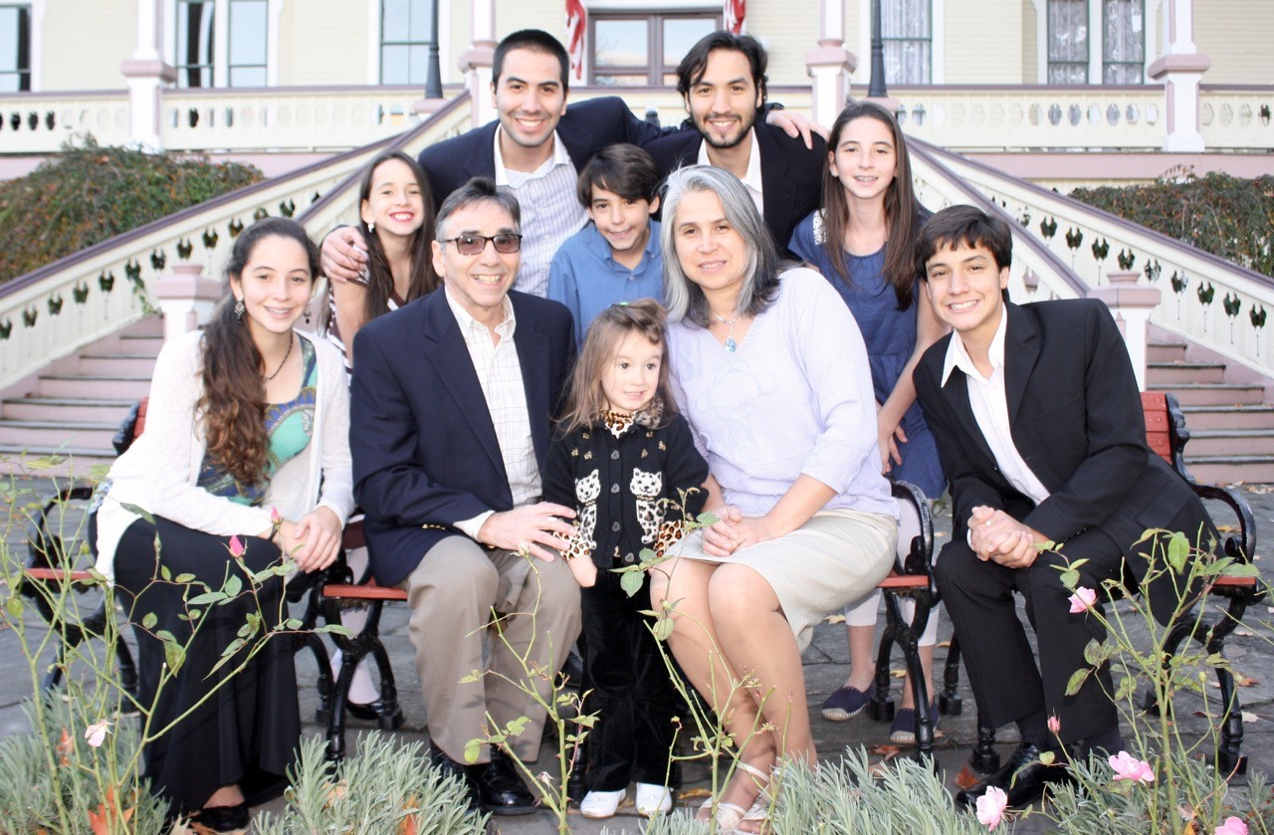

MISSIONARY FOR THE MONTH

DAN & VALERIE WOODS

**HOT DOG**

**ROAST**

July 21 @ 6:00

**LEAD**

Be in prayer for those in leadership as they minister to us – Sunday School Staff: Jen Hulbert, Alicia Hartong, Shirley Barrett, Brendon Dierker, Mark Coleman, Dave Pensworth, Alan Lair and Pastor Waldo.

**SERVE**

Every month that has a fifth Tuesday in it, a group from Grand Heights goes to the Gospel Mission in Dayton to help serve a meal. Why not sign up for July 30th.

**GROW**

Be sure to check out our Growth Group Bible Studies this week!

Ladies: Tuesday 9:30 at the Church

Men: Tuesday 7:30 at the Fairborn McDonalds

Men: Thursday 7 PM at the Church

Couples: Thursday 7 PM at the Pensworth’s

**There Are Still a Number** of tasks needing to be done throughout the Church. See Steve Bachowski for the details.

**Teens:** July 14th – Lazer Tag – Check on details in the Teen Room.

**Missionaries are coming!** Several missionaries will be visiting us the next few months! Save the dates: Aug 11–Steve Schenk; Sept 1–Gary Holtz;

Sept 22–Steve & Becky Dye.

**Teens:** Be planning early for our trip to Kings Island on August 12th. Ticket purchases will begin

on August 4th.

**OUR CONDOLENCES on the passing of Ruth Shurte as she went to be home with the Lord on July 2nd. Please pray for Dick and the Shurte Family.**

**NOTE: Thelma will be on vacation this week. The best way to contact the office will be to call Pastor’s cell phone number (416-6923).**

Serving with the Jewish Population

In Sao Paulo, Brazil

Pray about serious financial needs.

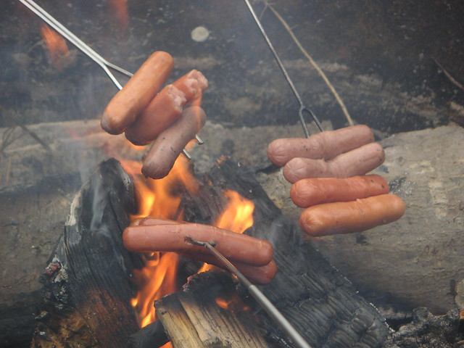

**Dave & Anna**

**Pensworth’s Home**

Come and bring your

Friends and side dishes.

This will be a great

night of fellowship for

all of us.

Please plan to attend!

**DEACON FLOCK MEETINGS**

On or around

August 4th

See your Deacon for details!



**Verse of the Week:**

**1 Timothy 3:7**

He must also have a good reputation with outsiders, so that he will not fall into disgrace and into the devil’s trap

.

**CONNECT**

This morning Pastor will be speaking on a Pastor’s reputation in the community. He is not only the leader of the church but is to be a leader in the community.

**VACATION BIBLE SCHOOL FOOD PROJECT**

978 Items - Food items collected during VBS that was donated for Fairborn FISH!!!

**Calendar of Events:**

July 14 Trustee’s Meeting 3:00

July 15 Ladies Dinner Out –Cherry House

July 21 Hot Dog Roast @ Dave & Anna’s

July 30 Gospel Missions

Aug 3 Men’s Breakfast/Devotions

Aug 4 Deacon Flock Meetings

Aug 11 Trustee’s Meeting 3:00

Aug 11 Steve Schenk – Awana Missionary

Aug 12 Teens to Kings Island

Aug 18 Ladies Hike/Glen Helen

Aug 23 Overcomer Movie Opens

Aug 25 Young’s Dairy Run

Sep 1 Gary Holtz – Missionary Speaker

Sep 2 Labor Day Holiday

Sep 8 Awana & Adult Fall Programs Begin

Sep 15 Stephen Gruber – Guest Speaker

Sep 22 The Dye Family–Missionary Speaker

Sep 28 OARBC Ladies South Bethel Con.

Oct 11-13 Ladies Retreat at Skyview Ranch

Oct 19 Fall Festival @ Hartongs

A dining room table

Description generated with very high confidence

**BIRTHDAYS/ANNIVERSARIES**

July 8 Katelyn Suter (B)

July 13 Deanna Bragg (B)

**YOUNG’S DAIRY RUN**

Sunday, August 25th

Meet for ice cream at 7:00 p.m. Head out to Young’s for a great evening of enjoyment. Driving Range, Putt-Putt Golf, Batting Cages, Train, Slide. Have fun and meet at 7:00 p.m.

FAMILY NIGHT KICK-OFF

September 8 – 5:30 P.M.

AWANA, TEENS, MEN & WOMEN

Plan to be there for a great

launch for our Fall programs!



**LADIES HIKE**

Sunday, August 18

@ Glen Helen Park in Yellow Springs

Meet at church 3:30 p.m.

Hike begins at 4:00 p.m.

**Ladies Dinner Out**

Monday, July 15th

@ 6:00 pm

Cherry House Café

1241 Meadowbridge Dr. Beavercreek, OH



**Grand Heights Baptist Church**

1611 Armstrong Road

Fairborn, Ohio 45324

937-878-7971

[www.grandheights.org](http://www.grandheights.org)

July 7, 2019

**OF GOOD REPUTATION**

**1 Timothy 3:7**

May 26, 2019

***Our Mission:***

***We exist to glorify God as we help people move closer to Jesus in their spiritual journey.***