**FUTURE ACTIVITIES**

* September - Labor Day Weekend Rough & Rugged
* September/October – Ladies Retreat
* October – Disc Golf Tourney
* November – Underground – Jr. High Retreat
* December – Hunter’s Retreat
* December – Young Adult Retreat
* December – Christmas Dinner

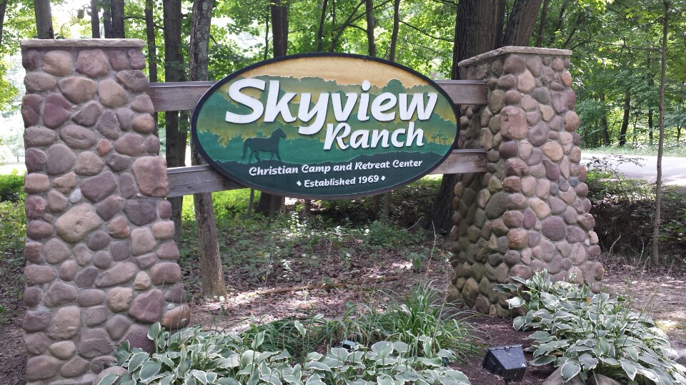

Executive Director for Latin America and the Caribbean

**JULY BIRTHDAYS AND ANNIVERSARIES**

**July 4 Charles Prichard (B)**

**July 8 Katelyn Suter (B)**

**July 13 Deanna Bragg (B)**

**July 29 Ruth Marvin (B)**

**July 29 Bob/Thelma Hughes (A)**

***Our Mission: We exist to glorify God as we help people move***

***Closer to Jesus in their spiritual journey.***

***WELCOME TO******GRAND HEIGHTS***

**Welcome to our Sunday Service Today – RAIN or SHINE! In compliance with current safe distancing we are continuing our indoor/outdoor service. You have the option of coming into the church or staying in your car in the church parking lot for the church message. It will be broadcasted on the 88.7 FM station.**

**An Order Of Service packet is available upon arrival. Arrive at 10:15 to allow time to park. Service is scheduled to begin at 10:30.**

**If you are visiting with us today for the first time and you are inside, please register at our Welcome Center.**

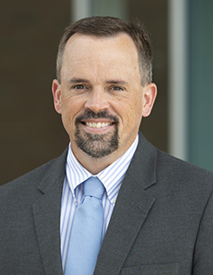

**DR. JASON LEE**

**INTERIM PASTOR**

**Sunday Morning Service**

**July 4th at**

**10:30 A.M.**

**SINNERS BROUGHT NEAR Colossians 1:21-23**

**PFP at Lunch**

**Pray for a Pastor**

**Please pray each day at lunch for a new pastor and for wisdom for the Pulpit   
Committee as it conducts the search on behalf of the church.**



**PULPIT COMMITTEE REPORT**

**At the present time, the Pulpit Committee has no applicants. The last applicant withdrew his name from consideration last Sunday night. Please continue to pray that God will send the individual that He chooses to serve as Senior Pastor.**

**YOUTH SUMMER ACTIVITIES @ THE PRICHARDS**

**All at 6:00-9:00 pm - July 9th; August 6th; September 10th**

**MISSION FOR THE MONTH OF JULY**

**SKYVIEW RANCH CAMP**

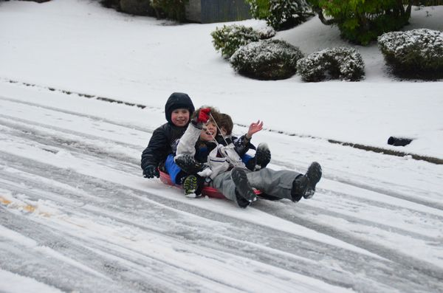





JULY 4, 2021

IF YOUR FAMILY IS IN NEED IN ANY WAY, PLEASE CONTACT YOUR DEACON OR THE CHURCH OFFICE.



**HAPPY**

**JULY 4TH**

**HAVE A SAFE AND HAPPY HOLIDAY!**

YOUTH ACTIVITY AT THE PRICHARD’S

Friday, July 9th at

6-9 pm

**Come & Bring Friends**

**Let Whitney know you and your friends are coming (720-232-6436)**



**Grand Heights Baptist Church**

**1611 Armstrong Road**

Fairborn, OH 45324

**(937)878-7971**

**E-mail: ghbcnet@grandheights.org**