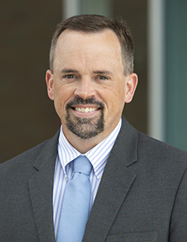

**DR. JASON LEE**

**INTERIM PASTOR**

**Sunday Morning Service**

**July 25th at**

**10:30 A.M.**

**ENCOURAGED HEARTS**

**Colossians 2:1-5**

**CHURCH SECRETARY POSITION**

Thelma will be retiring October 1, so we are looking for a new secretary.  In short, the position is part-time at 25 hours per week. The secretary handles a wide range of routine office tasks, part of which require proficiency in using email and common office management software such as Microsoft Word and Excel.  Pay is $12 to $16 per hour depending on education and experience. Benefits include paid time off for major holidays, vacation time, and sick leave.  The church also pays the employer half of social security.  If interested, please contact Alan Lair, Allan Hartong, or Bob Sudduth.

**PFP at Lunch**

**Pray for a Pastor**

**Please pray each day at lunch for a new pastor and for wisdom for the Pulpit   
Committee as it conducts the search on behalf of the church.**



**YOUTH SUMMER ACTIVITIES @ THE PRICHARDS**

**All at 6:00-9:00 pm - August 6th; September 10th**

***WELCOME TO******GRAND HEIGHTS***

**Welcome to our Sunday Service Today – RAIN or SHINE! In compliance with current safe distancing we are continuing our indoor/outdoor service. You have the option of coming into the church or staying in your car in the church parking lot for the church message. It will be broadcasted on the 88.7 FM station.**

**An Order Of Service packet is available upon arrival. Arrive at 10:15 to allow time to park. Service is scheduled to begin at 10:30.**

**If you are visiting with us today for the first time and you are inside, please register at our Welcome Center.**

**JULY /AUGUST BIRTHDAYS AND ANNIVERSARIES**

**July 29 Ruth Marvin (B) July 29 Bob/Thelma Hughes (A)**

**Aug 1 Bob/Cindy Sudduth (A) Aug 2 Alyssa Coleman (B)**

**Aug 5 Juliana Coleman (B) Aug 5 Henry Stark (B)**

**Aug 14 Allan Hartong (B) Aug 16 Diane Waldo (B)**

**Aug 19 Mark/Susan Coleman (A) Aug 20 Dave/Bettina Imes (A)**

**Aug 22 Auggie Hartong (B) Aug 28 Rose Sizemore (B)**

**Aug 30 Tom/Diane Waldo (A)**

***Our Mission: We exist to glorify God as we help people move***

***Closer to Jesus in their spiritual journey.***

**FUTURE ACTIVITIES**

* September - Labor Day Weekend Rough & Rugged
* September/October – Ladies Retreat
* October – Disc Golf Tourney
* November – Underground – Jr. High Retreat
* December – Hunter’s Retreat
* December – Young Adult Retreat
* December – Christmas Dinner

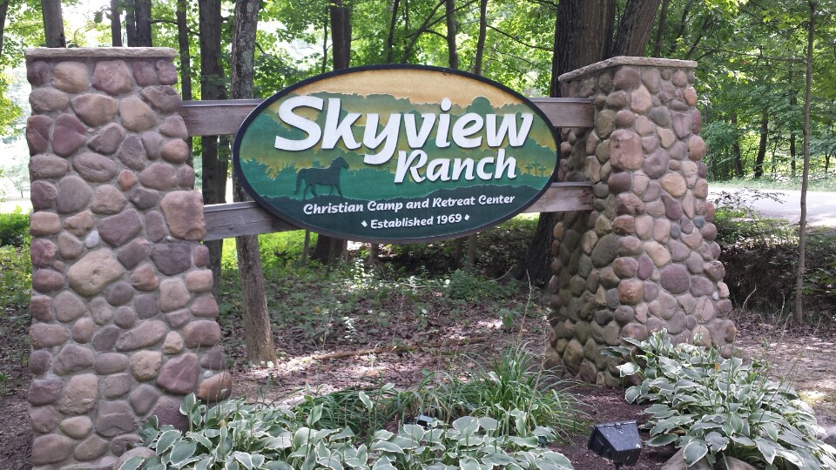

Executive Director for Latin America and the Caribbean

**MISSION FOR THE MONTH OF JULY**

**SKYVIEW RANCH CAMP**

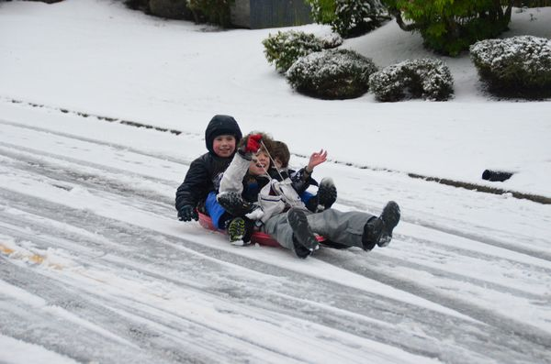



JULY 25, 2021

IF YOUR FAMILY IS IN NEED IN ANY WAY, PLEASE CONTACT YOUR DEACON OR THE CHURCH OFFICE.

**AUGUST CONGREGATIONAL OPPORTUNITIES**

YOUTH ACTIVITY AT THE PRICHARD’S

Friday, August 6th at

6-9 pm

**Come & Bring Friends**

**Let Whitney know you and your friends are coming (720-232-6436)**

**CALENDAR EVENTS**

**Tues – 9:30 am – Ladies Prayer Meeting**

**Wed – 7:00 pm – Prayer Meeting**

**Sun – July 25 Sunday School @ 9:15 am**

**Sun – July 25 – Sunday Morning Worship Service @ 10:30**

**Sun – July 25 – Communion**

**August – Food Donations to FISH – Fairborn Food Pantry**

**Fri – August 6 – Youth Activity @ the Prichard’s Home**

**Wed - August 11 – Board Meeting @ 7:30 pm**

**Wed – August 18 – Quarterly Congregation Meeting 7:00 p**

**Tue – August 31 – Dayton Gospel Mission – (5th Tuesday)**

**SERVING AT DAYTON GOSPEL**

**August 31st – 5:00 pm**

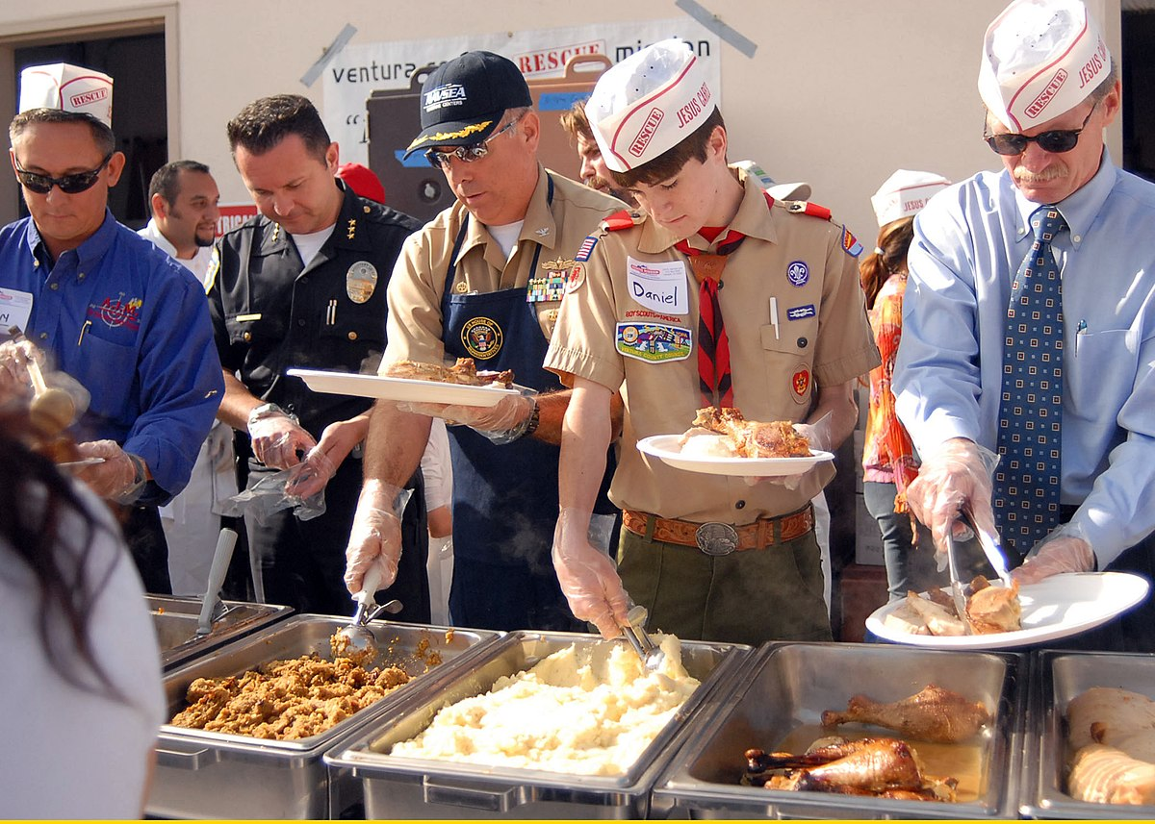

**FAIRBORN FOOD PANTRY**

**August 1 thru 31st**

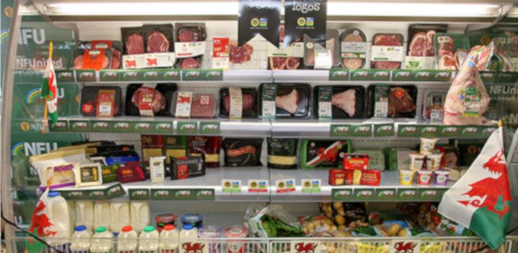



**Grand Heights Baptist Church**

**1611 Armstrong Road**

Fairborn, OH 45324

**(937)878-7971**

**E-mail: ghbcnet@grandheights.org**