**Summer Activities** are currently being planned so please save these dates:

July 21 Hot Dog Roast at Dave and Anna’s

August 4 Deacon Flock Meetings

August 25 End of Summer - Young’s Run

Please continue to **Pray for the Pulpit Committee** as they continue to interview potential candidates for our next Senior Pastor. Pray for wisdom and unity!



**Dave & Anna**

**Pensworth’s Home**

Come and bring your

favorite dish and dessert.

This will be a great

night of fellowship for

all of us.

Please plan to attend!

***Welcome to Grand Heights!***

*We are glad you are here with us this morning! You will find Grand Heights to be a friendly and diverse community of people dedicated to impacting our community and the world with the Gospel of Jesus Christ!*

**HOT DOG**

**ROAST**

July 21 @ 6:00

[](https://www.bing.com/images/search?view=detailV2&ccid=t88%2bPWPO&id=7387F37954BB639828A4D3B1A27DE64F4B65B8D9&thid=OIP.t88-PWPOwCEyuok48hEHYgHaFL&mediaurl=https://iscrapapp.com/wp-content/uploads/2014/05/pennies-for-scrap.jpg&exph=716&expw=1024&q=picture+of+pennies&simid=608025402043271171&selectedIndex=0)

**There Are Still a Number** of tasks needing to be done throughout the Church. See Steve Bachowski for the details. A detailed list is posted on the CONNECT Board.

**Missionaries are coming!** Several missionaries will be visiting us the next few months! Save the dates:

Aug. 11–Steve Schenk;

Sept. 1–Gary Holtz;

Sept. 22–Steve & Becky Dye.

**Fall Ladies Planning Meeting** will be July 28th at 3:30 p.m. All ladies are invited. Please plan to attend.

**NEEDED:** We are now staffing the Nursery every Sunday Morning for our Service. Volunteers are needed. Please see Kathy Rudy to volunteer.

**Verses of the Week: Jeremiah 9:23-24**

**23**This is what the Lord says: “Let not the wise boast of their wisdom or the strong boast of their strength or the rich boast of their riches, **24**but let the one who boasts boast about this: that they have the understanding to know me, that I am the Lord, who exercises kindness, justice and righteousness on earth, for in these I delight,” declares the Lord.

.

**GROW**

Be sure to check out our Growth Group Bible Studies!

Ladies: Tuesday 9:30 AM at the Church

Men: Tuesday 7:30 AM at Fairborn McDonalds

Men: Thursday 7 PM at the Church

Couples: Thursday 7 PM at the Pensworth’s

**CONNECT**

This morning Pastor will be speaking on Getting to Know God, “Our Knowable God”. One of the great truths about God is that the Creator of the Universe has chosen to reveal Himself to us!

**SERVE**

Every month that has a fifth Tuesday in it, a group from Grand Heights goes to the Gospel Mission in Dayton to help serve a meal. Why not sign up for July 30th. Sign up on the SERVE Board!

**LEAD**

Be in prayer for those in leadership as they minister to us – Our Deacons: Alan Lair, Dave Pensworth, Bob Sudduth, Mark Coleman, Allan Hartong and Rick Pensworth (Emeritus).



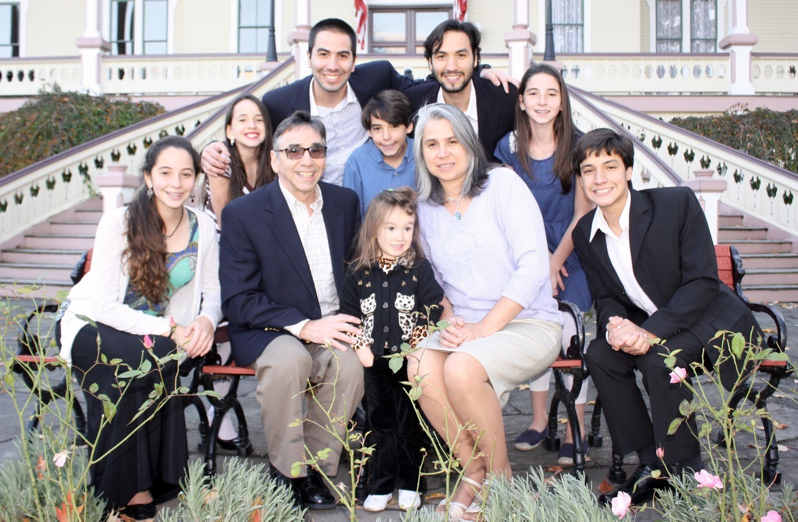

Serving with the Jewish Population

In Sao Paulo, Brazil

Pray about serious financial needs.

MISSIONARY FOR THE MONTH

DAN & VALERIE WOODS

**TEENS TO KINGS ISLAND**

August 12th

See Mark Coleman for ticket information



**DEACON FLOCK MEETINGS**

On or around

August 4th

See your Deacon for details!

**Calendar of Events:**

July 21 Hot Dog Roast @ Dave & Anna’s

July 28 Ladies Planning Meeting 3:30 p.m.

July 30 Gospel Missions

Aug 3 Men’s Breakfast/Devotions

Aug 4 Deacon Flock Meetings

Aug 11 Steve Schenk – AWANA Missionary

Aug 12 Teens to Kings Island

Aug 18 Trustee’s Meeting 3:00

Aug 18 Ladies Hike/Glen Helen

Aug 23 Cedarville Involvement Fair

Aug 23 Overcomer Movie Opens

Aug 25 Young’s Dairy Run

Sep 1 Gary Holtz – Missionary Speaker

Sep 2 Labor Day Holiday

Sep 8 AWANA & Adult Fall Programs begin

Sep 15 Stephen Gruber – Guest Speaker

Sep 22 The Dye Family–Missionary Speaker

Sep 28 OARBC Ladies South Bethel Conv.

Oct 11-13 Ladies Retreat at Skyview Ranch

Oct 13 Trustee’s Meeting 3:00 p.m.

Oct 19 Fall Festival @ Hartong’s home

Oct 29 Gospel Missions

Nov 2 Men’s Breakfast/Devotions

Nov 3 Daylight Savings Time Ends

Nov 13 Annual Church Budget Meeting

**BIRTHDAYS/ANNIVERSARIES**

July 23 Benjamin Hulbert (B)





WOMEN’S RETREAT

September 11 – 13

Skyview Ranch

Great fun, food and fellowship

Activities include: Horseback riding, Bonfires, Ziplines, Giant swing, Shooting and much more.

Sign-up at Skyviewranch.org

FAMILY NIGHT KICK-OFF

September 8 – 5:30 P.M.

AWANA, TEENS, MEN & WOMEN

Plan to be there for a great

launch for our Fall programs!

YOUNG’S DAIRY RUN

Sunday, August 25th

Meet for ice cream at 7:00 p.m. Head out earlier for a great evening of enjoyment: Driving Range, Putt-Putt Golf, Batting Cages, Train, Slide. Have fun and meet at 7:00 p.m.

**LADIES’ HIKE**

Sunday, August 18

@ Glen Helen Park in Yellow Springs

Meet at church 3:30 p.m.

Hike begins at 4:00 p.m.





**Grand Heights Baptist Church**

1611 Armstrong Road

Fairborn, Ohio 45324

937-878-7971

[www.grandheights.org](http://www.grandheights.org)

July 21, 2019

**OUR KNOWABLE GOD**

**Jeremiah 9:23-24**

May 26, 2019

***Our Mission:***

***We exist to glorify God as we help people move closer to Jesus in their spiritual journey.***