**JULY BIRTHDAYS & ANNIVERSERIES**

**July 13 Deanna Bragg (B) July 23 Ben Hulbert (B)**

**July 29 Bob/Thelma Hughes (A) July 29 Ruth Marvin (B)**

**PULPIT COMMITTEE REPORT**

The committee continues its search for a pastoral candidate to bring before the church.  Just recently the committee was considering two applicants and decided that one of them was not the right choice for Grand Heights.  The other was invited to candidate here. However, he opted to candidate at a different church. Although this was very disappointing to the committee, we recognize that God is sovereign over this process as He is over all of creation.  The committee continues its search and is once again seeking qualified applicants. Please continue to pray for wisdom for the committee.

* Pray for safety in travels to Chili, Brazil, Cuba
* Effectiveness of Ministry to Missionaries
* Fruit from preaching and teaching
* Helping out during this Covid 19 need for finances and medical supplies!

***Fix our eyes not on what is seen, but on what is unseen. What is seen is temporary, but what is unseen is eternal. 2 Cor 18* MATTHEW 5:16**

*Welcome to* ***GRAND HEIGHTS***

Welcome to our Sunday Service Today – RAIN or SHINE! In compliance with current safe distancing we are having our indoor/outdoor service. Gary Holtz will be our speaker for this Sunday’s message.You have the option of coming into the church or staying out in your car in the church parking lot for the church message. It will be broadcasted on the 88.1 FM station. To pick up the Audio, you need to have a vehicle with a working FM radio.

A packet of information is available upon arrival. Arrive at 10:15 to allow time to park. Service is scheduled to begin at 10:30. This Indoor/Drive-in service will allow those in our fellowship with health issues to safely come and worship the way they would be most comfortable.

You can also find the Order of Service Packet on the Church Web Site. Go to Grand Heights Baptist Church Fairborn Ohio and print a copy of this Packet. If you have a problem, please contact:

Allan Hartong @ 937-718-0533.

**ABWE – Executive Director for Latin America and the Caribbean**

**Prayer Requests – finances, health for their families & workers.**

1. **FISH –**Big THANKS for our Supplies
2. **Dyes – Ministering in Berlin** – Passport for Steve
3. **Skyview Ranch** – Decided to cancel all Youth Over-night Summer Camp Programs this summer.
4. **Casey Kuang** – Florida ministry to Chinese scholars.
5. **Phil & Becky McDonald** – LEAD ministries to closed door nations, WAR International
6. **Dan & Valerie Woods** – Ministering in Sao Paulo, Brazil
7. **Scott & Nikki Russell** – Helps missionaries by providing resources and daily encouragement

**\* OTHER MINISTRY UPDATES \***

MISSIONARY FOR THE MONTH OF JULY 2020

SCOTT AND NIKKI RUSSELL

***Our Mission: We exist to glorify God as we help people move closer to Jesus in their spiritual journey.***

***Our Mission: We exist to glorify God as we help people move closer to Jesus in their spiritual journey.***

 ***Mission: We exist to glorify God as we help people move closer to Jesus in their spiritual journey.***



IF YOUR FAMILY IS IN NEED IN ANY WAY, PLEASE CONTACT YOUR DEACON OR THE CHURCH OFFICE.

A large sign in a field

Description generated with very high confidence

CALENDAR EVENTS

Tues. – 9:30 a.m. - Ladies Prayer Mtg.

Wed. – 7:00 p.m. – All church Prayer Mtg.

Wed. – July 15 – Church Board Mtg. @ 7:30 p.m.

Sun. - August 16 – Church Board Mtg. after a.m. Service

Wed. – August 19 – Congregational Mtg. at 7:00 p.m.

Ga

**ALL CHURCH**

At this time we have begun to restart the Ladies Tuesday morning prayer time which is at 9:30 a.m. All ladies are welcome. The churches Prayer and Missions time meeting has also been restarted on Wednesday evenings at 7:00 p.m. Everyone is Welcome to participate. During this time period, we are honoring the recommendations of the State of Ohio on the Coronavirus Epidemic. It is not possible at this time to schedule fellowship events. We are using the Multi-purpose Room for our Sunday Morning Services. You also can stay in your parked car and listen on 88.1 FM station.

Gary is our Guest Speaker today. His wife, Betty and he live in the Fairborn area. Even though they retired at the end of 2019 with 43-1/2 years of active service with Baptist Mid Missions, they continue to have a mentoring relationship at Wright State and Cedarville Univesity with students from many countries. Today we WELCOME them.

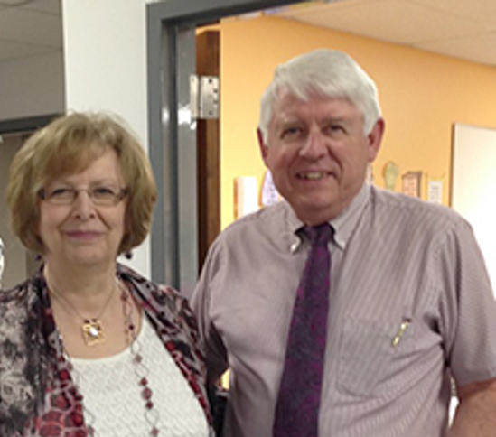

**GUEST SPEAKER TODAY – GARY HOLTZ**

**JULY 12, 2020**

July 12, 2020

**Grand Heights Baptist Church**

**1611 Armstrong Road**

**Fairborn, OH 45324**

**(937)878-7971**

**E-mail: ghbcnet@grandheights.org**