**JUNE/JULY BIRTHDAYS AND ANNIVERSARIES**

**Jun 30 Charles/Whitney Prichard(A) July 2 Bob Hughes (B)**

**July 2 Gretchen Hartong (B) July 4 Charles Prichard (B)**

**July 8 Katelyn Suter (B) July 13 Deanna Bragg (B) July 29 Bob/Thelma Hughes (A) July 29 Ruth Marvin (B)**

***Our Mission: We exist to glorify God as we help people move***

***Closer to Jesus in their spiritual journey.***

***WELCOME TO******GRAND HEIGHTS***

**Welcome to our Sunday Service Today – RAIN or SHINE! In compliance with current safe distancing we are continuing our indoor/outdoor service. You have the option of coming into the church or staying in your car in the church parking lot for the church message. It will be broadcasted on the 88.7 FM station.**

**An Order Of Service packet is available upon arrival. Arrive at 10:15 to allow time to park. Service is scheduled to begin at 10:30.**

**If you are visiting with us today for the first time and you are inside, please register at our Welcome Center.**

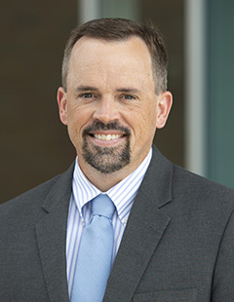

**DR. JASON LEE**

**INTERIM PASTOR**

**Sunday Morning Service**

**June 20th at**

**10:30 A.M.**

**Christ Is Everything Colossians 1:15-20**

**PRAISES FOR THE PAST MONTHS**

* **Good attendance, in person and online with a few visitors and new couples.**
* **Steve was at Word of Life Bible Institute Germany, teaching.**
* **The women’s Bible study was attended (over Zoom) by 15 women from 10 countries.**
* **Meeting one on one with some members of their congregation.**



Executive Director for Latin America and the Caribbean

**PFP at Lunch**

**Pray for a Pastor at Lunch**

**Please pray each day at lunch for a new pastor and for wisdom for the Pulpit   
Committee as it conducts the search on behalf of the church.**



**PULPIT COMMITTEE REPORT**

**At the present time, the Pulpit Committee is looking at a potential**

**applicant. The Committee has had several phone interviews with this individual. Please continue to pray that the search by the**

**Committee will have a positive outcome.**

**YOUTH SUMMER ACTIVITIES @ THE PRICHARDS**

**All at 6:00-9:00 pm - July 9th; August 6th; September 10th**

**MISSIONARIES FOR THE MONTH OF JUNE**

**STEVE AND BECKY DYE – MISSIONARIES IN GERMANY**

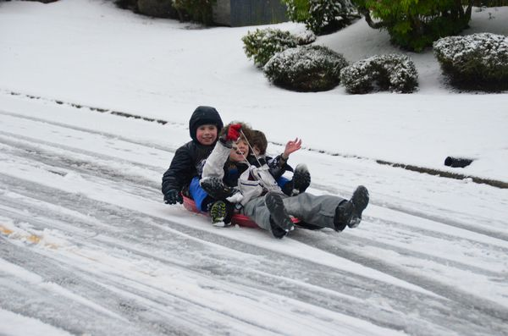

IF YOUR FAMILY IS IN NEED IN ANY WAY, PLEASE CONTACT YOUR DEACON OR THE CHURCH OFFICE.

JUNE 27, 2021

CALENDAR EVENTS

Tues – 9:30 am - Ladies Prayer Mtg.

Wed – 7:00 pm – Prayer Meeting

Sun – June 27 – Sunday School @ 9:15 a.m.

Sun – June 27 – Sunday Morning Worship Service @ 10:30

Sun – June 27 – Communion

Tue – June 29 – Dayton Gospel – Meet at the church 5p.m.

Sun – July 4 - Holiday – No evening activities

Fri – July 9 – Youth Activity @ the Prichard’s Home

Wed – July 14 – Board Meeting @ 7:30 pm

Sun – July 25 - Communion

**THANK YOU TO THE PEOPLE WHO HAVE BEEN WORKING ON THE LANDSCAPING IN THE PARKING AREA AND CLEARING OUT THE WEEDS IN THE FLOWER BEDS, TRIMMING TREES AND BUSH AREA.**



**DINNER FOR DAYTON GOSPEL MISSIONS**

**WHEN: Tuesday, June 29 – Meet here at the church @**

**5:00 P.M.**

**WHAT: Serving meals and cleaning up following the dinners that are served that evening.**

**CONTACT: Let Allan Hartong know that you are available to help. His phone number is 937-718-0533**

**Grand Heights Baptist Church**

**1611 Armstrong Road**

Fairborn, OH 45324

**(937)878-7971**

**E-mail: ghbcnet@grandheights.org**