**Summer Activities** are currently being planned so please save these dates:

June 17-29 Campers to Skyview Ranch

July 7 Ice Cream Social @ the Church

July 21 Hot Dog Roast at Dave and Anna’s

August 4 Deacon Flock Meetings

August 25 End of Summer - Young’s Run

Please continue to **Pray for the Pulpit Committee** as they continue to look at resume’s and interview potential candidates for our next Senior Pastor. Pray for wisdom and unity!

***Welcome to Grand Heights!***

*We are glad you are here with us this morning! You will find Grand Heights to be a friendly and diverse community of people dedicated to impacting our community and the world with the Gospel of Jesus Christ!*



[](https://www.bing.com/images/search?view=detailV2&ccid=t88%2bPWPO&id=7387F37954BB639828A4D3B1A27DE64F4B65B8D9&thid=OIP.t88-PWPOwCEyuok48hEHYgHaFL&mediaurl=https://iscrapapp.com/wp-content/uploads/2014/05/pennies-for-scrap.jpg&exph=716&expw=1024&q=picture+of+pennies&simid=608025402043271171&selectedIndex=0)

A special thank you to everyone who worked or provided support items for this years Vacation Bible School. It was a great week.

Total Registered 60

Food For Fish 614 Items

Our Sympathy

To Kyle and Vicki Smith on the passing of Vicki’s Father on June 4th. The funeral was in Texas. Please pray for the family.

**There Are Still A Number** of tasks needing to be done throughout the Church. See Steve Bachowski for the details.

**Missionaries are coming!** Several missionaries will be visiting us the next few months! Save the dates:

June 23 – Dustan Horst August 11 – Steve Schenk

Sept 1 – Gary Holtz September 22 – the Dyes.

**Teens:** Be planning early for our trip to Kings Island on August 12th. Ticket purchases will begin August 4th!

**Dustan Horst** will be with us next week and sharing in the Morning Service. Dustan is our missionary to teens with Word of Life.

**Pastor and Diane** will be camping on Kelly’s Island with their family, the week of June 23 - 28. If you have a need, please call a Deacon.

Verse of the Week:

1 Samuel 20:4

**4**Jonathan said to David, “Whatever you want me to do, I’ll do for you.”

**LEAD**

Be in prayer for those in leadership as they minister to us – Board Members: Treasurer – Bob Sudduth, CE – Deb Jones, Missions – Cindy Sudduth, Financial Secretary – Mary Hulbert, Church Clerk – Rachele Bachowski.

**SERVE**

This month is one of our Food for FISH collections. Vacation bible School has gotten us off to a great start. Plan to bring your food items in by the 30th. Can we top the previous Vacation Bible School Total?

**GROW**

Be sure to check out our Growth Group Bible Studies this week!

Ladies: Tuesday 9:30 at the Church

Men: Tuesday 7:30 at the Fairborn McDonalds

Men: Thursday 7 PM at the Church

Couples: Thursday 7 PM at the Pensworth’s

**CONNECT**

This morning Pastor will be sharing a message about the unique relationship between Jonathan and David. We learn that the role of influencer is given to each of us . . . . . especially men.

Mission Project for VBS:

**FISH Food Pantry**

Accepting Food and Cash Donations!

[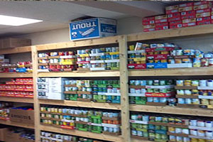](https://www.foodpantries.org/li/fish-fairborn)



Ladies Dinner Out

Saturday, July 15th

@ 6:00 pm

Cherry House Café

1241 Meadowbridge Drive

Beavercreek, OH

ICE CREAM SOCIAL

July 7th @ 6:00 pm

At the Church

Please bring your favorite ice cream to share.

Also be sure to invite others to join you!

This is a great activity for inviting others!







Dave and Anna

Pensworth’s Home

Come and bring your friends and side dishes.

This will be a great night of Fellowship for all of us.

Please plan to attend!

Today is Father’s Day

Each man at church this morning will be honored and challenged to be

the man God calls

each of us to be!

Happy Father’s Day

to each of you.



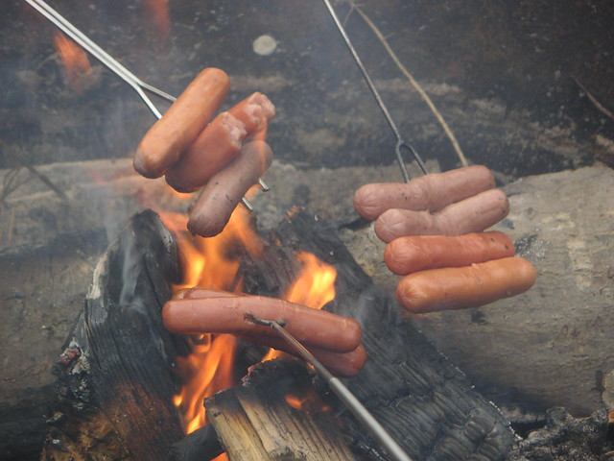

HOT DOG ROAST

July 21 @ 6:00 P

**Grand Heights Baptist Church**

1611 Armstrong Road

Fairborn, Ohio 45324

937-878-7971

[www.grandheights.org](http://www.grandheights.org)

June 16, 2019

May 26, 2019

LIKE A FATHER. . . . .

JONATHAN

HAPPY FATHERS DAY

**BIRTHDAYS/ANNIVERSARIES**

June 16 Rich Henry (B)

June 20 Beth Hetzel (B)

June 20 Greg & Melinda Dierker (A)

June 21 Titus Hartong (B)

June 21 Nathan Hartong (B)

**Calendar of Events:**

June 1-30 FISH Donations

June 17-29 Campers to Skyview Ranch

June 23 Dustan Horst – Guest Missionary

July 4 Holiday – Church No Activities

July 6 Men’s Breakfast/Devotions

July 7 Ice Cream Social @ Church 6:00 PM

July 15 Ladies Dinner Out

July 21 Hot Dog Roast @ Dave & Anna’s

July 30 Gospel Missions

Aug 3 Men’s Breakfast/Devotions

Aug 4 Deacon Flock Meetings

Aug 5 Ladies Hike

Aug 11 Steve Schenk – Awana Missionary

Aug 12 Teens to Kings Island

Aug 16-17 Women of Joy Conference/Indiana

Aug 23 Overcomer Movie Opens

Aug 25 Youngs Run

Sep 1 Gary Holtz – Guest Missionary

Sep 2 Labor Day Holiday

Sep 8 Awana & Family Kick Off Night

Sep 15 Steve Gruber – Guest Missionary

**Youth BBQ Kick Off**

Sep 15 Steve Gruber – Guest Missionary

***Our Mission:***

***We exist to glorify God as we help people move closer to Jesus in their spiritual journey.***

A person standing in front of a sunset

Description generated with very high confidence