

**PULPIT COMMITTEE REPORT**

The Comimittee continues its search for a pastoral candidate to bring before the church. At the moment we have some applicants that we are still considering. We plan to hear them speak, maybe in June. Then a decision will be made whether either will be invited to candidate. Please continue to pray for wisdom for the committee and for an end to the coronavirus.

**ABWE - Regional Director of**

**Middle East and North Africa**

**Prayer Requests – finances, health for their families & workers.**

1. **FISH –**Big THANKS for our Supplies
2. **Dyes – Ministering in Berlin** but currently in U.S.
3. **Skyview Ranch** – Decided this week to cancel all Youth Summer Camp Programs this summer.
4. **Casey Kuang** – Florida ministry to Chinese scholars.
5. **Phil & Becky McDonald** – LEAD ministries to closed door nations, WAR International
6. **Dan & Valerie Woods** – Ministering in Sao Paulo, Brazil
7. **Steve & Pam Schenk** – Planning their Retirement from AWANA as of July 31st.

**\* OTHER MINISTRY UPDATES \***

***Let your light shine before others, that they may see your good deeds and glorify your Father in heaven.* MATTHEW 5:16**

* Safe August trip to Berlin for Steve Becky, and Zach.
* Pray for Lord’s protection during Covid pandemic.
* Pray for valuable time with family and profitable completion of furlough in U.S.
* Pray for Steve’s new role.

MISSIONARY FOR THE MONTH OF JUNE 2020

STEVE AND BECKY DYE

**JUNE BIRTHDAYS & ANNIVERSERIES**

**June 16 Rich Henry (B) June 20 Beth Hetzel (B)**

**June 21 Nathan Hartong (B) June 21 Titus Hartong (B)**

**June 23 Dave & Anna Pensworth (A)**

**June 24 Cindy Sudduth (B)**

**June 25 Alan & Vicki Lair (A) June 28 Ken & Mary Hulbert (A)**

*Welcome to* ***GRAND HEIGHTS***

Welcome to our Drive-In Sunday Service Today – RAIN or SHINE! In compliance with current safe distancing we are having an outdoor Service. Kevin A. Pierpont will be our guest speaker. To pick up the Audio,you need to have a vehicle with a working FM radio.

A packet of information is available upon arrival. Several men will direct you to park. Please do not allow anyone to leave their vehicle. The building is closed to the public as we cannot make arrangements to keep everyone safe. Arrive at 10:20 to allow time to park. Service is scheduled to begin at 10:30. This Drive-in service will allow those in our fellowship with health issues to safely come and worship together.

You can also find the Order of Service Packet on the Church Web Site. Go to Grand Heights Baptist Church Fairborn Ohio and print a copy of this Packet. If you have a problem, please contact:

Allan Hartong @

(937-718-0533).

***Our Mission: We exist to glorify God as we help people move closer to Jesus in their spiritual journey.***

***Our Mission: We exist to glorify God as we help people move closer to Jesus in their spiritual journey.***

 ***Mission: We exist to glorify God as we help people move closer to Jesus in their spiritual journey.***



ALL ACTIVITES ARE HELD AT THIS TIME HONORING THE RECOMMENDATIONS OF THE STATE OF OHIO ON THE CORONAVIRUS EPIDEMIC – IF YOUR FAMILY IS IN NEED IN ANY WAY, PLEASE CONTACT YOUR DEACON OR THE CHURCH OFFICE.

**ALL CHURCH**

At this time we have no scheduled activities. We are honoring the recommendations of the State of Ohio on the Coronavirus Epidemic. It is not possible at this time to schedule events but we are planning to

set up the Multi-purpose Room for

our Sunday Morning Services beginning.

June 21st. We will follow the

State suggestions for arranging seating.

A large sign in a field

Description generated with very high confidence

**Kevin & Carolyn have 8 children, 2 of them still live at home. They have 1 daughter, 7 sons – 2 live at home, 3 daughter-in-laws, 3 cute granddaughters, and 1 handsome grandson.**

**GUEST SPEAKER – Kevin A. Pierpont**

**JUNE 14, 2020**

Kevin Pierpont serves as Facilities Care Team Leader at Camp Barakel in Fairview, Michigan. He holds a Bachelor of Religious Education degree from Calvary Christian College and Seminary in South Bend, Indiana. He has served as senior pastor of First Baptist Chuch in Mt. Pleasant, Michigan, 2014-2017, and as senior pastor of Higgins Lake Baptist Church in Higgins Lake, Michigan from 2003 to 2014.

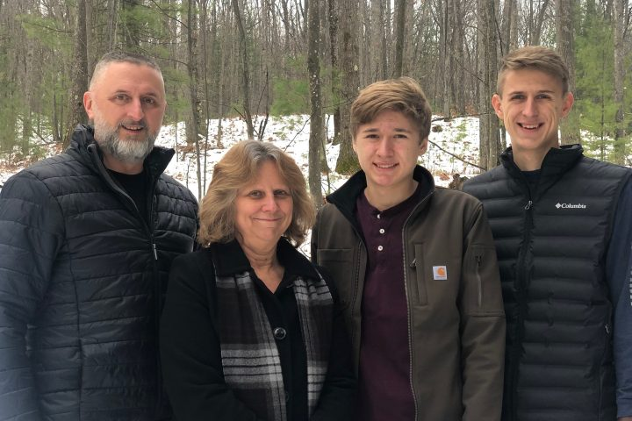

June 14, 2020

**Grand Heights Baptist Church**

**1611 Armstrong Road**

**Fairborn, OH 45324**

**(937)878-7971**

**E-mail: ghbcnet@grandheights.org**