**MAY BIRTHDAYS & ANNIVERSERIES**

**May 20 Brendon Dierker (B)**

**May 21 Drake Pensworth (B)**

**May 22 Mark Fischer (B)**

**May 26 Braden Hetzel (B)**

**AWANA Missionaries for OHIO**

**PULPIT COMMITTEE REPORT**

The Comimittee continues its search for a pastoral candidate to bring before the church. We had expected to conduct an interview but we were prevented from doing so because of restrictions due to the virus. At the moment we have two applicants that we are still considering. We hope to hear both speak, maybe in June. Then a decision will be made whether either will be invited to candidate. Please continue to pray for wisdom for the committee and for an end to the coronavirus.

*Welcome to* ***GRAND HEIGHTS***

Welcome to our Drive-In Sunday Service Today – RAIN or SHINE! In compliance with current safe distancing we are having an outdoor Service. Randy Tate will be our speaker. You need to have a vehicle with a working FM radio. A packet of information is available upon arrival. Several men will direct you to park. Please do not allow anyone to leave their vehicle. The building is closed to the public as we cannot make arrangements to keep everyone safe. Arrive at 10:20 to allow time to park. Service is scheduled to begin at 10:30. This Drive-in service will allow those in our fellowship with health issues to safely come and worship together. You can also find the Order of Service Packet on the Church Web Site. Go to Grand Heights Baptist Church Fairborn Ohio and print a copy of this Packet. If you have a problem, please contact:

Allan Hartong @

(937-718-0533).

Prayer Requests

1. **FISH –** This spring has been a very difficult time for many. Some have lost their loved ones, lost their jobs or have been layed off until the quarantine is lifted. Children have not completed their school year because schools are closed. Many in the medical field have risked their lives and are working many hours and still are very susceptible to the disease. Just helping with the food shortage can be helpful to them. So please help in this small way by bringing in non-perishable foods. It will be delivered at the end of May.
2. **Russells** – Pray for their work and the many missionaries they oversee in Latin America. Because of Coronavirus they are working on line and very busy with crisis management.

**\* OTHER MINISTRY UPDATES \***

**“I have set the LORD always before me. Because He is at my right hand, I will not be shaken.” Psalm 16:8**

Pray for:

* Clubs unable to finish the year in person
* Plans for fall clubs
* Financial support
* Ministries to churches
* Safety in travel

***Our Mission: We exist to glorify God as we help people move closer to Jesus in their spiritual journey.***

***Our Mission: We exist to glorify God as we help people move closer to Jesus in their spiritual journey.***

 ***Mission: We exist to glorify God as we help people move closer to Jesus in their spiritual journey.***

MISSIONARY FOR THE MONTH OF MAY 2020

STEVE AND PAM SCHENK



ALL FOLLOWING ACTIVITES ARE HELD AT THIS TIME HONORING THE RECOMMENDATIONS OF

THE STATE OF OHIO ON THE CORONAVIRUS EPIDEMIC – IF YOUR FAMILY IS IN NEED IN ANY WAY, PLEASE CONTACT YOUR DEACON OR THE CHURCH OFFICE.

There will be a Drive-In Trunk Wedding Shower for Bethany Fisher and Drake Pensworth after the morning Drive-In Service May 24th. At the end of the service their car trunk will be open for depositing gifts, cards, recipes, advice and for guests to take a treat. You give your best wishes to Bethany and Drake from 6 feet away. We ask you to bring on 3X5 cards 1)a recipe and 2)a verse or note of encouragement or advice. All ladies are encouraged to participate! Contact Cindy (937-478-7886) or Mary (937-901-6614) with questions.

ALL CHURCH

May 17th @ 10:30 – Morning Drive-In Service

Arrive by 10:20 a.m.

May 24th – Trunk Wedding Shower for Bethany/Drake

May 27th @ 7:00 p.m. – Meeting

Annual Business/Elections Meeting

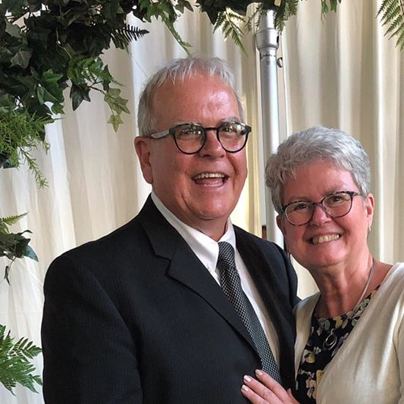

Randy and Janet Tate

**Guest Speaker – RANDY TATE**

**May 17, 2020**

**Grand Heights Baptist Church**

**1611 Armstrong Road**

**Fairborn, OH 45324**

**(937)878-7971**

**E-mail: ghbcnet@grandheights.org**

May 17, 2020