**AWANA Missionaries for OHIO**

**JUNE BIRTHDAYS & ANNIVERSERIES**

**June 4 Kathy Rudy (B) June 4 Kyle/Vicki Smith (A)**

**June 7 Warren/Ann Tate (A) June 10 Lucas Dierker (B)**

**June 11 Anna Pensworth (B)**

**June 12 Rick/Laura Pensworth (A) – 60th Anniversary**

**PULPIT COMMITTEE REPORT**

The Comimittee continues its search for a pastoral candidate to bring before the church. We had expected to conduct an interview but we were prevented from doing so because of restrictions due to the virus. At the moment we have two applicants that we are still considering. We hope to hear both speak, maybe in June. Then a decision will be made whether either will be invited to candidate. Please continue to pray for wisdom for the committee and for an end to the coronavirus.

*Welcome to* ***GRAND HEIGHTS***

Welcome to our Drive-In Sunday Service Today – RAIN or SHINE! In compliance with current safe distancing we are having an outdoor Service. Jonathan Dingledine will be our speaker. You need to have a vehicle with a working FM radio.

A packet of information is available upon arrival. Several men will direct you to park. Please do not allow anyone to leave their vehicle. The building is closed to the public as we cannot make arrangements to keep everyone safe. Arrive at 10:20 to allow time to park. Service is scheduled to begin at 10:30. This Drive-in service will allow those in our fellowship with health issues to safely come and worship together.

You can also find the Order of Service Packet on the Church Web Site. Go to Grand Heights Baptist Church Fairborn Ohio and print a copy of this Packet. If you have a problem, please contact:

Allan Hartong @

(937-718-0533).

**Prayer Requests – finances, health for their families & workers.**

1. **FISH –**Just helping with the food shortage can be helpful to the neighboring families in this area. So please help in this small way by bringing in non-perishable foods. Following our last service in May, donations will be accepted that day and delivered that week.
2. **Dyes – Ministering in Berlin** but currently in U.S.
3. **Skyview Ranch** – Decided this week to cancel all Youth Summer Camp Programs this summer.
4. **Casey Kuang** – Florida ministry to Chinese scholars.
5. **Phil & Becky McDonald** – LEAD ministries to closed door nations, WAR International
6. **Dan & Valerie Woods** – Ministering in Sao Paulo, Brazil

**\* OTHER MINISTRY UPDATES \***

**“I have set the LORD always before me. Because He is at my right hand, I will not be shaken.” Psalm 16:8**

Pray for:

* Clubs unable to finish the year in person
* Plans for fall clubs
* Financial support
* Ministries to churches
* Safety in travel

***Our Mission: We exist to glorify God as we help people move closer to Jesus in their spiritual journey.***

***Our Mission: We exist to glorify God as we help people move closer to Jesus in their spiritual journey.***

 ***Mission: We exist to glorify God as we help people move closer to Jesus in their spiritual journey.***

MISSIONARY FOR THE MONTH OF MAY 2020

STEVE AND PAM SCHENK



ALL ACTIVITES ARE HELD AT THIS TIME HONORING THE RECOMMENDATIONS OF THE STATE OF OHIO ON THE CORONAVIRUS EPIDEMIC – IF YOUR FAMILY IS IN NEED IN ANY WAY, PLEASE CONTACT YOUR DEACON OR THE CHURCH OFFICE.

ALL CHURCH

At this time we have no scheduled activities. We are honoring the recommendations of the State of Ohio on the Coronavirus Epidemic. It is not possible at this time to schedule events and we are hoping that

in the near future we will be able to have our

Services inside the church while also following

State suggestions for seating.

WEDNESDAY EVENING, May 27 at 7:00 p.m., the church membership voted on the election of Board

Members for the 2020-2021 year. The following

People were elected for the coming terms.

Deacons – Mark Coleman; Bob Sudduth

Trustees – Steve Bachowski; Drake Pensworth

Missions Director – Anna Pensworth

Financial Secretary – Mary Hulbert

Christian Education Director – Cindy Sudduth

A large sign in a field

Description generated with very high confidence

**GUEST SPEAKER – Jonathan Dingledine**

**May 31, 2020**

"We welcome **Jonathan Dingeldine** to our pulpit today.  Jonathan serves as a pastoral intern at Calvary Baptist Church in Covington, KY.  He has a B.S. in Bible fromClarks Summit University and is working on  a  Master of Divinity degree from Baptist Bible Seminary in Clarks Summit, Pennsylvania.

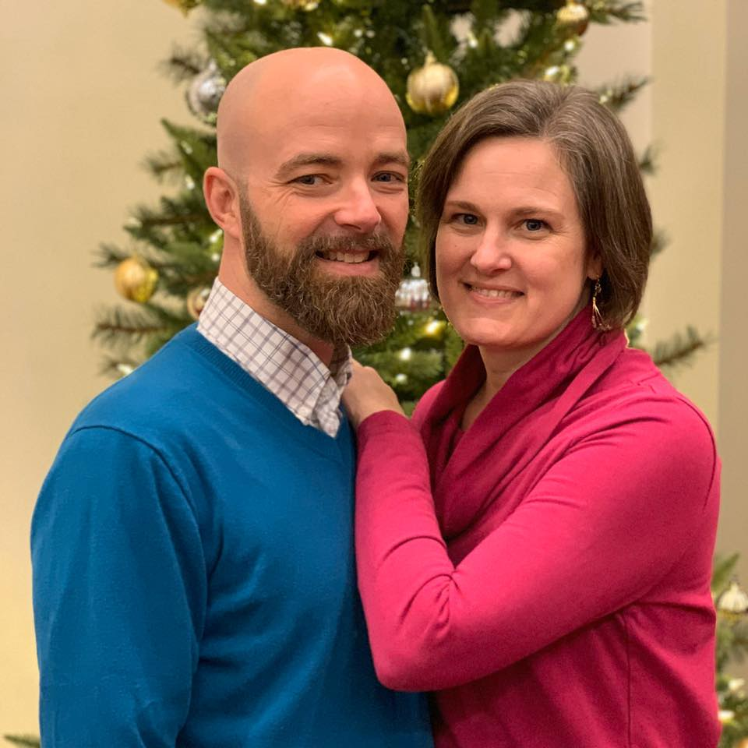

**Grand Heights Baptist Church**

**1611 Armstrong Road**

**Fairborn, OH 45324**

**(937)878-7971**

**E-mail: ghbcnet@grandheights.org**

May 31, 2020