**ADULT SUNDAY MORNING BIBLE FELLOWSHIP**

**Gospel of Mark (Chapter One) Sunday @ 9:15 a.m. – Room 301**

**Pulpit Committee Report**

**The committee continues to seek a pastoral candidate to bring before the church. Please pray for discernment for the committee as it carries out this most important work.**



**2021 Annual Election Meeting / Nominating Committee**

The Annual Election will be in May. A Nominating Committee has been appointed and they are: Alan Lair, Committee Chairman; Allan Hartong; Brendon Dierker; Beth Hetzel; & Kathy Rudy. The committee will be seeking candidates for several positions.

**AWANA - MISSIONARIES FOR THE MONTH OF MAY**

**MIKE & KRIS REED**

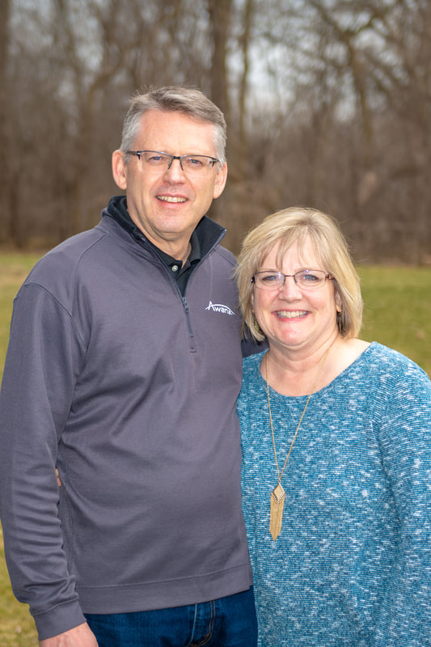

Executive Director for Latin America and the Caribbean

**Our Mission  
The vision and driving passion of Awana are that all children and youth will come to know, love and serve the Lord Jesus Christ. Awana missionaries carry out this vision through relationships with local churches. They assist local church leaders to develop and lead  
ministries related to children and youth in a way that works in their particular setting.**

***WELCOME TO******GRAND HEIGHTS***

**Welcome to our Sunday Service Today – RAIN or SHINE! In compliance with current safe distancing AND wearing face masks, we are having our indoor/outdoor service. You have the option of coming into the church or staying in your car in the church parking lot for the church message. It will be broadcasted on the 88.7 FM station.**

**An Order Of Service packet is available upon arrival. Arrive at 10:15 to allow time to park. Service is scheduled to begin at 10:30.**

**If you are visiting with us today for the first time and you are inside, please register at our Welcome Center.**

**MAY Birthdays and Anniversaries**

**May 2 Alan Lair (B) May 15 Dave & Teresa Burk (A)**

**May 20 Brendon Dierker(B) May 21 Drake Pensworth (B)**

**May 22 Mark Fischer (B) May 26 Braden Hetzel (B)**

**Apr 20 George/Shirley Barrett**

**DR. JASON LEE**

**INTERIM PASTOR**

**Sunday Morning Service**

**May 2nd at**

**10:30 A.M.**



**LADIES BIBLE STUDY - Mondays @ 7:00 P.M.**

**A Bible Study by Kay Arthur & Pete DeLacy “TRUSTING GOD IN TIMES OF ADVERSITY”**

**You must wear a face mask and**

**seating is in compliance with current safe distancing!**

***Our Mission: We exist to glorify God as we help people move***

***Closer to Jesus in their spiritual journey.***

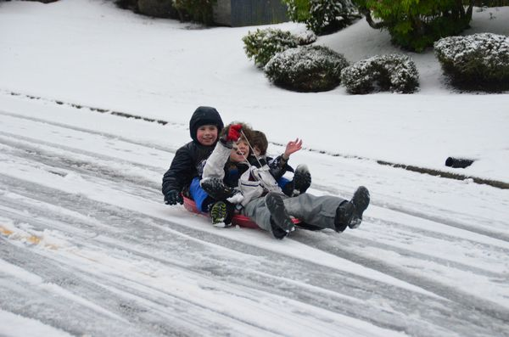

MAY 2, 2021

IF YOUR FAMILY IS IN NEED IN ANY WAY, PLEASE CONTACT YOUR DEACON OR THE CHURCH OFFICE.

CALENDAR EVENTS

Tues – 9:30 am - Ladies Prayer Mtg.

Sun – May 2– Sunday School @ 9:15 a.m.

Sun – May 2 – Sunday Morning Worship Service @ 10:30

Sun - May 2 – Teens Night @ 5:30 p.m.

Sun – May 2 – Awana Awards Night @ 5:30 p.m.

Mon – May 3 – Ladies Bible Study @ 7:00 p.m.

Wed – May 5 – Missions Prayer Meeting @ 7:00 pm

Thur – May 6 – Men’s Small Group Mtg @ 7:00 pm

Sun – May 9 – Mother’s Day

Wed – May 12 – Church Board Meeting @ 7:30 pm

Wed – May 19 – Congregational Quarterly @ 7:00 pm

Annual Election Meeting

**May 1st thru**

**May 31st**

**Please help out in this way so that others who are in need can get through these trying times. Grocery bags and boxes are located in the hallway across from the kitchen. Please put your non-perishable items in these containers.**



**TONIGHT IS THE LAST MEETING FOR THIS SEASONS AWANA! IT IS AWARDS NIGHT.**

**SEPTEMBER 12TH IS THE FALL OPENER!**



**THE AWANA CLUBS OF GRAND HEIGHTS BAPTIST CHURCH**

**Meets on Sunday Nights**

**@ 5:30 p.m.**

**Pre K – 6th Grades**

**AWANA Clubs of GHBC**

**Grand Heights Baptist Church**

**1611 Armstrong Road**

Fairborn, OH 45324

**(937)878-7971**

**E-mail: ghbcnet@grandheights.org**