**Summer Activities** are currently being planned so please save these dates:

June 10-14 VBS

June 17-29 Campers to Skyview Ranch

July 7 Ice Cream Social

July 21 Hot Dog Roast at Dave and Anna’s

August 4 Deacon Flock Meetings

August 25 End of Summer - Young’s Run

Please continue to **Pray for the Pulpit Committee** as they continue to look at resume’s and interview potential candidates for our next Senior Pastor. Several members are visiting a potential candidate this weekend.

***Welcome to Grand Heights!***

*We are glad you are here with us this morning! You will find Grand Heights to be a friendly and diverse community of people dedicated to impacting our community and the world with the Gospel of Jesus Christ!*

**VACATION BIBLE SCHOOL**

**JUNE 10-14**

**9 AM - NOON**

[](https://www.bing.com/images/search?view=detailV2&ccid=t88%2bPWPO&id=7387F37954BB639828A4D3B1A27DE64F4B65B8D9&thid=OIP.t88-PWPOwCEyuok48hEHYgHaFL&mediaurl=https://iscrapapp.com/wp-content/uploads/2014/05/pennies-for-scrap.jpg&exph=716&expw=1024&q=picture+of+pennies&simid=608025402043271171&selectedIndex=0)

**SERVE**

Vacation Bible School is June 10-14 (see the information on the right column). Deb Jones is now recruiting workers and helpers. Sign up on the Serve board. Volunteer TODAY to impact lives for eternity.

**GROW**

Be sure to check out our Growth Group Bible Studies this week!

Ladies: Tuesday 9:30 at the Church

Men: Tuesday 7:30 at the Fairborn McDonalds

Men: Thursday 7 PM at the Church

Couples: Thursday 7 PM at the Pensworth’s

**CONNECT**

This morning Pastor will be continuing our study on the qualifications of a Pastor from 1 Timothy 3. This week we will be examining respectable, hospitable, and able to teach as our next virtues.

**Dirty Pennies** are needed for a science experiment during VBS. If you can contribute some, please leave them in the container near the kitchen. Afterwards we will put them toward the VBS offering.

**There Are Still a Number** of tasks needing to be done throughout the Church. See Allan Hartong for the details.

**A SPECIAL THANK YOU** to all who helped last Saturday at our Workday and on Tuesday evening the Ladies Planting of Flowers. We accomplished a lot. Thank You!

**Missionaries Are Coming!** Several missionaries will be visiting us the next few months! Save the dates:

June 24th – Dustan Horst August 11th Steve Schenk

Sept 1st – Gary Holtz Sept 22 – The Dyes



**LEAD**

Be in prayer for those in leadership as they minister to us – Deacons: Alan Lair, Mark Coleman, Dave Pensworth, Bob Sudduth, Allan Hartong and Rick Pensworth

**Help Needed:**

Decorations – May 31 & June 9

Game Director

Team Coaches K-1 & 2-3

Team Assistants

Food Donations

Craft Supply Donations

**Sign up on the Serve Board Today**

**Verse of the Week:**

**1 Timothy 3:2**

**Now the overseer must be above reproach, the husband of but one wife, temperate, self-controlled, respectable, hospitable, able to teach,**

Mission Project for VBS:

**FISH Food Pantry**

Accepting Food and Cash Donations!

[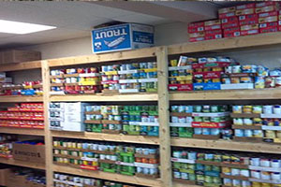](https://www.foodpantries.org/li/fish-fairborn)



Pastor Waldo is reducing

the size of his library. On the

table in the MPR are books

by Charles Swindoll, Charles

Stanley, David Jeremiah and

Tony Evans. Books are free

donations accepted.

LADIES HIKE – June 2nd

Charleston Falls Preserve

2535 Ross Road - Tipp City

Carpool at the Church 4PM

Others at the park 4:30 PM

Questions? Contact

Rachele @ (937) 609-9117

Kathy @ (937) 765-0477

**TODAY’S GRADUATION PARTIES:**

Ben Hulbert - 12:30–4:00 @ Hulbert’s Home

Madison Prosser – 2-5:00 @ Bath Twp. Park

Alison Bachowski – 5-8:00 @ Grand Heights

**BE SURE TO CONGRATULATE** **OUR GRADUATES AS THEY MOVE TO THE NEXT**

**PHASE OF THEIR LIVES!**

**Calendar of Events:**

May 26 Ben, Madison, Alison Grad. Parties

May 27 Memorial Day

May 29 VBS Decorations (Dinner Provided)

June 1-30 FISH Donations

June 1 Men’s Breakfast/Devotions

June 2 Ladies Hike

June 9 VBS Final Decorations

June 10-14 Vacation Bible School

June 16 Father’s Day – No PM Activity

June 17-29 Campers to Skyview Ranch

July 4 Holiday – Church No Activities

July 6 Men’s Breakfast/Devotions

July 7 Ice Cream Social

July 15 Ladies Dinner Out

July 21 Hot Dog Roast @ Dave & Anna’s

July 30 Gospel Missions

Aug 3 Men’s Breakfast/Devotions

Aug 5 Ladies Hike

Aug 16-17 Women of Joy Conference/Indiana

**BIRTHDAYS/ANNIVERSARIES**

May 26 Braden Hetzel (B)



Qualifications for Being A Pastor:

“RESPECTABLE, HOSPITABLE,

ABLE TO TEACH”

May 26, 2019

May 26, 2019

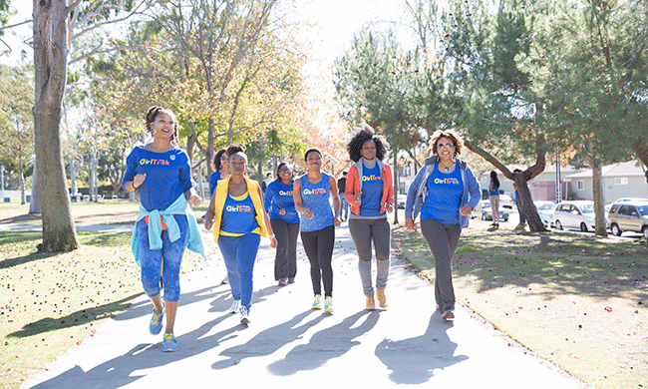

**Graduation Sunday is June 2nd**

We will be honoring our High School and College graduates on that day!

High School College

Alison Bachowski Brandon Hulbert

Rachael Hartong Josh Burk

Ben Hulbert

Madison Prosser

***Our Mission:***

*We exist to glorify God as we help people move closer to Jesus in their spiritual journey.*

[](https://www.bing.com/images/search?view=detailV2&ccid=QCqWndUC&id=6DCA54A2202A8C3423113B41597E1F1602F996B2&thid=OIP.QCqWndUCBA-bnNZdkeRJEgHaEo&mediaurl=http://i.telegraph.co.uk/multimedia/archive/01950/lib_1950367b.jpg&exph=388&expw=620&q=free+pictures+of+library+books&simid=608024220927462867&selectedIndex=0)

**Grand Heights Baptist Church**

1611 Armstrong Road

Fairborn, Ohio 45324

937-878-7971

www.grandheights.org