**PFP at Lunch**

**Pray for a Pastor at Lunch**

**Please pray each day at lunch for a new pastor and for wisdom for the Pulpit   
Committee as it conducts the search on behalf of the church.**

**MAY & JUNE BIRTHDAYS AND ANNIVERSARIES**

**May 26Braden Hetzel (B) Jun 4 Kyle/Vicki Smith (A)**

**Jun 4 Kathy Rudy (B) Jun 10 Lucas Dierker (B)**

**Jun 11 Anna Pensworth (B) Jun 11 Kyle Upshaw (B)**

**Jun 12 Dominic Prichard(B)Jun 12 Rick/Laura Pensworth (A)**

**Jun 14 Teddy Stark (B) Jun 16 Rich Henry (B)**

**Jun 20 Beth Hetzel (B) Jun 20 Greg/Mel Dierker (A)**

**Jun 21 Nathan Hartong (B) Jun 21 Titus Hartong (B)**

**Jun 23 Dave/Anna Pensworth (A) Jun 24 Cindy Sudduth (B)**

**Jun 25 Alan/Vickie Lair (A) Jun 30 Charles/Whitney Prichard (A)**

***WELCOME TO******GRAND HEIGHTS***

**Welcome to our Sunday Service Today – RAIN or SHINE! In compliance with current safe distancing AND wearing face masks, we are having our indoor/outdoor service. You have the option of coming into the church or staying in your car in the church parking lot for the church message. It will be broadcasted on the 88.7 FM station.**

**An Order Of Service packet is available upon arrival. Arrive at 10:15 to allow time to park. Service is scheduled to begin at 10:30.**

**If you are visiting with us today for the first time and you are inside, please register at our Welcome Center.**



**DR. JASON LEE**

**INTERIM PASTOR**

**Sunday Morning Service**

**May 23rd at**

**10:30 A.M.**



**Open House Invitation for Braden Hetzel’s Graduation Party**

**Saturday, June 5, 2021,1:00-4:00 p.m.**

**Grand Heights Baptist Church**

**1611 Armstrong Road**

**Fairborn, OH 45324**

**Please help us celebrate the graduation of Braden Hetzel**

**from Wayne High School.**

**YOUTH SUMMER ACTIVITIES @ THE PRICHARDS (Tentative Dates)**

**All at 6:00-9:00 pm - July 9th; August 6th; September 10th**

**AWANA - MISSIONARIES FOR THE MONTH OF MAY**

**MIKE & KRIS REED**

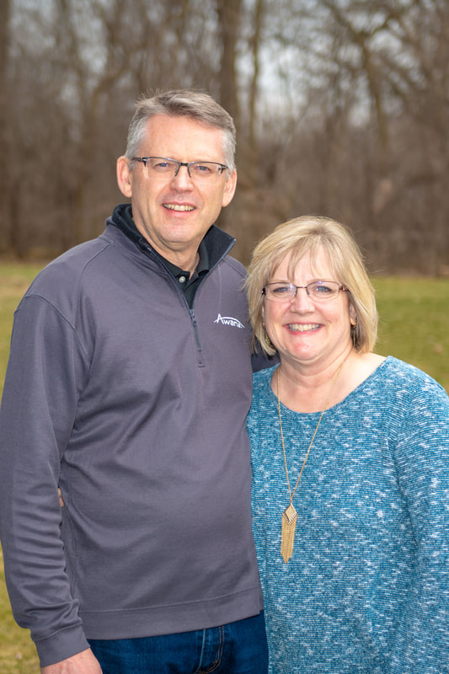

Executive Director for Latin America and the Caribbean

**Our Mission  
The vision and driving passion of Awana are that all children and youth will come to know, love and serve the Lord Jesus Christ. Awana missionaries carry out this vision through relationships with local churches. They assist local church leaders to develop and lead  
ministries related to children and youth in a way that works in their particular setting.**

***Our Mission: We exist to glorify God as we help people move***

***Closer to Jesus in their spiritual journey.***



MAY 23, 2021

IF YOUR FAMILY IS IN NEED IN ANY WAY, PLEASE CONTACT YOUR DEACON OR THE CHURCH OFFICE.

CALENDAR EVENTS

Tues – 9:30 am - Ladies Prayer Mtg.

Sun – May 23 – Sunday School @ 9:15 a.m.

Sun – May 23 – Sunday Morning Worship Service @ 10:30

Thur – May 27 – Men’s Small Group Mtg @ 7:00 pm

Sun – May 30 – Communion

Sun – May 30 – Church Picnic @ the Hartongs – 1:00 pm

Fri – June 4 – Teen Cookout @ Prichards – 6:00-9:00 pm

Sun – June 6 – Honoring 2021 Graduates

Wed – June 16 – Board Meeting @ 7:30 pm



**May 1st thru**

**May 31st**

**Please help out in this way so that others who are in need can get through these trying times. Grocery bags and boxes are located in the hallway across from the kitchen. Please put your non-perishable items in these containers.**



**CHURCH PICNIC AT THE HARTONGS**

**MAY 30TH @ 1:00 P.M.**

**Contact Allen Hartong if you are planning on attending this Memorial Day Picnic. A count is needed to know how much food needs to be prepared. This is not a Potluck meal although you may bring a dessert. The Hartong’s address is 900 N. Enon Road, Yellow Springs, OH 45387**

**Grand Heights Baptist Church**

**1611 Armstrong Road**

Fairborn, OH 45324

**(937)878-7971**

**E-mail: ghbcnet@grandheights.org**