**Ladies**: The next activity is a Planting Day

on May 21 @ 6:30 p.m. Please bring your

gloves and trowel. Contact Kathy Rudy for

more details!

**Summer Activities** are currently being planned so please save these dates:

June 10-14 VBS

June 17-29 Campers to Skyview Ranch

July 7 Ice Cream Social

July 21 Hot Dog Roast at Dave and Anna’s

August 4 Deacon Flock Meetings

August 25 End of Summer - Young’s Run

Please continue to **Pray for the Pulpit Committee** as they continue to look at resume’s and interview potential candidates for our next Senior Pastor.

May 25th Skyview Ranch will be celebrating 50 years of ministry. Free food and great testimonies. Register online to attend! Pastor will be speaking at 1:30.



***Welcome to Grand Heights!***

*We are glad you are here with us this morning! You will find Grand Heights to be a friendly and diverse community of people dedicated to impacting our community and the world with the Gospel of Jesus Christ!*

**VACATION BIBLE SCHOOL**

**JUNE 10-14**

**9 AM - NOON**

[](https://www.bing.com/images/search?view=detailV2&ccid=t88%2bPWPO&id=7387F37954BB639828A4D3B1A27DE64F4B65B8D9&thid=OIP.t88-PWPOwCEyuok48hEHYgHaFL&mediaurl=https://iscrapapp.com/wp-content/uploads/2014/05/pennies-for-scrap.jpg&exph=716&expw=1024&q=picture+of+pennies&simid=608025402043271171&selectedIndex=0)

**Help Needed:**

Decorations – May 31 & June 9

Game Director

Team Coaches K-1 & 2-3

Team Assistants

Food Donations

Craft Supply Donations

**Sign up on the Serve Board Today**

**GROW**

Be sure to check out our Growth Group Bible Studies this week!

Ladies: Tuesday 9:30 at the Church

Men: Tuesday 7:30 at the Fairborn McDonalds

Men: Thursday 7 PM at the Church

Couples: Thursday 7 PM at the Pensworth’s

**SERVE**

Vacation Bible School is June 10-14 (see the information on the right column). Deb Jones is now recruiting workers and helpers. Sign up on the Serve board. Volunteer TODAY to impact lives for eternity.

**CONNECT**

This morning Pastor will be sharing two of the virtue requirements of a Pastor, a one-woman man and temperate. These two virtues are key to his being a blameless example for us to follow.

**LEAD**

On Wednesday we elected new officers for the next few years. Be sure to pray for these men and women as they begin their terms of service.

**Verse of the Week:**

**1 Timothy 3:2**

**Now the overseer must be above reproach, the husband of but one wife, temperate, self-controlled, respectable, hospitable, able to teach,**

**Dirty Pennies** are needed for a science experiment during VBS. If you can contribute some, please leave them in the container near the kitchen. Afterwards we will put them toward the VBS offering.

**Craft Preparation** - help is needed. There are projects like cutting that need your help. Check it out in room 105. Contact Cindy Sudduth, 937-478-7886, with any questions:

**There Are Still a Number** of tasks needing to be done throughout the Church. See Allan Hartong for the details.



Mission Project for VBS:

**Fish Food Pantry**

Accepting Food and Cash Donations!

[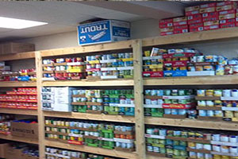](https://www.foodpantries.org/li/fish-fairborn)



**Calendar of Events:**

May 21 Ladies Planting Party 6:30

May 25 Rachael – Graduate Party/3:00

May 25 Skyview Ranch 50th Anniversary

May 26 Ben; Madison; Alison Grad. Parties

May 27 Memorial Day

May 29 VBS Decorations

June 1 Men’s Breakfast/Devotions

June 2 Ladies Hike

June 9 VBS Final Decorations

June 10-14 Vacation Bible School

June 16 Father’s Day – No PM Activity

June 17-29 Campers to Skyview Ranch

July 4 Holiday – Church No Activities

July 6 Men’s Breakfast/Devotions

July 7 Ice Cream Social

July 15 Ladies Dinner Out

July 21 Hot Dog Roast @ Dave & Anna’s

July 30 Gospel Missions

**BIRTHDAYS/ANNIVERSARIES**

May 20 Brendon Dierker (B)

May 21 Drake Pensworth (B)

May 22 Mark Fischer (B)

LADIES HIKE – June 2nd

Charleston Falls Preserve

2535 Ross Road - Tipp City

Carpool at the Church 4PM

Others at the park 4:30 PM

Questions Contact

Rachele @ (937) 609-9117

Kathy @ (937) 765-0477

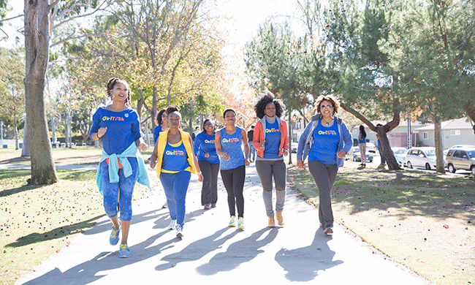

**Graduation Sunday is June 2nd**

We will be honoring our High School and College graduates on that day!

High School College

Alison Bachowski Brandon Hulbert

Rachael Hartong Josh Burk

Ben Hulbert

Madison Prosser

**Dates of Graduation Parties:**

Rachael Hartong May 25 – 3:00 @ Hartongs

Ben Hulbert - May 26 12:30–4:00 @ Hulbert’s Home

Madison Prosser – May 26 2-5:00 @ Bath Twp. Park

Alison Bachowski – May 26 5-8:00 @ Grand Heights

**BE SURE TO CONGRATULATE** **OUR GRADUATES AS THEY MOVE TO THE NEXT**

**PHASE OF THEIR LIVES!**

Pastor Waldo is reducing

the size of his library. On the

table in the MPR are books

by Charles Swindoll, Charles

Stanley, David Jeremiah and

Tony Evans. Books are free

donations accepted.

Qualifications for Being A Pastor:

“Faithful and Temperate”

May 19, 2019



***Our Mission:***

*We exist to glorify God as we help people move closer to Jesus in their spiritual journey.*

[](https://www.bing.com/images/search?view=detailV2&ccid=QCqWndUC&id=6DCA54A2202A8C3423113B41597E1F1602F996B2&thid=OIP.QCqWndUCBA-bnNZdkeRJEgHaEo&mediaurl=http://i.telegraph.co.uk/multimedia/archive/01950/lib_1950367b.jpg&exph=388&expw=620&q=free+pictures+of+library+books&simid=608024220927462867&selectedIndex=0)

**Grand Heights Baptist Church**

1611 Armstrong Road

Fairborn, Ohio 45324

937-878-7971

www.grandheights.org